THE 5782/2021 ANTHOLOGY FOR THE JEWISH NEW YEAR

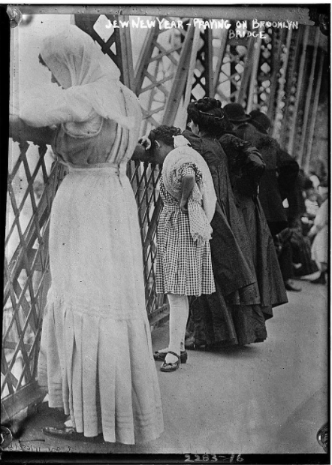
Historical photo of Jews reciting the Tashlich service on the Brooklyn Bridge in the early 1900s

SHANAH TOVAH

We all pray that the New Jewish Year of 5782 will be the year that our millenniums-old hopes for the Geulah (Redemption) will be fulfilled and that G-d should bless all of Klal Yisroel with overwhelming brochos in both the realms of gashmius (material prosperity) and ruchnius (spirituality).

Despite our hopes, the dreaded Corona virus continues to plague us with new mutations and obviously we should learn from Above to be put our trust and faith mainly in our Father in Heaven and not to just to place out bets in “believing in science” as a hopeless alternative to relying on G-d.

May this year be one in which G-d protects both the Jewish Land of Israel and our host country – the United States from the folly of its political leaders, whom all too often act for their own selfish benefits and on their own agendas and not on the Ratzon (desire) of Hashem.

This Rosh Hashana 5782 marks our 13th year of publishing the Shabbos Stories and our sixth year of publishing the Brooklyn Torah Gazette, with a total of more than 600 Shabbos Stories emails and just slightly more than 250 Brooklyn Torah Gazette emails.

Each week’s emails can be found on the popular ParshaSheets.com website. We have also created a ShabbosStories.com website in which all of our past hundreds of Shabbos Stories and Brooklyn Torah Gazette emails can be accessed and printed out for enjoyable reading at your Shabbos and Yom Tov tables.

In addition to including the Shabbos Stories and Brooklyn Torah Gazette editions for Rosh Hashanah 5782, this new anthology also includes a large selection of supplementary (non-Rosh Hashana) articles and stories that touch on various topics that arouse our Pintele Yid (Jewish heart.)

Daniel Keren
(18th day of Elul, August 26, 2021)
The 5782 jewish new year anthology
Compiled by Daniel Keren
Printed L’illuy nishmas Nechama bas R’ Noach, a”h

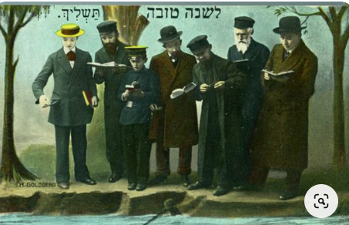
Historic early 20th Century Rosh Hashanah card designed by H. Goldberg highlighting the Tashlich ceremony

Shabbos Stories for Rosh Hashanah 5782………………………..………..Page 4
Brooklyn Torah Gazette for Rosh Hashanah 5782………………….....Page...15
Supplemental Stories for Rosh Hashanah 5782…………………….…..Page...44

Shabbos Stories for
Rosh hashanah 5782
Volume 13A, Issue 1 1-2 Tishrei/ September 7-8 2021
Printed L’illuy nishmas Nechama bas R’ Noach, a”h

For a free subscription, please forward your request to keren18@juno.com

Story #1188
The Shofar of the
Cracked Bell
By Chaya Halberstam-Evers
From the desk of Yerachmiel Tilles
editor@ascentofsafed.com

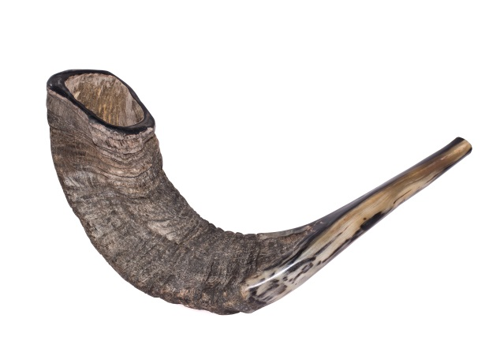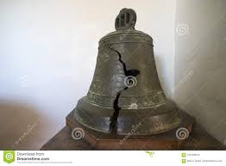

It was the end of a Siberian summer, in 1940. My grandfather, Rabbi Meir Halberstam, a young boy of 13 years old at the time, was imprisoned in a work camp together with his grandfather, the Rebbe of Zhemigrod, Rabbi Sinai Halberstam.
Young Meir had moved with his family to Palestine to settle in the holy city of Jerusalem in 1936, before the war had broken out. In honor of his upcoming Bar Mitzvah, his father sent him on a boat back to Poland where he would be able to celebrate this auspicious day in the chasidic court of his holy grandfather.
Upon his arrival in Poland, the rumble of war was approaching. Disciples, family, and community members were all scrambling to save their lives. With the Nazis at their heels, young Meir escaped with his Grandfather and immediate family to Russia. At last they were safe from the Nazi enemies, or so they thought.
Due to the large amount of Polish refugees in Russia, the Russian government seized the opportunity to use them as slaves. Charging them as enemies of the state since they had Polish passports, young Meir and his Grandfather's whole entourage were sentenced to heavy slave labor in the cold Siberian plains.

The Mild Siberian Summer Had Ended
Rosh Hashana was approaching, and the mild Siberian summer had ended, ushering in the tundra-like winds and cold. Young Meir noticed that with each passing day, his Grandfather, the Rebbe of Zmigrad was becoming more and more depressed. “How will we blow the shofar?” he cried. Although he had the holy shofar that had been passed down from his ancestors, the thought of being caught blowing it by the evil Russian guards, brought dread to his very being.
It was two nights before Rosh Hashana, and young Meir devised a daring plan. He awoke in the middle of the night, and wrapped cloth around his hands and feet in order to muffle any noise he would make. From his window, he watched the wild guards drinking and dancing late into the night. He waited until they were all stooped over in a drunken sleep and quietly trudged through the wind and cold to the front of the work camp, where the giant camp bell stood.
He looked to all sides to make sure he was unobserved, then climbed up a very high post until he reached the top of the bell. With all his might he unraveled the rope holding the bell and watched the entire bell come crashing to the ground, where it shattered into many small bits and pieces. He then descended the post and quietly returned to his barrack.

There Was an Uproar in the Camp
The next morning there was an uproar in the camp. Upon awakening, the guards saw the broken bell and realized that they would have a problem waking all the prisoners in time. It would take weeks until they would be able to get a new bell.
Young Meir then shared with his grandfather the brave mission he had done the previous night and whispered his plan.
By the time all the prisoners were up, the guards where quite angry and looking for someone to blame. Instead, young Meir’s uncle came forward and related to the head commander that he had an old shepherd’s horn that his father would gladly blow each morning to wake the prisoners until they received a new bell. Upon hearing this, the commander ordered him to bring the horn at once.
The Rebbe arrived, shofar in hand, and began to blow long notes. “Let me blow it” yelled the commander, grabbing it out of the Rebbe’s hands.
The commander took the shofar in his hands and brought it to his mouth, but no matter how hard he blew, no sound came out. It was at this moment of frustration that young Meir’s uncle advised the commander to let his Father blow it, since he was a “professional” horn blower. The commander then appointed the Rebbe as the official waker, who would be responsible to wake the prisoners each morning until a new bell was mounted.

Word Spred Quickly Throughout the Camp
Word spread quite quickly throughout the camp. All the Jewish prisoners knew that the Rebbe of Zmigrad, would blow his holy shofar the next morning, on Rosh Hashana. As the frosty morning beckoned, each prisoner was up early awaiting the sound of the shofar. The Rebbe wept as he blew the horn, the prisoners cried and prayed, and young Meir stood proudly as he watched the notes of the shofar break the darkness on that crisp Siberian morning. It was a shofar blowing that he never would forget.
My grandfather went through many more trials and hardships until he made it back to the shores of Israel (then Palestine) where he was welcomed and celebrated for the great miracles that happened to him.
Although I am a grandchild of Reb Meir Halberstam, I have only recently heard this story and it made a deep impression on me. Rosh Hashana is a very special time for our family. For me, it has always been a holiday of hope, and positivity, as we surely believe that the Al-mighty will embrace us and hold us, as he ushers us into a beautiful and sweet new year.

Recalling Her Grandfather’s Shofar
I try to think about the shofar that Zaidy (my grandfather) heard all those years ago on that cold Siberian morning, and the strength that it gave him and all the Jews who heard it. Perhaps this year, if I close my eyes and listen with my soul, I can internalize the sounds of the shofar and I will hear the sounds of faith, courage, and hope that it gave my grandfather.
~~~~~~~~~~~~~~
Source: Adapted and supplemented by Yerachmiel Tilles from an article on //chabad.org.
[Chaya Halberstam-Evers, is an educator and writer who lives with her husband and four children in Amsterdam.]
Connection: ROSH HASHANA
Biographical note: Rabbi Sinai Halberstam, the first Rebbe of Zhmigrod (1869-1941),was a son of Rabbi Boruch of Gorlitz, the 4th son of the Divrei Chaim, Rabbi Chaim Halberstam, founder of the Sanz dynasty. He died in the Omsk forest in Siberia, shortly after the events of the above story. Many of his male descendants became rebbes, including five grandsons who currently are Zhmigrod rebbes, in USA, Israel and Belgium.

Reprinted from the Rosh Hashanah 5781 email of KabbalaOnline.org, a project of Ascent of Safed.

12 People Who Left Their Mark on Rosh Hashanah
By Yehuda Altein

1. Adam
Rosh Hashanah, the head of the Jewish year, coincides with the sixth day of Creation—the day G-d created Adam, the first human. This is by no means coincidental. G-d specifically chose the birthday of the first human as the day that marks the Jewish New Year.
Why do we celebrate Rosh Hashanah on the anniversary of humankind, as opposed to the anniversary of the universe (six days earlier)? Because we—descendants of Adam—play an integral role in Creation. G-d created an incomplete world. It is up to us to use the coming year to fill in that gap, by instilling the world with Divinity and sanctity, one mitzvah at a time.

2. Eve (Chava)
Shortly after Adam was created from the dust of the earth, G-d determined that it was “not good for man to be alone”¹ and He created Eve (Chava), the first woman.
Rosh Hashanah is thus the anniversary of the creation of the first man, as well as the first woman. Ironically, while Eve was the paradigm of fertility (the very name Chava means “mother of all life”²), the other women on this list struggled to conceive.

3. Sarah
Our matriarch Sarah was barren for many years, until miraculously giving birth to Isaac at the age of 90. Our Sages tell us that it was on Rosh Hashanah that G-d “remembered” Sarah, resulting in Isaac’s conception.³
To recall this event, the Torah readingof the first day of Rosh Hashanah relates the story of Isaac’s birth and formative years.

4. Isaac
The Torah readingof the second day of Rosh Hashanah also features Isaac. It relates the story of the binding of Isaac, in the merit of which we pray that G-d judge us favorably and grant us a year of blessings. One detail of this story is the ram whose horns were tangled in a thicket—recalled by the shofar, made from a ram’s horn.⁴

5. Rachel
Rachel watched as her sister Leah bore Jacob one son after the next, while she remained barren. Finally, on Rosh Hashanah, Rachel was also remembered On High, resulting in her pregnancy with Joseph.⁵

6. Joseph
Years later, in the dramatic saga of Joseph’s life, Rosh Hashanah appears once again: It was the day he was released from prison, after being falsely accused of attempting to act immorally with the wife of his master Potiphar.⁶

7. Chana
Chana, mother of the prophet Samuel, is the third of the trio of barren women who were remembered on High on Rosh Hashanah.⁷ Some add that Rosh Hashanah was the day she offered a silent prayer in the Tabernacle in Shiloh, which the High Priest Eli mistook as a sign of intoxication.⁸
In commemoration, we read Chana’s story in the haftarahof the first day of Rosh Hashanah. This moving account underlines the power of prayer, demonstrating that if we invest our hearts and souls into our prayers, G-d will surely heed our requests.

8. Gedaliah
After Nebuchadnezzar destroyed the first Holy Temple in Jerusalem, he appointed the righteous Gedaliah, son of Ahikam, as the governor of the remaining Jews. Under his leadership, the small group of Jews began to recover and reclaim some sense of peace and security. However, this tranquility was not to last. On Rosh Hashanah, Gedaliah was slain by a jealous, treacherous Jew named Yishmael. Whoever survived the massacre fled to Egypt, and the last embers of Jewish life in the Land of Israel were extinguished.
To commemorate this sad milestone in our history, the day following Rosh Hashanah is kept as a fast day, known as Tzom Gedaliah.

9. Rabbi Amnon
One of the most soul-stirring prayers recited on Rosh Hashanah is Unetaneh Tokef. Its passages describe in vivid terms how all created beings pass before G-d on this day, and He decides the fate of each one. We are reassured, however, that even if negative occurrences are in store, “repentance, prayer, and charity revoke the evil of the decree.”
Who composed this haunting text?
Legend has it that it was composed by an early medieval scholar named Rabbi Amnon. After being punished by the local duke for refusing to renounce his faith and become a Christian, the crippled sage was brought to the synagogue on Rosh Hashanah, where he led the congregants in a newly composed addition to the High Holiday liturgy.
(Note: According to some versions of the account, Rabbi Amnon instructed the duke to amputate his legs, as punishment for his delay in responding to the duke’s offer. However, this version is problematic, as it is forbidden to willingly mutilate one’s body.⁹Also note that prayer appears to predate Rabbi Amnon.)

10. Rabbi Shimon the Great
The machzor—the prayer book used on the High Holidays—is replete with prayers exclusive to Rosh Hashanah (and Yom Kippur). Many of these prayers are known as piyutim (plural for piyut), liturgical compositions written in poetic style expressing the awesomeness of the day.
One of the first composers of piyutim was Rabbi Shimon the Great, a saintly tenth-century scholar from Germany. Many of the piyutim in the machzor were penned by him, and some of them include the Hebrew acrostic: Shimon bar (son of) Yitzchak.
Legend has it that one of Rabbi Shimon’s sons was kidnapped and raised as a Christian, rising in rank until he was appointed pope. On a mission to Rome on behalf of the Jewish community, Rabbi Shimon met with the pope and discovered his long-lost son, who subsequently returned to Judaism.
Read: Rosh Hashanah Services at a Glance

11. Jews in Concentration Camps and Soviet Gulags
Over the course of our history, Jews have taken the most extreme measures possible to mark this holy day and perform the sacred rite of blowing the shofar. Shofars were even smuggled into concentration camps and Soviet gulags and blown in secrecy, demonstrating that no one and nothing can destroy the indomitable Jewish spirit.

12. You!
Rosh Hashanah is a day of prayer, a time to ask the Almighty to grant us a year of peace, prosperity, and blessing. But it is also a joyous day, when we proclaim G-d King of the Universe. The Kabbalists teach that the continued existence of the universe depends on G-d’s desire for a world, a desire that is renewed when we accept His kingship anew each year on Rosh Hashanah. This is something that is up to each and every one of us, by hearing the shofar blasts and resolving to serve G-d over the upcoming year to the best of our ability. So the true hero of Rosh Hashanah is no one else but you.

FOOTNOTES
1. Genesis 2:18.
2. Genesis 2:23.
3. Rosh Hashanah 11a.
4. Genesis 22.
5. Ibid.
6. Ibid.
7. Ibid.
8. See comment of Chatam Sofer on Magen Avraham, Orach Chaim 581:15.
9. Likutei Sichot, vol. 29, p. 478.

Reprinted from the Rosh Hashanah 5781 email of Chabad.Org Magazine.

Get It in Writing

At an engagement celebration, the Kallah’s father was asked to put into writing the financial commitment that he promised to the young couple.
He did not want to do so, saying that they should take his word for it since he was a very dedicated father who always watched out for his children.
R’ Elchonon Wasserman, who was present at the time, immediately answered the Mechutan's claim based on the Tefila we say in Shmoneh Esrei during Aseres Yimei Teshuva.
“Zachreinu L'Chaim Melech Chafeitz BaChaim V'Chasveinu B'Sefer HaChaim.”
We have already asked Hashem to remember us for life, why do we then say to inscribe us in the book of life? Hashem does not forget and is equally devoted to His dear children. Nevertheless, we ask to have it in writing. From here we see, said R’ Elchonon, that as honorable a person may be... always get it in writing!

Reprinted from the Rosh Hashanah 5781 email of Migdal Ohr.

Six Hundred Dinars
Minus Six
From the Midrash as told by Rabbi Tuvia Bolton

Rabbi Shimon Bar Yochai (who lived in the 2nd century CE in the Holy Land) was possibly the holiest man that ever lived. Besides authoring the 'Zohar', being a master of the oral Torah and a miracle worker, he was one of the few Jews in history who spent every instant of his time learning Torah; no casual conversations, coffee breaks and certainly no vacations—only Torah.
So everyone was surprised when, the day after Rosh Hashanah (Jewish New Year's Day) he showed up at the door of his nephews' home and began to lecture them about the importance of giving charity to the poor.
Although they didn't really have money to spare and totally didn't understand the urgency of what he was saying, they listened attentively; when Rabbi Shimon spoke everyone listened.
"Give with an open hand," Rabbi Shimon adjured. "Don't worry about tomorrow, G-d will provide. And most important: write it all down. Every penny you give, write it down and carry the list with you at all times. I want to see a big sum at the end of the year."
Rabbi Shimon made them promise and he left.

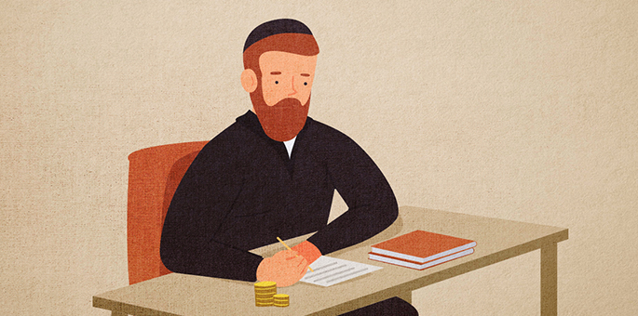
Art by Rivka Korf Studio (Miami)

Almost a year later they had another strange visit—from a posse of Roman soldiers with an order for their arrest. Someone accused them of selling silk without paying the tax to the government. They began weeping and protesting their innocence but to no avail.

Trembling with Fear as They Were Led Off to Prison
Trembling with fear, they were led off to prison where they were given a choice: either pay an outrageous fine of six hundred dinar or produce an even more outrageously priced silk garment for the king, both of which were utterly beyond their means.
When Rabbi Shimon heard what had happened he immediately rushed to the prison and got special permission to visit his relatives.
"Where is the account of the charity you gave?" He asked. "How much did you give?"
"Here," they replied as one of them pulled the small parchment from his pocket.
Rabbi Shimon took the account and noticed that they had given almost six hundred dinar; they were just six dinar short. "Do you have any money with you?" he asked.
They produced six dinar that they had sewn into their garments in case they needed it. Rabbi Shimon took the money, bribed one of the officials, the charges were dropped and they were released.
Rabbi Shimon explained to them what had happened. "This past Rosh Hashanah I dozed off and dreamt that the government would demand of you six hundred dinars. That is why I told you to give charity, to negate the decree."
"Then why didn't you tell us about that?" they complained. "We would have given the money immediately and spared ourselves a lot of anguish."
"But then," replied Rabbi Shimon. "You wouldn't have done the mitzvah for its own sake." (From Midrash Rabbah, Vayikrah 34:12)

Reprinted from the Rosh Hashanah 5781 email of Chabad.Org Magazine.

The Master Key
By Rabbi Shlomo Yosef Zevin

One year, Rabbi Israel Baal Shem Tov said to Rabbi Ze’ev Kitzes, one of his senior disciples: “You will blow the shofar for us this Rosh Hashanah. I want you to study all the kavanot (Kabbalistic meditations) that pertain to the shofar, so that you should meditate upon them when you do the blowing.”
Rabbi Ze’ev applied himself to the task with joy and trepidation: joy over the great privilege that had been accorded him, and trepidation over the immensity of the responsibility. He studied the Kabbalistic writings that discuss the multifaceted significance of the shofar and what its sounds achieve on the various levels of reality and in the various chambers of the soul. He also prepared a sheet of paper on which he noted the main points of each kavanah, so that he could refer to them when he blew the shofar.
Finally, the great moment arrived. It was the morning of Rosh Hashanah, and Rabbi Ze’ev stood on the reading platform in the center of the Baal Shem Tov’s synagogue amidst the Torah scrolls, surrounded by a sea of tallit-draped bodies. At his table in the southeast corner of the room stood his master, the Baal Shem Tov, his face aflame. An awed silence filled the room in anticipation of the climax of the day—the piercing blasts and sobs of the shofar.
Rabbi Ze’ev reached into his pocket, and his heart froze: the paper had disappeared! He distinctly remembered placing it there that morning, but now it was gone. Furiously, he searched his memory for what he had learned, but his distress over the lost notes seemed to have incapacitated his brain: his mind was a total blank. Tears of frustration filled his eyes. He had disappointed his master, who had entrusted him with this most sacred task. Now he must blow the shofar like a simple horn, without any kavanot. With a despairing heart, Rabbi Ze’ev blew the litany of sounds required by law and, avoiding his master’s eye, resumed his place.
At the conclusion of the day’s prayers, the Baal Shem Tov made his way to the corner where Rabbi Ze’ev sat sobbing under his tallit. “Gut Yom Tov, Reb Ze’ev!” he called. “That was a most extraordinary shofar-blowing we heard today!”

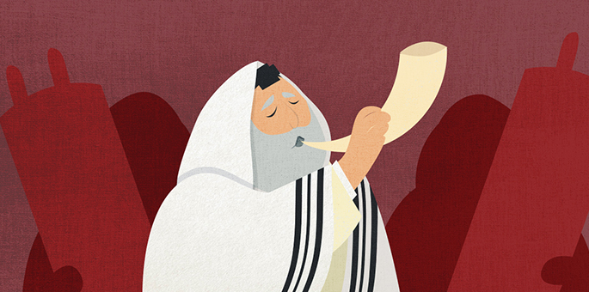
Art by Rivka Korf Studio

“But Rebbe…”
“In the king’s palace,” said the Baal Shem Tov, “there are many gates and doors, leading to many halls and chambers. The palace-keepers have great rings holding many keys, each of which opens a different door. But there is one key that fits all the locks, a master key that opens all the doors.
“The kavanot are keys, each unlocking another door in our souls, each accessing another chamber in the supernal worlds. But there is one key that unlocks all doors, that opens up for us the innermost chambers of the divine palace. That master key is a broken heart.”

Reprinted from the Rosh Hashanah website of Chabad.Org Magazine. Translated and adapted by Yanki Tauber from Rebbi Shlomo Yosef Zevin’s “Sippurei Chassidm.”
Brooklyn torah gazette
For rosh hashanah 5782
Volume 6, Issue 1 (Whole Number ???) 1 Tishrei 5781/September 7-8, 2021
Printed L’illuy nishmas Nechama bas R’ Noach, a”h

Reprinted from the September 10, 2018 edition of the Daily Express (U.K.)

Judgement Day or Holiday

We are now in the judgment days – the days of Rosh Hashanah. What is the essence of these days? On the one hand, these are judgment days and everyone is trembling from their awe. On the other hand, we acknowledge the posuk about this day (Nechemia 8:10) – Go, eat rich foods and drink sweet beverages… for today is sacred to our L-ord. Do not be sad, the enjoyment of Hashem is your strength’. Apparently, this posuk is telling us to be happy and certainly not to be sad, then what is the proper approach to this day?
It is told regarding one of the distinguished in Yerushalayim, that right in the middle of Yom Kippur his grandson came to him and happily said, “Saba, there are only three hours left until the fast is over.”
His grandfather replied, “How sad that there are only three hours left to this holy and exalted day!”
It is brought down in ‘Sfas Emes’ that on Rosh Hashanah we must be very happy, more than the rest of the year, since HaKadosh Baruch Hu judges the world and a person cannot be judged unless he is present. If so, then it is as if HaKadosh Baruch Hu is found at our side.
We say this in Unesaneh will mankind all' – Tokef pass before you like members of the flock’, and because of this we hardly request material things, for one who is close to the King lacks nothing. The holy Baal Shem Tov says that the holiday of Rosh Hashanah is a day of joy, therefore we recite ‘shehechiyanu’.
It is also brought down in his name that when one cries on this day it is a cry of joy that He kept us alive and we reached this time. It emerges from these words that Rosh Hashanah is truly a day of joy, but together with this we remember that this day is also Judgment Day, but we put our trust in our Father Who judges us, that our judgment will come to light.

The main thing to remember is that our focus should be to continue to serve Him wholeheartedly, and all that we want and ask for is to be able to fulfill the will of Yisbarach Shemo.
May it be the will to serve with pure service, with joy and a good heart, and our tefillos should be accepted with mercy. - Tiv HaMoadim – Rosh Hashanah

Reprinted from the Rosh Hashanah 5781 email of Tiv Hakehila in Yerushalayim.

Praying that the Cow Should Continue Giving Milk?
By Mrs. Michal Horowitz

R’ Yisroel Stone, the Chabad rabbi of the Chabad Lower East Side (NY), shared the following story:
At or around midnight the Saturday night before Rosh Hashanah, Ashkenazic Jewish communities around the world begin reciting Selichot — the penitential prayers in preparation for the High Holidays.
A story is told about Rabbi Shmuel Munkes, a disciple of the Alter Rebbe (R’ Shneur Zalman of Liadi, 1745-1812, founder of Chabad), a very devout and spiritual man with a strong sense of humor.
One year, as he traveled to be with his Rebbe for Rosh Hashanah, he spent Shabbat at a roadside inn owned by an elderly Jewish couple. At midnight, the owners dutifully roused their guests to join them at the local synagogue for Selichot.
When they came to Rabbi Shmuel’s room, he seemed confused.

Why Are You Waking Me
Up in the Middle of the Night
“Why are you waking me up in the middle of the night?” he asked.
“To recite Selichot,” they replied.
“I’ve never heard of this prayer before,” he said. “What is it all about?”
The owners seemed bewildered at the site of a bearded and respectable looking rabbi, who apparently had never heard of this ancient Jewish custom. So they began to explain: “We pray to G-d that the cow gives milk in the coming year and that we make enough money to support our family.”
Rabbi Shmuel then turned serious and said to them: “You’re waking up in the middle of the night the week before the holiest day of the year to pray for your cow?! That’s not what the High Holidays are all about!”

Let Us Not Forget that Our
Focus During the High Holidays
Indeed, let us not forget that while we surely should be praying for materialistic good, our focus during the High Holidays should be on our relationship with G-d, and our commitment to being the best Jews that we can be. As we pass before G-d this Rosh Hashana, as a shepherd counts his flocks, let us recommit ourselves to living meaningful, connected and purposeful lives. While we daven that ‘the cow should give milk’, let us not forget that Rosh Hashana is Coronation Day. Let us daven that G-d’s Presence be revealed in our world, that truth shall prevail over falsehood this coming year, that light shall dispel the darkness that envelops us, and that peace shall finally be bestowed upon our people, our Land, our city of peace, and this world.
May we merit to hear the call of the great shofar this coming new year, which will signal our final redemption and ultimate return. גליותינו לקבץ נס ושא לחרותינו גדול בשופר ותקע - and blast the great shofar of our freedom, and raise the banner of the ingathering of the exiles (weekday amidah).

Reprinted from the Rosh Hashanah 5781 email of a A Short Vort.

“Today is the Birth(day) of The World." (Rosh Hashana Prayers)

These words are said after the blowing of the Shofar on Rosh HaShana. Chazal tell us that Hashem began Creation on the 25th of Elul and Rosh HaShana corresponds to Friday, the day that Man was created. We celebrate Rosh HaShana on this date because before Man was created, there was no purpose to the world yet.
As Hashem says, “I did not create the world to be desolate, but formed it to be populated.” (Isaiah 45:18) Though this is the typical translation of the phrase, that this is the day the world was born, the word ‘harah’ doesn’t mean birth, but conception.
We find in numerous places (including the Haftarah of Chana on the first day of Rosh Hashana) the phrase, “vatahar vatailed bain,” and she conceived and she gave birth to a son.
If this is so, then what is meant by saying “this is the day the world was conceived”? The world was created; we should say, “Hayom Huledes Olam.”
The truth is that the word used here is very precise. This is the day the world was conceived, when it began its journey to completion. Now that human beings existed, the world could come to its perfection.
As R’ Akiva told Turnus Rufus HaRasha, Hashem left things in Creation undone so that we might become His partners in it. All people are born with a ‘tzelem Elokim,’ the form of Hashem.
But we know Hashem has no form! To what, then, are we referring? We are referring to His role as a Creator. Each person is imbued with the ability to create, do, and achieve things in the world. We don’t have to accept situations as they are; we can try to improve them.
That is why on Rosh HaShana, when we ask Hashem for a new year to accomplish things on this earth and in the Heavens above, we say this is the day the earth was conceived. It was the beginning of a growth stage that would continue forward with each person adding what they could.
Nothing is yet determined or set, and we can maximize the outcomes of our efforts. That is the type of year we can and should ask for: one that will give us opportunities to grow and achieve, and in which we commit to using it as such.

Reprinted from the Rosh Hashanah 5781 email of Migdal Ohr.

Letter from the Kalever Rebbe
For Rosh Hashanah 5781

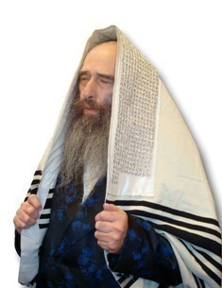

When a person finds himself in a situation where he may feel exempt from some aspect of serving the Creator, for example if he has an excuse that would prevent him from davening with a minyan, due to fear or other difficulties, if despite this, he musters up the energy to encourage himself to fulfill all of the mitzvos in the best possible manner, this arouses a tremendous merit in Heaven for him.

A Story is Told About Rebbe Levi Yitzchok
A story is told about the holy Rebbe Levi Yitzchok of Berdichev, zt”l, that one Erev Pesach after the time when one is no longer allowed to own any chometz, he asked one of his assistants to go to the homes of gentiles and try to purchase a particular type of imported whiskey that the Russian Czar declared to be contraband throughout his Empire. The black market sales were easy to find, as every gentile told him that they could sell this prohibited whiskey in abundance.
Afterward, the holy Rebbe gave a large sum of money to the assistant, and sent him to every Jewish home in town, asking them to sell him a bit of chometz for this large sum. The assistant went to every Jewish home, and he returned empty-handed, because not even one Jewish family had even a small amount of chometz, not even an amount smaller than the size of an olive.
The following Rosh Hashanah, several months later, before sounding the Shofar, the holy Berditchiver Rov, zt”l began his sermon, and he opened with an impromptu prayer, “Ribono Shel Olam! Master of the Universe! The Czar outlawed importing whiskey from this other country, and he hired thousands of officers and inspectors, and he openly punishes anyone who owns it. Yet I found that every home has plenty of it. On the other hand, You wrote in Your Torah that a Jew cannot have a kzayis of chometz in his home on Pesach, and You did not appoint any officer or inspector to find or to punish the violator. Despite all this, I was unable to find even a tiny crumb of chometz in any Jewâ€™s possession on Erev Pesach! Are they not worthy to be blessed with a sweet and happy New Year?!”

Keeping Laws of the Land for Fear of Punishment
This is largely true at all times including ours. People keep the laws of the land for fear of punishment. When there is no fear the laws are trampled upon. The Nations of the world who practice a religion primarily do so when they have no other choice. The minute they have free choice they neglect their religion. Not so the Jews, who have an eternal soul and strive to serve G-d out of deep love and sacrifice. Even when they have a legitimate excuse to go easy, they still strive to do all the Mitzvahs in the best possible fashion.
Therefore, our ancestors for over three millennia throughout the chain of generations since Avraham Avinu to our own generation, always engaged in self-sacrifice in order to fulfill the Torah and mitzvos in every situation. Even the simplest Jews in the old days, who needed to work hard all day long in order to eke out a meager living would always daven with minyan in shul every day for every public prayer service, in order to hear Kaddish, Kedushah, and Borchu, and to answer Amen, knowing that this brought tremendous nachas to their Father in Heaven Who gives them life.

Setting Times to Study Torah Despite Extreme Difficulty
They also set aside times to study Torah even when this was extremely difficult to fit into their busy schedules. A simple Jew from Russia once told me that he lived in a place where the Communists forced him to work all day long, starting at 5 am, and they could kill someone who arrived late at work, so he would wake up at 3 am in order to learn Torah and daven before work.
The month of Tishrei was full of heroic deeds. Jews would show tremendous self-sacrifice to perform the Mitzva of Shofar, Succah, Esrog, etc. This was done in most trying times such as the Marranos in fifteenth century Spain, in Russia under Communism, and even in the Auschwitz hell.
Along these lines, it is said that my holy ancestor Rebbe Shalom of Belz, zt”l, once sat in his chair before the Shofar sounding with an obvious look of sorrow on his face, and he did not want to go to sound the Shofar for a long time, until suddenly he stood up with obvious joy and sounded the Shofar.
Afterwards, he told the story of how he perceived that there was a tremendous persecution in Heaven against the Jewish community, and he felt that he was unable to sound the Shofar until he was able to overcome this decree. By Divine inspiration, he was able to telepathically see how a group of boys who were kidnapped and drafted into the Russian army by the Czar’s Cantonist decree secretly gathered together to pray on Rosh Hashanah.

Spent a Long Time Searching for an Animal Horn
Even though they were locked away in the army barracks, they decided that they had to do whatever they could to find a shofar, thus they spent a long time searching the entire camp, until they found an animal horn that they were able to get some sound out of with great difficulty, and one of them who had some meager knowledge of how to blow a shofar got some sound out of this horn.
They put in tremendous effort with love of Hashem to sound these notes, and this brought tremendous nachas in Heaven, and the entire Divine persecution was nullified. When the holy Belzer Rebbe was shown this, he was able to sound the Shofar.

Shofar that was hidden and blown in the Auschwitz concentration camp

This power of faith is our heritage from our holy ancestors, who rejoiced in the ability to pursue the mitzvos of Hashem with love. We found this particularly with the story of the Akeidas Yitzchak, where Avraham Avinu and Yitzchak Avinu rejoiced tremendously over the opportunity to offer such a great sacrifice in order to fulfill the mitzvah of their Father in Heaven, to the point where the angel had to tell Avraham that he should not harm Yitzchak in any manner, not even in a slight way to do the mitzvah, inasmuch that they did not feel any joy in being exempt from this, just this opposite, it caused them both anguish to be spared from this opportunity. For this reason, Hashem sent a ram caught in a bush by its horns, in order that they should, at the very least, offer some form of sacrifice to Hashem, so that they should not be left empty-handed.

The Merit of Yishmael
Yishmael the son of Avraham also fulfilled the difficult mitzvah of Bris Milah when he was 13 years old, and in this merit his progeny earned the capability to overtake and pain the Jews in the final exile, as the Holy Zohar explains in Parshas Vayera.
However, Kabalistically speaking, his merit is limited, because his devotion to G-d was motivated by fear of punishment and not by love, and he only sought to fulfill that which G-d commanded him specifically, but in general his behavior was negative and he was forced to leave his parents’ home. This is a merit for our community in comparison to the good deeds of other communities, including the Bnei Yishmael, because their devotions are motivated by fear of punishment and not by love like the pious Jews dedicate themselves to demonstrate their boundless love for the Creator.
This is demonstrated by the differences between the two Parshiyos we read on Rosh Hashanah. On the First Day, we read the story of Yishmael, who is called the son of the maidservant, because he and his mother served the Creator like slaves and maidservants who serve only out of fear. On the Second Day, we read the parshah of Akeidas Yitzchak, where we see how to worship our Father in Heaven like a son who fulfills the commands of his father motivated by love.

The Concept of Tekias Shofar
According to this, it is possible to explain the concept of Tekias Shofar, as Chazal explain that one of the reasons for this mitzvah is to commemorate the ram that was caught by its horns in the bush who was sacrificed in place of Yitzchak, and it is possible to explain that this reminds us of how our holy ancestors desired so much to fulfill the mitzvah from love with self-sacrifice until the point where Hashem had to send a ram in order to allow the Patriarchs to sacrifice something, and this inspires us to accept upon ourselves to continue to follow the ways of our ancestors to run after the mitzvos in every situation, as this is a tremendously great merit, more than any other faith community, and in this merit we will be worthy to be rescued and redeemed from our enemies and from all sorrows.
May it be Hashem’s Will that we should be written and sealed immediately for a good year of life.

The King and the
Disobedient Son
By Rabbi Tuvia Bolton

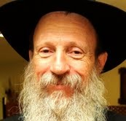

Try to remember the first time you ever heard the Shofar on Rosh Hashanah?
There are millions of Jews throughout the world that cannot. They never heard the Shofar in their lives. In fact, they do not know that they are Jewish or they simply don’t care. But the Baal Shem Tov taught in a parable that every Jew, without exception, feels the same strange awakening when he hears the Shofar.

A Parable from the Baal Shem Tov
Here is the Baal Shem Tov’s parable:
Once there was a great king that had a mischievous ten-year-old son. The young price had requested from his father several times to let him play with the town children outside of the castle wall but his father refused each time saying, “Soon you will be King, and a King must be different”.
But eventually the son decided that he was bored and one day when no one was looking, he changed his royal garments for some old clothes, hid himself under some baskets in the back of a wagon that was about to leave the palace, and in minutes he was outside, free! (According to other versions of the story the king purposely sent his son far away to see how he would fare).
At the first opportunity he jumped out of the wagon, and was on the way to begin playing with other children and having fun.
It wasn’t long until he ran out of money, but he was enjoying himself and he didn’t want to stop. So he learned how to beg and was soon living each day as it came, constantly on the move.
He wandered from city to city and country to country. The days turned into weeks and the weeks to months and before he knew it, ten years had passed and he had become a strong young man. But he hardly looked like the prince he really was, in fact he barely looked human.

He Looked Like Some Wild Animal
His ragged clothes, long dirty hair and fingernails and his strange stare made him look like some wild animal. He had long forgotten about playing games and his only thought was to keep moving and keep alive, collecting money for food.
He wandered so much that one day he unknowingly returned to the country of his birth. But he remembered nothing. The first place he headed for was the huge castle thinking that there he would get a large donation, but he was in for a surprise. As soon as he tried opening the gates the guards pushed him away and a fight ensued.
Meanwhile, every day for the last ten years the king would climb high up in one of the castle towers, gaze into the distance and hope to see his son. What more could he do? He had already sent out hundreds of messengers and searchers year after year with no results.
Again today he remembered his son’s angelic face, his warm smiling eyes, and a small tear trickled down his cheek. “Another empty day,” he thought to himself, as he slowly turned to once again descend the tower steps.

The Fight was Both Fast and Furious
Meanwhile down at the castle gates the fight was going fast and furious and the guards were taken surprise by the strength and speed of this wild man. Then, in a moment of temporary victory, he lifted his head, saw the profile of his father's face high in the tower. And he began to cry.
“What is this?” he thought to himself “Why am I crying? I never cry!”
Then, in a flash, it all came back to him. “I remember that building and this wall! This is my house! Wait! That old man in the window must be MY FATHER!! The KING!!!”
But those few seconds cost him dearly. The guards were striking him mercilessly. He tried to protect himself from the blows but it was too late and he realized that he was about to lose consciousness. So he desperately began crying out; “FATHER, FATHER!!! HELP!!! SAVE ME!! PLEASE SAVE ME!!”
But it didn’t work. In the ten years that he was away he had forgotten his native tongue, his father did not understand him, and he was turning to leave.
Suddenly, the young man screamed. It came from somewhere deep inside of him, somewhere that was even deeper than all these awesome memories and deeper than all the pain he was feeling. Even the guards were startled for a moment. First a long piercing scream then a broken cry.
The king turned. “What is that?” he said to himself, “What is that scream?”

The Eyes of My Son
He ran to the window and looked down and their eyes met “Those eyes!” The King’s mind was racing, “Those are the eyes of royalty! Those are the eyes of my son!!! MY SON!!”
The King ran down the winding tower stairs to the huge castle gates, pushed them open and ran outside toward his son. He shoved away the guards and embraced the wild man in torn clothes and dirty hair saying, “My son, My son, don’t ever leave me again.” And the prince was home again.
This is the parable of the Baal Shem Tov; The King is G-d. His son is the Jewish people. The Castle is the Synagogue and the scream is the blast of the Shofar.

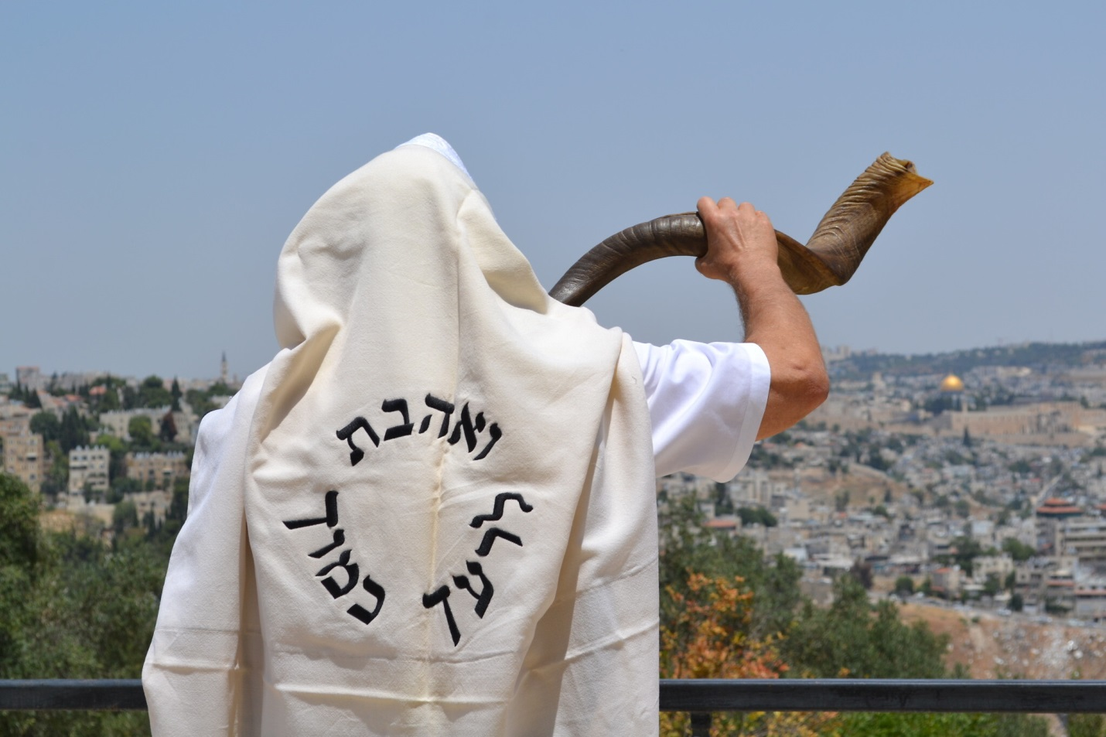

All the year we think that we are just ordinary people and G-d is far away. But once a year on Rosh Hashanah we enter the Shul and realize that it’s not so; we are royalty! The King of all creation is our father! It’s just that something is stopping us, making us almost lose our consciousness; we desperately need the help of the King himself.
But when we try to call out, we discover that we forgot the language we can’t really open our hearts.

The Language that G-d Really Understands
So we blow the Shofar. And that is the language that G-d really understands. The Shofar is a scream from the essence of the Jewish heart – “Father, Father, save me!” This is what every Jew feels every time he hears the Shofar on Rosh HaShanah.
That is why the Torah portion which always is read just before Rosh Hashanah "Nitzavim" begins with the uniting of all the Jews: “You are all standing today all of you every Jewish person”
And the [Lubavitcher] Rebbe explains that “today” here refers to Rosh Hashanah; on this day the Shofar unites all the Jewish people.
But too often this feeling is ignored, misinterpreted, or forgotten. And this is the job of Moshiach.
The Moshiach will educate all the Jewish people so that no one ignores, forgets, or misinterprets this G-dly arousal.
That is what we pray for three times a day: Sound the Great Shofar and gather all of us.

Begging G-d to Send Moshiach
We are begging G-d to send the Moshiach and accompany him with him an inspiration from above a “Great Shofar”; that will arouse the Jewish identity in each and every Jew.
Sounds hard to believe? Well it’s already happening. Today myriads of Jews are regaining consciousness.
May this year bring the arrival of Moshiach and may every Jew hear the message that the Shofar carries: “HaShem!! We Want Moshiach NOW!”
May you all have a good, sweet, healthy, happy, prosperous New Year together with Moshiach NOW!

Reprinted from the Rosh Hashanah 5781 email of Yeshiva Ohr Tmimim in Kfar Chabad, Israel.

The Shofar that is Not Blown Erev Rosh Hashanah
By Rabbi Sholom DovBer Avtzon

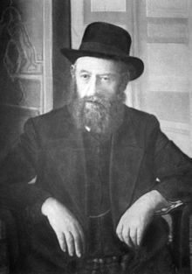
The Rebbe Rashab (1860-1920)

The Minhag [among Jews who blow the shofar during the month of Elul] is not to blow the Shofar on [the day before] Rosh Hashanah. I decided to present a story which the [Lubavitcher] Rebbe uses to give another explanation as why that is the minhag. (The common explanation is to confuse the Satan).
When the Rebbe Rashab was in Lubavitch, he would accept people for yechidus three days a week: on Sundays, Tuesdays, and Thursdays. During the summer months, when he would go (on a yearly basis) to a nearby home in the country for health reasons, he would return to Lubavitch on Monday morning.
Once, during the first years of his nesius, a chossid came to the Rebbe Rashab and tearfully described his dire situation, beseeching the Rebbe for a brochah.

The Rebbe Cannot Help the Chossid
“I cannot help you,” the Rebbe replied.
Hearing these words, the man was devastated. Despite his unfortunate situation, he had not despaired until now, as he had complete faith that the Rebbe could and would certainly help. Therefore, he had made the long trip to Lubavitch to beseech the Rebbe for a brochah. But now that the Rebbe said he could not help, that meant he was doomed! The chossid left the Rebbe’s room and began crying uncontrollably.
The Rebbe’s brother, Reb Zalman Aharon, heard the man’s cry and anguish. Unaware of what had happened, he approached him to see if there was anything he could do to help him.
Reb Zalman Aharon gently inquired as to what was going on. Relieved to be able to unburden himself, the man poured out his heart to him. He explained his dire plight, and his emunah that the Rebbe would be able to help him. “But now,” he concluded, “the Rebbe said that he cannot help, so all is lost!” With that, he broke out in tears once again.

Reb Zalman Aharon Felt Bad for the Anguished Man
Hearing the man’s troubles, Reb Zalman Aharon felt bad for him. He went to his brother, the Rebbe, and complained, “A Jew comes to you for help and you send him away empty-handed?! He is brokenhearted!”
Putting on his gartel, the Rebbe replied, “Tell him to enter for yechidus again.”
This time, when he entered the room, the Rebbe gave him a brochah and he was indeed helped.
When our Rebbe repeated this story, he asked, “Why did the Rebbe Rashab first say that he could not help him, causing him so much pain, when we see that later he was able to help him?!”
The Rebbe explained:
“Initially, when the individual entered for yechidus, he was on a lower level, and the Rebbe was indeed not able to help him. However, when he broke out in tears and beseeched Hashem for mercy, that humility and bittul elevated him to a higher level, and then he was able to be helped.”
The Rebbe explains there that this is similar to the custom of not blowing the shofar on Erev Rosh Hashanah. One can ask: It is the last day of Elul, and the shofar plays such an integral role in the teshuvah feelings/process of this month. So why do we take away this reminder and inspiration at the last moment?

Your Good Actions Might Not Have Been Enough
One of the explanations is that by not blowing the shofar, we are being told: “As good as your actions throughout the month were, they might not have been enough. You cannot merely rely on the inspiration received from blowing the shofar. Instead, look deeper into your innermost thoughts and see: Did you really repent and change?” This awakens in us a deeper sense of what is expected of us, and propels us to a higher level (just as hearing that the Rebbe could not help him enabled the chossid to reach a higher level).
To explain the answer of confusing the Satan, I heard the following parable.
An individual has a civil case against someone else, and he knows that he is in the right. He feels confident in the pretrial hearings and evidence presented, that his excellent lawyers are going to prove his case. At the same time he notices that the other litigant is nervous, obviously he knows he is losing it and is concerned.

The Day Before the Trial is to Begin
Then on the day before the trial is to begin, he notices the other litigant sitting in a restaurant with the judge. So although he knows he is in the right, his instinct informs him that the fix is in. Evidently the judge is either a personal friend or is being bribed. So being that he feels this way, one can understand that it is going to take away his strength when he presents his opening argument etc. He has the feeling that whatever he says is not going to be listened to.
The same is by us, each day in Elul, we give additional tzedokah, say more Tehillim, and blow the shofar. Evidently that demonstrates our concern, and the Satan feels good. But on erev Rosh Hashanah, when the halacha instructs us not to blow the shofar, it is as if Hashem informed us that it is no longer needed. The only reason why it is no longer needed is because the fix is in and therefore the Satan loses his bluster.
May each and every one of Klal Yisroel be blessed with a Kesiva v’chasima tova, and Hashem shall fulfill everyone’s request in all aspects.

Rabbi Avtzon is a veteran mechanech and the author of numerous books on the [Lubavitcher] Rebbeim and their chassidim. He can be contacted at avtzonbooks@gmail.com

A Tale of Two High Holidays: Why Orthodox Jews Are Going to Synagogue While Everyone Else is on Zoom
By Shira Hanau

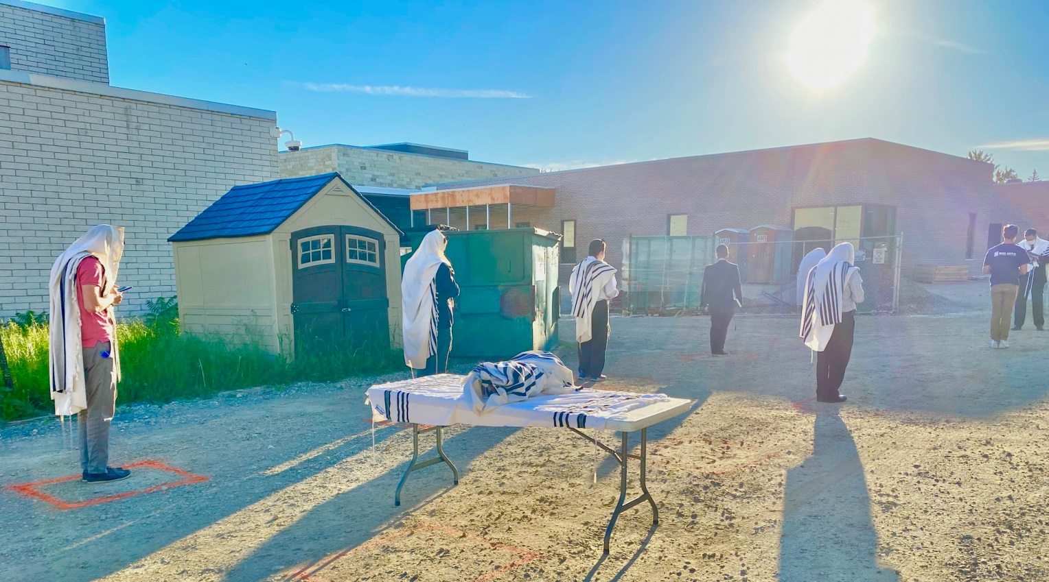
A socially distanced outdoor service at the Green Road Synagogue, a Modern Orthodox synagogue in Cleveland, Ohio, in August 2020. (Courtesy of Rabbi Binyamin Blau)

(JTA) – At the Jewish Center on Manhattan’s Upper West Side, this year’s High Holidays will be anything but normal.
With eight services happening in various spaces throughout the building, on the roof and in the street (closed off to facilitate services), approximately 400 people will gather for socially distanced and masked services at the Modern Orthodox synagogue.
Within just a few blocks of the synagogue, members of eight Reform, Conservative, and Reconstructionist synagogues will gather at multiple street corners or lean out their windows to hear the shofar after attending Rosh Hashanah services over livestream.
The different services are emblematic of the starkly divided approaches to the High Holidays that American Jews will experience this year. While for Orthodox synagogues, services will largely be held in person, for most non-Orthodox synagogues, prayer will take place over livestream, with in-person offerings confined to short, outdoor rituals.

The Primary Difference is Their Approach to Halacha
Even before the pandemic, the two communities were different in many ways. But this year’s High Holidays have cast new light on the primary difference between Orthodox and non-Orthodox congregations across the country: their approach to halacha, Jewish law.
Jewish law is composed of the biblical and rabbinic texts that guide nearly every aspect of daily life. For Orthodox Jews, Jewish law is considered binding and is meant to be interpreted by rabbinic experts. For Conservative Jews, Jewish law is also considered binding, though the Conservative movement has shown more flexibility in adapting certain rules to changing circumstances. For the Reform movement, rabbinic answers to Jewish legal questions are seen as more “advisory” than “authoritative.”
During the pandemic itself, the Conservative movement has adopted some new rabbinic decisions, called teshuvot, to adapt Jewish practice to a socially distanced world.
In March, the Conservative movement’s Committee on Jewish Laws and Standards ruled that services requiring a minyan, or a quorum of ten adults, could be held over video conferencing in a moment of crisis. In May, the committee ruled that video conferencing could be used for Shabbat and holiday services when electronic devices would generally not be used. Conservative rabbis and congregants even worked with Zoom to make sure streaming would be possible without requiring the violation of other prohibitions.

No Major Orthodox Rabbis Have
Allowed the Use of Video Conferencing
By contrast, in the Orthodox community, video conferencing is not considered a valid substitute for the 10 adult men needed for an Orthodox minyan. And when it comes to Shabbat and holidays, no major Orthodox rabbis have allowed for the use of video conferencing.
Rabbi Yaakov Robinson, who works at Beis Medrash Mikor Hachaim, an Orthodox synagogue in Chicago, said that for Orthodox Jews, the act of gathering in a synagogue is “essential,” much like the work done by healthcare and grocery store workers.
“In our minds this is as essential of an essential service as possible,” said Robinson.

Many Orthodox Synagogues Began
Reopening in Late Spring and Early Summer
And for Robinson, the High Holidays won’t be the first time his synagogue returns to in-person services. His synagogue first reopened for Shabbat services in May, with distanced and masked services, meaning the synagogue has had months of practice. While many Orthodox communities first encouraged backyard minyans, many Orthodox synagogues began reopening at their synagogues in late spring and early summer.
“We’ve been doing this for so long and we’ve done well with it,” said Robinson of his synagogue’s services over the last several months.
But to Rabbi Vanessa Ochs, a professor of Jewish studies at the University of Virginia, High Holiday services are no less essential for Reform and Conservative Jews.
“Particularly for the thousands of thousands of American Jews who come together once or twice a year for the High Holidays and that’s how they identify themselves – it’s a necessity,” said Ochs.
For them, the non-Orthodox approach to using technology on holidays means a risk-benefit analysis around whether to hold in-person services yields another conclusion. “There is an alternative,” said Ochs.

The Two Parts of the Jewish World will
Come Together Around Shofar Blowing
One place where the two parts of the Jewish world will come together is around shofar blowing, a required component of Rosh Hashanah and Yom Kippur observance. While the Reform and Conservative movements have allowed for High Holiday services to take place over Zoom, many synagogues — in all parts of the Jewish world — have still organized opportunities to hear the shofar in person in an outdoor setting.
Here, too, halacha may play a role, as Conservative rabbis have not issued formal opinions about whether listening to a shofar over Zoom fulfills the commandment to hear its blast. But even more important for some is the chance to give community members a small in-person experience at a time when more is out of reach.
In addition to the shofar blowings organized by the liberal synagogues on the Upper West Side, local Orthodox synagogues have also organized opportunities to hear the shofar outdoors for those who are not comfortable attending a full in-person service, particularly older people or families with young children.
The public shofar blowing may be new for many communities, but the initiative has antecedents in the Chabad movement. Since the 1950s at the direction of the Lubavitcher Rebbe, Rabbi Menachem Mendel Schneerson, Chabad emissaries have blown the shofar in parks, hospitals and other public spaces in communities around the world for those who would not otherwise hear the shofar.
“It’s exciting to me as the rebbe’s student,” said Rabbi Shalom Paltiel of the Chabad Center in Port Washington, New York, “that in 2020, 70 years later, everybody is doing it, every temple from every denomination is taking the shofar to the local park.”

Reprinted from the September 18, 2020 dispatch of the Jewish Telegraphic Agency (JTA)

Highlights of the 2020 Labor Day Hakhel Yarchei Kallah Event – Reflections of Rosh Hashanah
By Daniel Keren

The second speaker at last year’s (2020) Labor Day Hakhel Yarchei Kallah Event at the Agudath Israel of Madison (Rabbi Reisman;s Shul) in Flatbush was Rabbi Elya Brudny, R’M of the Mirrer Yeshiva who spoke about “The Days of Rachamim and Selichos.”
He began by quoting the Mishna in Rosh Hashanah that says that on this day the Hallel we recite is connected to Shachris (the morning service.) It is a mitzvah to read the Hallel as soon as possible and that is why we do so in the morning service.
Why don’t we also blow the tekias hashofar (the shofar blasts) during Shachris? The explanation is that the non-Jewish (Roman) government didn’t want the Jews to blow the shofar at all and they sent their soldiers into all of the Jewish synagogues to make sure that the shofar wasn’t blown.
How the Jews Overcame the Romans in Order to Blow the Shofar
It didn’t occur to the Romans that the Jews would actually remain so long in the shul and that is why the Jews would blow tekias on the shofar later in the day at the Mussaf (Additional) service of Rosh Hashanah. And that is our practice to this day.

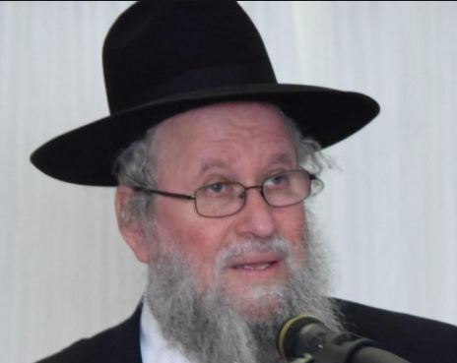
Rabbi Elya Brudny

A successful Rosh Hashanah results in a person being transformed into [being worthy of receiving] a new gift of life. Even if we weren’t worthy of it, Rabbi Brudy said, our performance of the service of Rosh Hashanah, especially the tekias hashofar transforms us into being deserving of the precious gift of life.
If there were any Yidden last year who when reciting the Unesanneh Tokef, when reading “who by dever (pestilence) would have taken it seriously and pleaded to the Abishter for protection and been sincerely shaken and terrified by the prospect; that might have been enough [of a merit] to have spared Klal Yisroel and the world from the damaging destruction and suffering of the [coronavirus] pandemic.
By reading and listening to the Klalos (the threat of Divine curses for not observing the Torah) of Parshas Ki Savo with sincere mesiras nefesh (self sacrifice) that would be sufficient for us to have [spiritually] suffered the curses and spare us from having to have endured those Klalos in a physical manner. The choice to be afflicted in a Virtual or [chas v’shalom/heaven forbid] in reality can depend on the sincerity of our davening.

Living Rosh Hashanah as if it Were Truly Din
Living the two days of Rosh Hashanah as if it is truly din (judgement) can enhance ou ability to daven properly and we should all be worthy of a chasima v’chasima tova (being written and inscribe for a good year in 5781).
The third speaker at the Labor Day Hakhel Yarchei Kallah Event was Rabbi Reuven Feinstein, Rosh Hayeshiva of the Yeshiva of Staten Island. He addressed the pertinent topic of “Making This Year’s Teshuvah Different.”

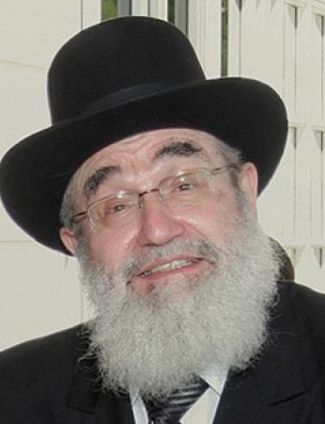
Rabbi Reuven Feinstein

He noted that we were then in the month of Elul, a month of reflection in preparation for Rosh Hashanah, the Yom Hadin (Day of Judgement). Punishments are a guide from Hashem as to what we were doing wrong.
We look back and see that our shuls and battei midrashim (Torah study halls) were closed down. Even Bilaam couldn’t achieve this curse against the Jews, even though he truly desired it. But this past year, G-d shut down our shuls and study halls. Why?

The Difference Between 100 Times and 101 Times
What is the difference between one, Rabbi Feinstein asked, who studies a piece of Torah one hundred times and another who studies that same piece of Torah one hundred and one times. After all, the person who studies just 100 times knows it very well. But it is not lishmo (for the sake of the heaven.)
There are those who study Torah because they are retired and they need something to do. Others get involved in studying Torah because they desire a social activity and attain this by joining a chabura (a study group). Whatever reason, they should try and transform their study of Torah into being for the sake of Hakodesh Baruch Hu.
We are suffering terribly from this megefah (the coronavirus pandemic). There is much talk about whether or not the virus will be developed by an American or an Israeli firm. But why are we not putting our trust into Hakodesh Baruch Hu. He brought this upon the world and He could just as easily take it away. Why, Rabbi Feinstein asked, can’t we believe that and truly put our trust in Him
When a person loses a lot of money, a person shouldn’t say, “Oy vey!” and feel terrible, even if that loss diminishes his style of living. This should [rather] be seen as a Kapporah gelt (atonement money). He should really be happy as that loss of money is in a sense a gift from Hashem resulting in his gaining a clean slate and forgiveness of his serious aveiras (sins.)

How to Bring Bracha (Blessing) into the Coming Year
The fourth speaker at the Labor Day Hakhel Yarchei Kallah Event was Rabbi Moshe Tuvia Lieff, mora d’asra of the Agudas Yisroel Bais Binyomin who offered thoughts on how to bring bracha (blessing) into the coming year.
The secret is for a Jew to be geshmach (feeling great pleasure). We are living today in a society where people are shouting “Ani normali/I am normal.”) Often the people shouting this are living alternative lifestyles that you and I would consider deviate and far from normal. We don’t base our lifestyles on the opinions of others.
Rabbi Lieff in reference to the recent violent Black Lives Matter demonstrations across the country said that he could understand that African-Americans who have suffered so much prejudice, if called an off color pejorative might consider that a hate crime.
Rabbi Lieff recalled a baal teshuvah who told him that when he went back to work after taking two days off from work to observe Rosh Hashanah, his non-Jewish colleagues joked that he knew how to enjoy life. The Yid told Rabbi Lieff that when those goyim celebrated their New Year, they lost themselves [in drinking and riotous celebrations.) When we celebrate Rosh Hashanah [after serious prayers in shul] we truly find ourselves. That is the difference between Jews and others [and our differing views of what is normali.]

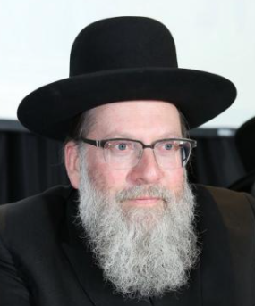
Rabbi Moshe Tuvia Lieff

The Tragedy that Struck Minneapolis
Let’s talk about Rosh Hashanah. A terrible year passed with a megefah and the racial riots. Rabbi Lieff was for many years a rabbi in Minneapolis. He said that driving through the streets after the recent riots (in the aftermath of the protests of the death of George Floyd who was brutally killed by a rogue cop in Minneapolis) was like riding through a war torn community. They destroyed their own hospitals, their own fire stations, their own police stations, their own convenience stores.
Rabbi Lieff who is still in contact with many of his former congregants in Minneapolis got a phone call that a major demonstration was being scheduled to go near their neighborhood and there was a great fear that it would turn into a riot with participants burning down the synagogue and other important Jewish institutions such as the yeshivas and Bais Yaakov schools.
Rabbi Lieff sent out an email to all his Brooklyn congregants in the Agudas Yisroel Bais Binyomin asking to please recite Tehillim for the safety of his former congregants in Minneapolis. The email was forwarded to thousands of other Jews around the world and as a result of that act of Ahavas Yisroel (love and concern for another Jew) the demonstration miraculously avoided the Jewish section of that war-torn city. The lesson we learn from this is not to totally place our trust in the governmental authorities but in Hakodesh Baruch Hu.
Why does Hashem judge us Rosh Hashanah? We are telling Him that he needs us, my wife and my children and my mother because we will recite brochas and do mitzvahs in the coming year.
Completing the Labor Day Hakhel Yarchei Kallah Event in Flatbush was a lecture by Rabbi Shlomo Francis, Mechaber (author) of the sefer “The Laws of an Eruv” on the topic “Eruving Understood! The Daf in Real Life – A Fascinating Multimedia Presentation.”

Reprinted from the September 24, 2020 edition of the Flatbush Jewish Journal.
A Great Defense
For Rosh Hashana
By Rabbi Moshe Meir Weiss

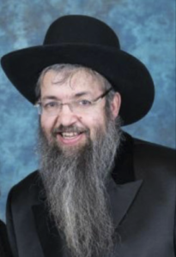

In parshas Haazinu, the Torah proclaims about Hashem, “HaTzur, tamim pa’alo – The Rock (a metaphor for Hashem Who is solid and stable like a rock), perfect are His ways.” The great Rav Yisroel Salanter, zt”l, zy”a, reveals one angle of Hashem’s perfection.
He explains that if a person is apprehended by the police for a serious crime and is duly convicted in court, he is incarcerated and serves a lengthy sentence. During this period, all too often, his wife and children become impoverished and suffer greatly.
Rav Salanter concludes that such judgement is not Hashem’s way for it is not perfect since it generates undeserved suffering to the wife and children. Thus, Rav Salanter develops, Hashem will not punish someone if the ripple effects of that punishment cause harm to the dependents if the dependents are not worthy of such suffering.
With this fundamental concept, we have a powerful tool to ensure for ourselves a successful New Year and that is to make ourselves needed by our loved ones. For, even if a father and husband has blatant flaws, if he is a good provider and a pleasant companion to his spouse and children, then they don’t deserve to lose him and they will provide him with protection. The converse is also true. If a wife is a proper eizer k’negdo and she is an attentive mother, then even if she has serious spiritual flaws, Hashem will be loath to take her away and break the set of husband and wife, or take a needed mother away from her loving children.
This is the concept which the Gemora reveals when it says that Nadav and Avihu died because they weren’t married and they didn’t have children. Everyone asks, How could the Gemora say this was the reason when the posuk says outright it was because they brought a foreign fire on the Altar. All the commentators answer in unison that they deserved to die because they brought the foreign fire but they would have been saved if they had wives that needed them or children that had to have them.
I know many who read this will shake their heads and say, what about the widow with twelve children who lost their husband to COVID or the young wife who dies from cancer leaving a bereft husband and family. Weren’t they needed? Where was their protection?
The answer is that if a person passes away at their keitz, their predetermined time, then being needed won’t help them. However, if punishment threatens to shorten their lives, then being needed is a lifesaving salvation. This is what the Orchos Chaim by Rav Luniel declares. “Harotze l’harich yamim, hevei marbeh b’achim v’rei’im – If you want to live long, have many brothers and friends,” because the more people who need you, the safer you are.
As the challenging year of 5780 comes to a close, I’d first like to thank the The Vues for giving me their wonderful stage to disseminate Hashem’s Torah, and I’d like to wish my dear readers and their families a year of good health, happiness, and everything wonderful.

Reprinted from the Rosh Hashanah 5780 edition of The Jewish VUES.

Erev Rosh Hashana Preparations

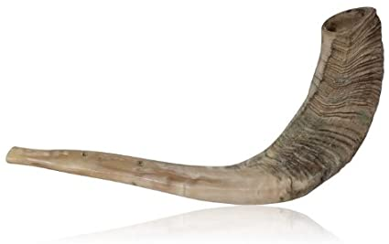

Once upon a time, an armed battalion, with the king at their helm, marched towards a city to demand their overdue taxes. If the residents weren't prepared to pay, they would pay with their lives. The people of the city were terrified. They were loyal citizens. They would pay the taxes if they could. But they simply didn’t have the funds.
The king and his men were still quite a distance from the city when the elders of the town went out to greet the king. The king sat with the city elders to hear them out.
The elders described to the king the terrible poverty that affected most of the citizens. "They sincerely wish they could pay the taxes, but they can't afford it." The king said, "I will give them a deduction. They only have to pay 2/3's of the debt."
The king and his army marched on and met with another delegation from the city. This time it was the middle-class workers. They pleaded with the king to pardon the taxes, and the king replied, "I will relieve you from another third of the debt."
The king and his army marched on, and when they were just outside of the city, the entire town came out to greet the king. They wore ripped and patched clothing. Their poverty was evident, and they begged the king to erase the debt. The king did so, and he returned with his soldiers to his capital city.
The Midrash Tanchuma tells this mashal, and it is quoted in the Tur (581). The Tur writes, "The nimshal is, on erev Rosh Hashanah the tzaddikim fast and Hashem pardons a third of their sins. During Aseres Yemei Teshuvah the middle-class level Yidden fast, and Hashem pardons another third. On Yom Kippur, when everyone fasts, Hashem forgives the Jewish people entirely."
This source teaches us the importance of erev Rosh Hashanah. It is one of the most important days for the atonement of the Jewish nation.

Reprinted from the Rosh Hashana 5781 email of Torah Wellsprings: Collected Thoughts from Rabbi Eli Biderman.

The Testimony of the Sun
On Rosh Hashanah

The Kol Bo teaches:
On Rosh Hashanah, the Satan testifies against the Jewish nation and states all their sins.
Hashem replies, "The Torah says that we listen to two witnesses. Bring two witnesses, and we will listen to your case."
The Satan calls the sun. The sun agrees to testify.
Then, the Satan calls the moon, but there is no moon on Rosh Hashanah! It is that holiday the moon hides. (The moon is concealed at the beginning of every month.)
Hashem says to the Satan, "Without two witnesses, your case is canceled." And the Jewish nation is inscribed for a good year.
However, the Satan did get the sun on his side, and there are times that even just one witness is enough. An example of this is the Gemara (Kiddushin 66), which states that one witness is sufficient to testify that someone has a מום ,flaw. (A cohen with a מום can't bring sacrifices in the Beis HaMikdash. If he does, the sacrifices are invalid.
One witness who testifies that a cohen has a mum has credibility.) Based on this Halachah, the Noda b'Yehudah (Tzlach, drush 1:6-8) says that the sun can testify against the Jewish nation. He can say that they looked where they shouldn’t have, they heard what they shouldn’t have listened to, spoke forbidden words, and that they are flawed people – in a spiritual sense).

It is like saying they are deaf, blind, mute, etc., because, in a spiritual sense, that is what happens when one doesn’t safeguard his senses. The sun is be believed because for מומים even one witness is sufficient. To be protected, the Noda b'Yehudah concludes, the solution is to do teshuvah. This will remove all flaws. This is the meaning of the pasuk (12:23 Devarim( when Rosh Hashanah comes approaches wash yourself with tears, and then, when the sun comes to testify against the Jewish nation, his testimony won't be accepted. And then the Yid will be permitted to return to the camp for the court will acquit him.

Reprinted from the Rosh Hashana 5781 email of Torah Wellsprings: Collected Thoughts from Rabbi Eli Biderman.

Supplemental Stories
for rosh hashanah 5782
1-2 Tishrei 5782/September 7-8, 2021
Printed L’illuy nishmas Nechama bas R’ Noach, a”h

For a free subscription, please forward your request to keren18@juno.com

Shofar in the ICU—Hakafot In the Chabad House
By Rabbi Avrohom Levitansky

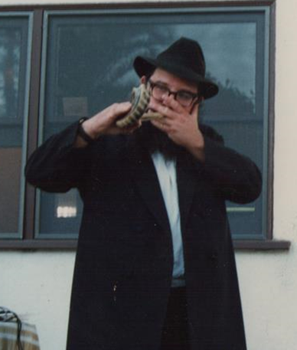

For decades, Rabbi Levitansky, shofar in hand during the month of Elul and the holiday of Rosh Hashanah, was a familiar and beloved sight in S. Monica.
Editors’ note: [Last year] Amidst temporary synagogue closures due to the ongoing coronavirus pandemic, lastt Rosh Hashanah more people than ever before were hearing the sounds of the shofar on the street, in parks, or through open windows.
While this may be unusual for many, Chabad-Lubavitch emissaries and volunteers have been blowing shofar outside the confines of a synagogue for more than six decades.
Beginning in 1953, the Rebbe, Rabbi Menachem M. Schneerson, of righteous memory, instructed anyone with a shofar who knew how to properly blow it to hit the streets and ensure that Jews without the ability to be in synagogue nevertheless hear its stirring cry.

Bowing Shofars on Street Corners, in Public Parks,
Military Bases, Hospitals and Prisons
Inspired by the Rebbe, in the decades since, Chabad activists and countless others have blown shofar on street corners, in public parks, on military bases, in hospitals and in prisons.
One of those activists was Rabbi Avrohom Levitansky, a Torah scholar and a pioneering Chabad emissary, who was sent by the Rebbe to California with his wife, Chaya Devorah, two weeks after their wedding, in the fall of 1967.
The Levitanskys joined Rabbi Shlomo Cunin at the nascent Chabad House at UCLA. In those early days of Chabad work, the pair—soon joined by more emissaries—passionately deployed the Rebbe’s mitzvah campaigns, among them, of course, the Shofar Campaign, to take California by storm. Over the next 50 years, they would revolutionize Jewish life on the West Coast.
Prior to each Rosh Hashanah, Chabad of California would organize a massive effort to blow shofar for hospitalized Jews throughout the state, and Levitansky continued these hospital visitations after he and his wife founded Chabad of S[anta] Monica in 1973.

Renaming California City – Simcha Monica
Rabbi Levitansky, who unilaterally renamed his hometown Simcha Monica, would often tell the following story to illustrate the Rebbe’s message that sounding the shofar for Jews “literally revives them” both physically and spiritually. He recorded it in writing some years before his untimely passing in 2007.
Heeding the Rebbe's call, this year too Chabad of S. Monica will be bringing shofar to the streets, including their famous public shofar event at the S. Monica pier.
The late Rabbi Avrohom Levitansky and his colleague, Rabbi Yerachmiel Stillman, both Chabad pioneers in California, blow shofar during the month of Elul in Mount Sinai Hospital in Los Angeles, circa 1973.
It is customary here in Simcha Monica that on the Jewish holidays we visit the homebound, as well as patients in the local hospitals, convalescent homes, and retirement homes, to enable them to perform the mitzvot of the holiday.
One Rosh Hashanah in the late 1970s, I was going around a hospital with my shofar to visit the Jewish patients there. Because it was yom tov, I could not use the elevator and was instead going up and down the steps. It so happened that as I opened the stairwell door on one of the floors, I found myself in the ICU Unit. Now, usually they do not allow people in the ICU, but here I found myself there.

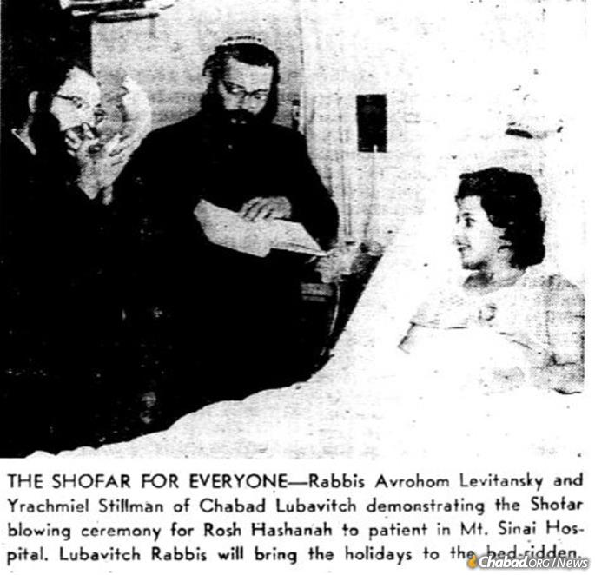

Nu, since I was already there, I asked the nurses on the floor if there were any Jews in that ward. They brought me to one elderly gentleman, who was lying in a fully enclosed oxygen tent. He was hooked up to all kinds of wires and tubes, which in turn were connected to a whole array of beeping machines.
Unfortunately, he was not conscious. I asked the nurse if it was OK for me to blow the shofar and she said yes. I took my shofar and blew it for him very softly. As I finished blowing, I noticed that there was some change in the machines. I asked the nurses about his condition, but they were not too optimistic about his prognosis.
The next day—since I already knew how to get into the ICU—I went to visit this man again. This time as I came in, I saw there was no tent around him. Although he was still connected to many machines, he was awake!
I asked him if he wanted to hear the shofar. It was difficult for him to talk, so he responded by signaling with his head that I should blow.

Blew the Shofar a Little Louder
Before I blew the shofar I asked him to repeat the blessing after me and saw his lips softly mouthing the blessing. Again I blew the shofar, this time a little louder than the day before. I told him “G-d willing when you get out of this place, come to Chabad House for the rest of the holidays: Yom Kippur, Sukkot and Simchat Torah!”
(I said this though I was really doubtful he would be able to make it.)
I went on to blow shofar for many other people that day and almost forgot about this incident.
Two weeks later, on Sukkot, I went to the hospital with my lulav and etrog. I went up the same staircase to see this gentleman. I went to this man's bed and … it was empty. I asked the nursing station what happened to the gentleman. “Discharged” they told me. It did not sound good.

The Elderly Gentleman Walks In
One week later, on Simchat Torah, as I was standing on the table during the Hakafot, an elderly gentleman walked in and came over to me waving his cane. He asked: “Rebbe, du derkonst mir nit?” (Rabbi, don’t you recognize me?)
I looked at him more closely, but I didn’t have a clue.
“You blew shofar for me at the hospital” he replied.
It was him, the ICU patient, who had been in very critical condition just three weeks earlier. Now he was in Chabad House ready to dance the Hakafot!
Until his passing in 2007, Rabbi Avrohom Levitansky was the shliach to S. Monica, Ca.

Reprinted from the Rosh Hashanah 5781 email of Chabad.Org Magazine.

How’d He Get
On “Chopped?”
By Joanne Palmer

Shalom Yehudiel of the Humble
Toast in Teaneck Serves Up His Story

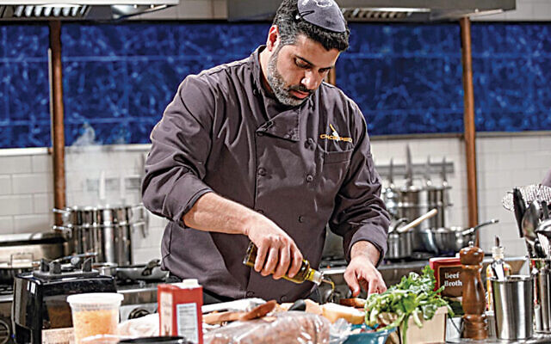

Shalom Yehudiel is the first chef to cook a kosher meal under rabbinical supervision on “Chopped.”
“I still don’t know until today how they found me,” Shalom Yehudiel said. “I have asked three, four times, and they just say, ‘We have our sources.’”
“They” are the producers of “Chopped,” a popular Food Network show that demands that competing chefs make meals out of random, apparently ill-assorted ingredients. He is an American-Israeli chef, entrepreneur, and philanthropist whose Teaneck restaurant, the Humble Toast, draws customers from around the region and whose delivery service, perhaps inevitably named the Humble Truck, provisions simchas throughout Bergen and Essex counties.
Mr. Yehudiel, who lives in Fort Lee, is the first contestant who both keeps and cooks kosher; in another first, the show made all necessary provisions for him.
The pretaped show that Mr. Yehudiel filmed will air on September 22. Then we’ll find out who won — he knows but is not allowed to say — but we still won’t know how their sources heard about him.
On the other hand, when you look at his career, it makes sense that he’d be on a cooking show’s radar screen.

Born in Israel, Descendant of Yemenite Jews
Mr. Yehudiel was born in Israel in 1982, the descendant of Yemenite Jews who’d been flown to Israel on eagles’ wings — that is, on the 1948 Israeli Operation Magic Carpet — and he was brought to the United States in 1989. His young parents, Sasi and Mazal, settled first in Elizabeth and then in Fair Lawn, where Rabbi Benjamin Yudin and his wife, Shevi, the founders and leaders of Shomrei Torah and the Orthodox community that grew around it, took an interest in them.
That interest was providential for the Yehudiels, who were not finding it easy to live in this strange land; they’d come looking for a better life, but their lack of resources, including their inability, at first, to speak English, threw hurdle after hurdle in their way. Eventually Shalom’s parents divorced; he and his siblings stayed in Fair Lawn with their father.
The Yudins were a lifeline for father and children; still, Shalom’s path wasn’t clear. “Because of Rabbi Yudin, I got the basis of what it is to grow up with a Jewish upbringing,” he said. The Yudins saw that he went to Camp Hillel; “the fondest memories of my life are from those summers in camp,” he said. He also went to three local yeshivot.

Was a Bit of a Class Clown
But his wasn’t a straight-ahead success story from the beginning. “Every one of those, I got thrown out of,” Mr. Yehudiel said. “I was a bit of a class clown; I like attention, and the rabbis weren’t having that.” So he graduated from Fair Lawn High School and got a job as a teller at the Commerce Bank when he was 19.
Mr. Yehudiel liked his work, and he did well. By the time he was 23, he’d risen to become a finance officer. “But I said to myself, ‘Listen, this is all good. I like what I do. But it’s not my passion. I want to do something I love.’
“And the first thing that came to my mind was food.
“Food to me is not just nourishment. To me, it’s very simple. Food equals love. When you put a plate of food in front of someone — a plate that you’ve put your heart and soul into making — it’s a way of showing them how much you care about them, and about how much attention you are paying to what is going into their body. And into their soul.”
The more he thought about it, the more Mr. Yehudiel realized that the restaurant business seemed right for him. “I love people, and for the most part people love me,” he said.

Signed Up for an Online Class at the Art Institute of Phoenix
He did some research and signed up for an online class at the Art Institute of Phoenix; he knew that he “wanted to be someplace else. Not in New Jersey.”
The first class he took was online, from Fair Lawn; “then I said okay, this is the time to sign up for the whole thing.” So he did, and moved to Phoenix.
The classes he took weren’t only about cooking. “You learn how to run a restaurant, set up a menu, cost things out,” Mr. Yehudiel said. He flourished. The NBA had an all-star game in Phoenix, and “they asked people in my school if they’d like to do a charity event for the NBA, where they’d be paired with different chefs from around the valley.”
He jumped at the chance, and was paired with Aaron May. “He’s also Jewish,” Mr. Yehudiel said; he also owns parts of at least three Phoenix-area restaurants. The two hit it off. “When I got there that evening, he told me my job basically would be plating hundreds of different little amuses” — that’s amuse bouche, little fancy appetizers that must both taste and look good — “and at the end he looked at me and said, ‘I like the way you work. Do you want a job?’” The answer, of course, was yes.

First Time He Walked into a Real Professional
Kitchen was an Intimidating Experience
“I will never forget walking into my first real professional kitchen,” Mr. Yehudiel said. “To say it was intimidating is a huge understatement.’”
His job was working with cold salads and desserts. “That’s usually the entry-level job. You’re not cooking anything. You’re not searing a duck. You’re just putting together salads and plating desserts.” He did that for six months, while he still was at culinary school; eventually he realized that he could learn more by working full time.
Mr. Yehudiel worked with Mr. May for a few years, “opening up restaurants, learning different cuisines,” he said. “He helped me get my start.” But because he knew that “when you are first starting out in your career, you should work for as many chefs as possible,” eventually Mr. Yehudiel left Mr. May’s group to work for the Arizona Biltmore, an extremely high-end hotel, and then for a group called Fox Restaurant Concepts. “That was also started by a Jewish guy,” Mr. Yehudiel said. (One of the restaurants where he worked is called the Arrogant Butcher; it’s notable because it’s just about the opposite of the Humble Toast, at least in name.)
As he moved around, Mr. Yehudiel also moved up; he became a sous chef, an executive sous chef, and eventually an executive chef, overseeing huge operations and starting new ones. As he climbed the restaurant ladder, he also moved farther and farther away from actual cooking, although he always was in the business of feeding people’s bodies and souls.
At the Arrogant Butcher, where he was a sous chef, “it had $7 million in sales, and it was always busy. That started giving me the experience of how to run a busy place. How to set it up, how to train your cooks, how to standardize your recipes. I got the knowledge and experience eventually to do it on my own.”
To clear something up here — Mr. Yehudiel did not keep kosher then. “Zero. Zilch. It meant nothing to me at that time,” he said. “I just focused on my career. I was maybe a little bitter about having been thrown out of all those yeshivas.”

Mr. Yehudiel’s Humble Truck delivers meals throughout the region, pandemic or no pandemic.

After some time, Mr. Yehudiel moved to California. “I’d always had the itch to move there,” he said. “Ever since I was a little kid. Even when I was in Israel, my father used to listen to the Eagles’ ‘Hotel California.’ Moving there was a dream.”
He had so many restaurant contacts by then that putting out feelers brought very fast results. He interviewed for Disney Land in Anaheim, “and they hired me on the spot,” without even watching him cook. “So all of a sudden I am a cast member at Disney,” Mr. Yehudiel said.
He had a wonderful job; he was paid very well; he lived in Huntington Beach. “Everything was going fantastic,” he said. “But somehow I still felt unfulfilled.

Questions Bothering Him at the Pinnacle of His Success
“At the pinnacle of my success, 10 years being away from New Jersey, I looked back and said, ‘Great. You have a great career. You work for a great place. But you see your parents and your brothers and sisters once or twice a year. So what are you doing all this for? All this hard work and dedication — what is it all for?’ My dad is my king, and I see him once or twice a year.
“So what is all this for?”
So after thinking about it for a few months, Mr. Yehudiel decided to take a break. He drove back to New Jersey, and moved back in with his father.
“My father keeps Shabbat and keeps kosher, so out of respect for my father I started keeping Shabbat,” Mr. Yehudiel said. “I didn’t want to be in my father’s house turning on the TV on Shabbat. That’s disrespectful.
“And after a few weeks of keeping Shabbat, my soul said to me, ‘This is what you have been missing all these years.’ After all those years of focusing on success, my neshama,” my soul, “was telling me what was important.”
He turned down a lucrative offer from Madison Square Garden. That was a hard choice that he does not underplay. “‘You followed your gut, not your soul, for your whole career,’” he remembered telling himself. “‘What are you going to do now? Take the money and run, or stay with what your soul is telling you?’”
Instead, he did some consulting for kosher restaurants in Monsey, and then he started the Humble Toast. It opened in October 2018.

The Restaurant’s Name was not an Accident
Its striking name is not accidental. “I try to live by the word humble,” Mr. Yehudiel said. “We have to realize that everything we receive in life is from G-d. We should always keep that mindset.
“No matter what happens, we should be humble and thankful, and we always should treat people the way they want to be treated. We should spread joy and love.”
What about toast? “Toast means a piece of bread, and it also means a l’chaim,” he said. “People can interpret it in whichever way they want.”
He also got married; his wife, Jacqueline Yehudiel, is the director of the Jewish National Fund in northern New Jersey. They are the parents of baby Nava.
Since the pandemic, the Humble Toast and the Humble Truck have been able to keep going. “The pandemic hit us like a ton of bricks and right away we knew that we would either sink or swim,” Mr. Yehudiel said. “Luckily, I didn’t have to fire anyone.” He is running a robust takeout and delivery service instead.
But he’s doing more.
“Within the first week of the pandemic, I put a message on Instagram saying, ‘I know that this is a crazy time, but please know that we are in this together, and that G-d is with us.
“‘If you don’t have food to eat, if you don’t know where your next meal is coming from, please talk to me.’”

Given Food to Those Affected by the Pandemic
Since then, he’s given food to people who need it, and his efforts have been supported by others who have seen what he’s doing and are moved by it.
“In the toughest of times, it’s been so wild to see the best side of people coming out,” he said. “Their really heartfelt emotions.
“I am so proud of my family and my staff. We really all rose to occasion, and we’ve been taking care of people who need to be taken care of.”
Okay. So how about “Chopped?”
How did it happen?
A few months after the Humble Toast opened, “I got an email, and the subject line says, ‘Chopped interview.’ I opened it up, and I saw that they asked if I would be interested in coming into Manhattan for an interview. They reached out to me. It was nuts. It fell into my lap.”
He went for an interview, somewhere in the meatpacking district. “They put makeup on me, and there were cameras in front of me, and I was just talking about my past. It took two hours or so, and they said, ‘Thank you very much for your time. We will be in touch.’”

Didn’t Hear Anything for Six Months
He heard nothing from them for six months, “and I just thought, ‘You know what? I’m not for them,’” Mr. Yehudiel reported. And then “I got an email saying, ‘When can we come to film a biopack?’” That’s a clip that’s edited into a 20- or 30-second introduction to each chef. “They came and filmed me,” he said. “It took pretty much all day.” He cooked for the camera crew and interviewer. And then, again, he waited.
“I didn’t know how TV works, but they did mention to me that at a certain point we rush, rush, rush, rush, and then we just wait,” he said.
“And then months later, I got another email that said, ‘These are the available dates that we have for you to be able to compete. Can you come in on one of those dates?’”
That’s when the question of kashrut became real. “I said, ‘Before I can sign off on this, let me speak to the Kof-K and the RCBC.” The Kof-K is a local organization that certifies kashrut, and the Rabbinical Council of Bergen County is the local association of Orthodox rabbis. The two groups work together.
Rabbi Daniel Senter, the Kof-K’s director, told Mr. Yehudiel that “this is a great opportunity for you, but you have to make sure that whatever you do, you do it in the right way. You are in the public eye. You don’t want to go on a show and have people wonder if he cooked non-kosher or would eat non-kosher.”

The Rabbi Negotiated the Arrangements
Rabbi Senter and “Chopped” representatives worked together; “they decided that rabbis could come and kasher my section of the kitchen and use only kosher ingredients.”
Because all the contestants get the same ingredients, all the contestants who competed against Mr. Yehudiel used only ingredients that could be kosher, but only Mr. Yehudiel’s ingredients were certified as kosher.
This was a first, Mr. Yehudiel said, and he’s grateful to “‘Chopped’ for being so accommodating, and to the RCBC and Kof-K for facilitating the whole thing.”
On the contest day — June 20, 2019, “a year and three months ago” — “I showed up at 6 a.m. at an undisclosed location,” Mr. Yehudiel said. “It was me and three other competitors and someone from the Food Network.” From there, they walked over to the studio. “They started hooking us up with microphones and gave us the chef jackets. They walked us through the set.
“And then the competition started.

The Most Nerve-Wracking Thing He Had Ever Done
“I am not going to lie to you. It was the most nerve-wracking thing I have ever done in my life.
“I can barely remember what I saw. What I cooked. What I did. It flew by. It is an immense amount of pressure. I have worked for Disney, for restaurant groups around the country, I am used to high intensity, to being very busy in a hot environment, but this was another level.
“This is not just about the food. It is also about you.
“I am very happy that I did it, and very proud that I represented Jews in a good light,” Mr. Yehudiel said.
If you want to find out what happened next, you’ll have to wait until September 22.

Reprinted from the September 17, 2020 email of the North Jersey – Rockland County Jewish Standard.

Jonathan Sacks, the U.K.’s Inclusive Former Chief Rabbi, Dies at 72
By Ari L. Goldman

Rabbi Jonathan Sacks in 2014. (Photo Credit - Associated Press)

Jonathan Sacks, the former chief rabbi of the United Kingdom who emerged as an important and widely heard voice on the role of religion in the modern world, died on Saturday in London. He was 72.
The cause was cancer, according to Dan Sacker, a spokesman. Rabbi Sacks, who wrote extensively and made frequent media appearances, withdrew from public life in mid-October after he announced that he was being treated for the disease.
While his religious home was Orthodox Judaism, Rabbi Sacks was one of the most inclusive voices within Judaism. In a 2013 study of his work, “Universalizing Particularity,” the editors wrote: “Sacks possesses a rare ability to hold in delicate balance the universal demands of the modern, multicultural world with the particularism associated with Judaism.”
His universalism sometimes got him in hot water with more fundamentalist elements of the Jewish community. When he was chief rabbi, Rabbi Sacks published “The Dignity of Difference: How to Avoid the Clash of Civilizations” (2002), a book whose central message was that religious communities had parity in their attempts to find G-d.

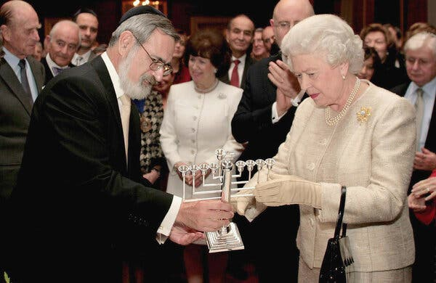
Queen Elizabeth II received a Hanukkah candlestick from Rabbi Sacks at St. James Palace in 2006 to mark the 350th anniversary of the re-establishment of the Jewish community in Great Britain. The queen had knighted him the year before. Photo Credit - Associated Press.

“G-d has spoken to mankind in many languages: through Judaism to Jews, Christianity to Christians, Islam to Muslims,” he wrote. “No one creed has a monopoly on spiritual truth; no one civilization encompasses all the spiritual, ethical and artistic expressions of mankind.”
He added: “G-d is greater than religion. He is only partially comprehended by any faith.”
Some in the Orthodox community accused him of heresy. Judaism, they said, is the ultimate truth. Rabbi Sacks later walked back some of his statements, subtly revising them in a later edition.
He served as the chief rabbi from 1991 to 2013. His official title was Chief Rabbi of the United Hebrew Congregations of the Commonwealth, a title that made him the head of a large network of Orthodox congregations but not of congregations at the ends of the Jewish religious spectrum, the liberal and ultra-Orthodox.

One of the Most Prominent Positions in Europe
Still, the title has always been one of the most prominent Jewish positions in Europe, and he used that pulpit effectively, both during and after his time as chief rabbi, to speak out against anti-Semitism and in favor of the State of Israel.
Rabbi Sacks was knighted by Queen Elizabeth in 2005 and made a life peer in the House of Lords in 2009. He maintained a close relationship with former Prime Minister Tony Blair, who said in a statement that the rabbi “had the rarest of gifts — expressing complex ideas in the simplest of terms.” He called him “a man of huge intellectual stature but with the warmest human spirit.”
Rabbi Sacks was a leader in interfaith relations and was close to the former archbishop of Canterbury, George Carey. Their shared interests went beyond religion: They had a mutual passion for the Arsenal soccer club and occasionally went to games together.
Jonathan Sacks was born on March 8, 1948, to Louis Sacks, a textile trader, and Louisa (Frumkin) Sacks, who had driven ambulances in London during the Blitz. Unlike other future rabbis, he did not attend Jewish schools as a child but rather was educated in Anglican schools. He studied philosophy at the University of Cambridge.

Drawn to Both Universal Philosophy and His Own Judaism
In a 2011 essay titled “Finding G-d,” he wrote that he had been drawn both to the universalism of philosophy and to the particularity of his own Judaism. At the time of his studies, he wrote, “the words ‘religion’ and ‘philosophy’ went together like cricket and thunderstorms: You often found them together, but the latter generally put an end to the former. Philosophers were atheists, or at least agnostics.”
In the mid-1960s, at age 19, he embarked on what he called a “Greyhound tour” of North America looking for academic and spiritual direction. Two encounters in particular were “life changing,” he wrote. He met with Rabbi Joseph Soloveitchik, the pre-eminent rabbinic scholar at Yeshiva University in New York, and with Rabbi Menachem Mendel Schneerson, the head of the Lubavitch movement, in Brooklyn.
“Rabbi Soloveitchik had challenged me to think,” Rabbi Sacks wrote, “Rabbi Schneerson had challenged me to lead.”

A Life Devoted to Jewish Study and Leadership
He decided to devote his life to Jewish study and leadership. He was ordained a rabbi in 1976 and later completed his Ph.D. in philosophy at the University of London. He went on to be the spiritual leader of several prominent London synagogues before being named chief rabbi in 1991.
Rabbi Sacks wrote more than 25 books, and the themes became more universal as time went on. His most recent book, published this year, is “Morality: Restoring the Common Good in Divided Times.” In 2009, he issued a new commentary on the daily prayer book, published by Koren, which has become a standard in many Orthodox congregations around the world. His TED talk from 2017, “Facing the Future Without Fear,” has had nearly 2 million views.
Rabbi Sacks is survived by his wife, Elaine; their children, Joshua, Dina and Gila; three brothers, Alan, Brian and Eliot, all of whom live in Israel; and nine grandchildren.
In 1991, shortly before he became chief rabbi, Rabbi Sacks appeared on a popular BBC program, “Desert Island Discs,” where celebrities are asked to imagine what they would take with them if they were stranded on a desert island. The host uses those items to shape a discussion about the guest’s life, career and passions.

Hoped His Epitaph would Be: His Soul Thirsted for G-d
Rabbi Sacks said that he would take a Talmud, the Jewish library of law and lore, and a pencil to write a commentary on it. As for music, he would take a devotional song from the Lubavitch tradition called “Tzomoh L’cho Nafshi,” which means, “My soul thirsts for you, G-d.”
“Quite simply,” he said, “I hope that someday something like that would be my epitaph: That his soul thirsted for G-d.”

Reprinted from the November 9, 2020 website of The New York Times. A version of this article appears in print on Nov. 10, 2020, Section B, Page 11 of the New York edition with the headline: Jonathan Sacks, 72, Chief Rabbi of U.K. Who Promoted Inclusion, Dies.

Saved by an Arab Angel
As related by Rachel Nir to Eliezer Shore

I will never forget that night, five years ago, when my husband and I almost died. It was an event of pure terror coupled with the deepest faith in G-d. Even now, so many years later, tears come to my eyes when I speak about it.
It was the third day of Chanukah, Kislev 27 (Dec. 9, 2015), and I was running errands in downtown Jerusalem. When I had finished, I called my husband, Shaul, to pick me up and we drove to Tel Aviv to do some shopping. While we were there, our oldest daughter, Livnat, called to invite us to her home in Avnei Hefetz about an hour away. Livnat is a widow with five children; her husband, Natanel, was killed in a terrorist attack 16 years ago.
Shaul and I felt that it was an opportune time to visit her, so we set out, first stopping in Yehud to visit my sister Tziporah. While we were there, we received a phone call from our other daughter, Hili, informing us that she had just given birth. It was her eighth child and her first boy in 11 years. Not only that, the baby was born on Hili’s 40th birthday. Shaul and I were overjoyed and decided to visit her later that evening, on our return to Jerusalem.
As we left my sister’s house, I asked her to walk us out to the car. The Talmud says that escorting guests on the road provides them with spiritual and physical protection, even after they have left one’s home. I’m careful to do this for my own guests, and I encourage our hosts to do the same for us when we are traveling.
Tziporah accompanied us out and blessed us for a safe arrival at our destination. I remember that she looked very concerned at the time and that I didn’t know why. I don’t think she knew why, either.

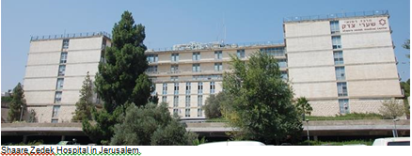

We arrived in Avnei Hefetz before nightfall. Livnat was there with all her children. We lit the menorah, sang, danced, and had a wonderful meal. At about 7:00 pm, Shaul suggested that we start making our way back to Jerusalem, to arrive in time to visit Hili at the Shaare Zedek Hospital.
Here, too, I asked Livnat to accompany us a few steps toward the car.
As we drove slowly on the dark, narrow road from the town to the main highway, I felt an overwhelming sense of gratitude to G-d for all that He had given us. “Look how many blessings we have in our lives!” I remarked to Shaul. “Our children, our grandchildren, the newest addition … there’s so much to thank G-d for!”

Something Struck thhe Car with Force
A few moments later, something hard struck the car with force.
“Is someone throwing stones at us?” I asked Shaul.
“No! It isn’t stones, it’s gunfire!”
An instant later, Shaul let up on the gas, and the car drifted across the road and stopped in a shallow ditch beside the opposite lane. With shock, I saw that the entire right side of Shaul’s face was covered with blood. He had been hit in the head! The next moment a sharp pain ran through my left hand. “My G-d, he’s right, these are bullets!” Suddenly, a barrage of gunfire shook our car. An Arab terrorist was shooting at us with a Kalashnikov rifle from about ten yards away. Flashes of light pierced the darkness, and the noise was deafening! All the car windows shattered from the shots.

My Whole Life Passed Before My Eyes
I felt like I was going to die. My whole life passed before my eyes, like in the stories. Although my sleeve was wet with blood, I felt no pain. My mind was crystal clear, and I felt no urge to scream or cry. I envisioned myself and Shaul already dead, and our children weeping for us at our funeral. It was like watching a movie.
On and on, the bullets pounded the car—36 in all. I didn’t even think of ducking down; I just sat there waiting to die. “How many more shots will it take to kill us both?” I wondered.
Suddenly, thoughts of our daughter Hili and her newborn baby rose in my mind. If we die now, she’ll have to sit shiva for seven days, until the very day of her son’s brit milah.
“Please, G-d,” I cried out silently. “It isn’t right! We have to be at my grandson’s brit! Hili has waited so long for this. Please don’t cause her pain and sadness on such a joyous event!”
My heart flooded with prayer and faith. For years, I had been working on seeing the good side of every situation, and that enabled me to call up those thoughts, even at that difficult moment.

I Imagined My Deceased Mother-in-Law
“G-d, please,” I whispered, “You are good to all, and everything You do is for the best. Please, let me see the good even in this situation!” I repeated a prayer of thanksgiving several times, as well as some psalms I knew by heart. I imagined my deceased mother-in-law storming the heavens, not willing to let her son be taken.
I glanced over at Shaul. He was losing consciousness. “My finger—I think I’ve lost it,” he muttered groggily. His left hand, still clutching the steering wheel, was covered with blood.
“Shaul! Don’t give up! Pass me your phone, I’ll call emergency!” I splashed some water on him from a water bottle, but his eyes were closing anyway.
There was a lull in the gunfire. All of a sudden, I saw a red sports car stop in the right lane across from us. The door opened, and a man stepped out and walked in our direction. Until today, I clearly recall his appearance: middle-aged, elegantly dressed in an orange cardigan sweater and light-colored slacks.
“Thank G-d,” I thought, “help has finally come.”
Approaching my side of the car, he addressed me through the shattered window.
“What’s happened to you?” he asked. I recognized his accent immediately.
“Oh, no,” I thought to myself. “Not another Arab! That’s all we need!” But then my next thought was, “G-d, I trust in You. Whatever You send us is for the best!”

The bullet-ridden car that the Nirs were driving on that fateful Chanukah night.

“We’ve been shot!” I cried. “Call an ambulance! Please!”
But he didn’t call—he didn’t even take out his cell phone. I was shocked!
“O G-d, only You can save us now,” I cried out silently. “Only You know what is best.”
My husband was on the verge of passing out. Again I shouted, “Wake up! Talk to me! Don’t give in!”
“Pardon me,” the Arab interrupted. “What’s your husband’s name?”
I blinked in surprise. “Shaul.”
The man walked around the front of the car to the other side and looked in at my husband.
“Shaul, Shaul!” His voice rang out loudly in the night—it resounds in my ears until today. “Don’t worry. Everything will be OK! You will be fine!”

A Jewish Driver Called the Army And an Ambulance
A moment later, a Jewish driver from Avnei Hefetz pulled up to the car. He called the army and an ambulance. In the meantime, the man in the orange sweater disappeared.
Twenty long minutes after that, two ambulances arrived. I was taken to the Meir Medical Center in Kfar Saba, while my husband was taken to Beilinson Hospital in Petah Tikva. He suffered organ failure upon arrival and underwent 15 hours of surgery to save his life. While still in the ambulance, I contacted someone in Avnei Hefetz, who called an emergency prayer meeting. Another gathering was also held in our community in the Old City of Jerusalem.
My husband unfortunately lost a finger from his left hand in the shooting and three other fingers were damaged. His right leg was also seriously wounded. Yet the bullets missed his knee and ankle by an inch. We saw this as a miracle, for the damage could have been far more severe.
Later on, the doctor who had operated on my husband told me this, “I was in the army and I know what a Kalashnikov bullet looks like. But I’ve never seen anything like this. Your husband took a bullet to the head. It fractured his skull, yet for some reason, didn’t penetrate. His brain was absolutely uninjured. All I had to do was clean and stitch up the wound. A true miracle!”

No One Knew What His Condition Would Be
My husband was sedated for an entire week. No one knew then what his condition would be—the doctors predicted that he would be in a wheelchair for the rest of his life. At best, it would take him six years to stand on his feet. But I never lost hope, and after he came back to himself we practiced guided imagery together. I told him to envision himself dancing with a sefer Torah on Simchat Torah, and walking up the stairs to his yeshiva. “You’re coming home on your own two feet,” I told him. My husband was in the hospital for five months, mostly due to the damage to his leg. In the end, though, another miracle came to be—half a year after the shooting, he was able to stand during the High Holiday prayers, dance on Simchat Torah, and climb the stairs to our apartment by himself.
As for me, when I arrived at the medical center, the staff took my handbag, since they noticed a bullet hole through the outside. In it, they found a ten-shekel piece that had been struck by a shell. “Look!” they showed me, excitedly. “This coin saved your life. It stopped a bullet!” I kept that coin and like to think of it as my Chanukah gelt.

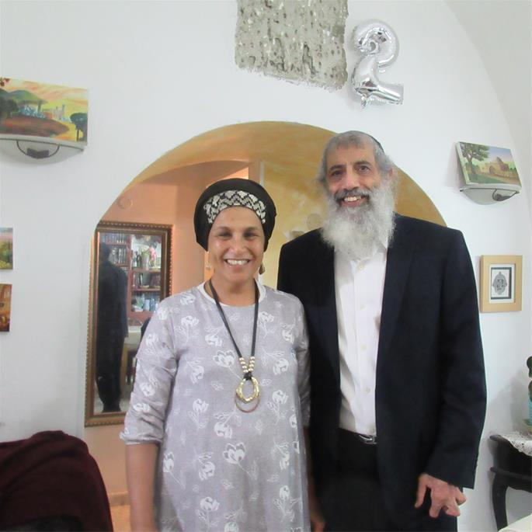
Shaul and Rachel Nir

Soon after that, when asked to remove my jewelry for a CAT scan, I realized that my precious gold bracelet was missing. I started screaming, “Someone stole my bracelet! Call the police!” My sister, who is a nurse, was with me. “Why are you getting so upset over a bracelet?” she reproached me. “Keep things in perspective—you’ve been hit in the hand by a bullet. You’re going to need serious surgery!”
The Bullet Struck the Bracelet
But she was wrong. A bullet had hit me, but it had struck the bracelet and broke it in two, while my hand remained mostly unharmed. Only the tendon of my thumb was slightly damaged and over time it healed. As for the scar that remains, I consider it a “souvenir” of the event. Whenever I look at it, I recall the verse, “It should be a sign upon your hand.” Another bullet hit my foot but left only a scratch. Yet another miracle!
I remember the doctor who bandaged my hand saying to me, “I see you’ve had a hard day, today,” to which I responded, “Actually not. It was quite a good day!” I was so full of gratitude to G-d.
The most inexplicable thing of all, however, was the man in the red car. You see, according to the army report, there were actually two terrorists. The first shot at us from the road with the Kalashnikov, while the second approached us from the left side with a pistol, apparently to “finish us off” at close range. Just yards away from the driver’s side, the army found a number of spent cartridges. This explains my husband’s leg wounds, which clearly came from a different direction than the initial shots.

The Mysterious Man Stood in the Line of Fire
When that mysterious man walked around our car and spoke to my husband, he stood right in the line of fire. The gunmen must have seen that he was an Arab and stopped shooting. So it was he who saved Shaul from certain death.
The army wanted to speak with him and I gave them all the details—his appearance, his clothing, his car—but despite an extensive search, they never uncovered his identity.
Elijah the Prophet is known as the malach habrit—the angel of the covenant. Until today, I feel that it was he who saved us, in the merit of my grandson’s brit milah, which I had prayed so intensely to attend.
As related by Rachel Nir to Eliezer Shore

Reprinted from the Parashat Vayeishev 5780 email of Chabad.Org Magazine.

HO FENG SHAN 1901 - 1997
The first diplomat who saved Jews by issuing visas for them to let them escape from the Holocaust

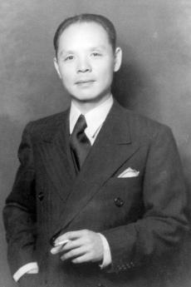
Ho Feng Shan

Dr. Feng Shan Ho, was given [by Yad Vashem] the title of Righteous Among the Nations. He was one of the first diplomats to save Jews by issuing them visas to escape the Holocaust. He was responsible for saving thousands of Jews in Nazi-occupied Austria in 1938 and 1939, yet he was completely unknown, even by the people whom he saved.
He was born on September 10, 1901, in rural Yiyang in Hunan Province, China. Poor and fatherless by age seven, he and his family were helped by the Norwegian Lutheran Mission.
Feng Shan Ho had a western liberal arts education and he was steeped in Confucian ethics. Ho possessed a dynamic, outgoing personality, boundless energy and a hot temper, offset by a quick wit and great sense of humor. He was described as a man with a "compassionate heart".
Dr. Feng Shan Ho was posted as First Secretary to the Chinese legation in Vienna in the spring of 1937.
Because of Ho's mastery of German and his dynamic personality, he was active in local cultural and intellectual circles. He was in great demand as a speaker on Chinese culture and customs. He had a wide ranging circle of friends in Vienna, especially among the intelligentsia, many of whom were Jewish.
At the time, Vienna had the third largest Jewish community in Europe. After years of assimilation, the Jews of Vienna seemed to be accepted into Austrian society. But this acceptance was only superficial.

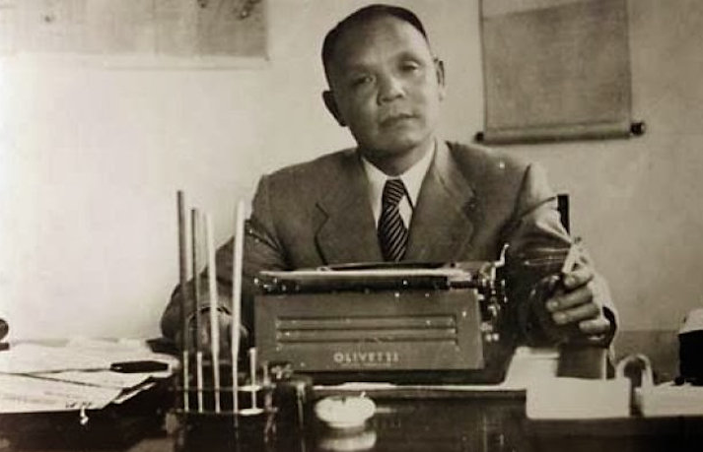

Following the Anschluss in 1938, 185,000 Jews there were subjected to a severe reign of terror and all foreign embassies and legations in Austria were closed. He was horrified by the fanatical welcome the Austrians extended.
Ho got orders to dissolve the legation and set up a Consulate General, In May 1938, Ho was appointed the Chinese Consul General in Vienna.
The Jews of Austria were increasingly in danger, and they needed help. The rush for visas assumed panic proportions during and immediately after Kristallnacht, in November 1938, when thousands of Jews were thrown into concentration camps.
Vienna became the center for emigration of Austrian Jews. All foreign consulates in the city were besieged by desperate Jews day after day, but most did not offer help.

Dr. Ho’s actions to help Austrian Jews aroused suspicion. His direct superior was Ambassador Chen Jie, who represented China in Berlin. Ambassador Jie was outspoken in his desire to strengthen bonds between Germany and China and ordered Dr. Ho to stop issuing visas. Yet Dr. Ho refused this direct order, doubling down on his life-saving visas instead.

The Nazis Confiscated the Building and Evicted the Consulate
Soon, Dr. Ho faced another obstacle to his life-saving work. The building that housed China’s consulate in Vienna was owned by Jew, and the Nazis confiscated the building and evicted the consulate. Dr. Ho quickly rented new office space with his own money so he could continue issuing life-saving visas.
By November 1938, Dr. Ho and the Chinese consulate in Vienna were known to be the last resort for Jews. On November 9 and 10, Germany and Austria were convulsed by violent anti-Jewish pogroms. Mobs burnt most of Vienna’s synagogues, ransacked Jewish owned businesses, and attacked Jews in the streets. Thousands of Jews were sent to the Buchenwald and Dachau concentration camps. Their families were told they could be released if their relatives procured visas or travel documents to other countries.
Each day, long lines formed outside the Chinese consulate. Gerda Gottfried Kraus recalled standing in one of those lines, and seeing Dr. Ho’s car approach the consulate. She and her husband sprinted towards Dr. Ho’s car, and her husband thrust his visa application at Dr. Ho through the car window. “Apparently, the consul general received it,” she recalled years later, “because he then got a call and received the visas.” Gerda and her husband were able to leave Austria and eventually settle in Canada, thanks to Dr. Ho.

Ho Issued Visas to Any and All Who Asked
Ho practiced a "liberal" visa policy, authorizing the issuing of visas to any and all who asked.
Eric Goldstaub, a 17-year-old Viennese Jew, was turned down by 50 consulates in Vienna before he went to the Chinese Consulate, where on July 20, 1938, he obtained 20 Chinese visas for himself and his extended family.
Shanghai was under Japanese occupation and a visa was not required for entry. But a visa, as proof of destination, was necessary for Jews to be allowed to leave Austria.
The Viennese Jewish community was officially dissolved in November 1942. By the end of the War, more than 65,000 Austrian Jews died in Nazi concentration camps and ghettos.
In May 1940, Consul General Feng Shan Ho left Vienna. In 1940 Dr. Ho was issued a “demerit” for defying his superiors and ordered to leave Vienna.

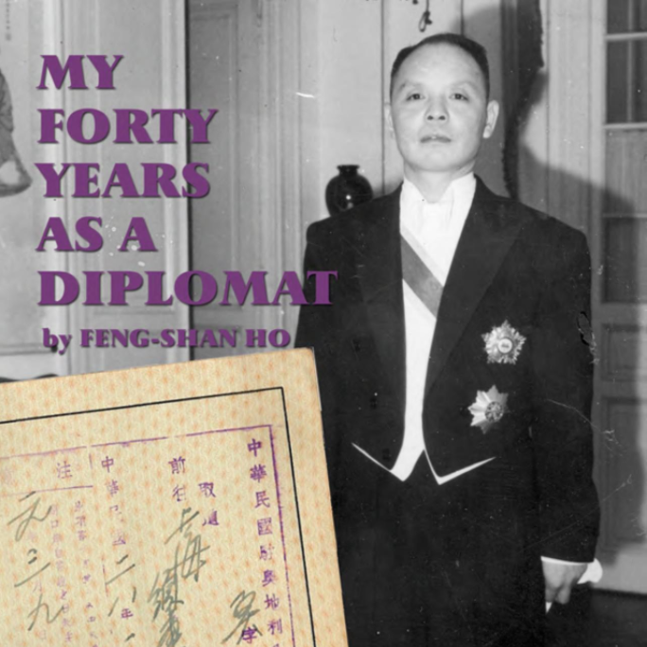

After war, Ho chose to remain loyal to the Chinese Nationalists, who had fled to Taiwan. He was ambassador in Egypt, in Middle Eastern countries, Mexico, Bolivia and then Colombia.
In 1973, after four decades in the diplomatic service, Feng Shan Ho retired to San Francisco, where He was a founding member of the Chinese Lutheran Church.
He wrote his memoirs, "Forty Years of My Diplomatic Life," published in 1990.
Since Dr. Ho never told anyone how many Jews he saved, it’s impossible to know the true extent of his wartime heroism. Historians have noted that one surviving visa issued by Dr. Ho bears a serial number of nearly 4,000. Current estimates are that Dr. Ho’s actions saved the lives of up to several thousand Austrian Jews.
“It was totally in character,” explained Dr. Ho’s daughter Manli Ho. “That is the kind of person he was – very principled, straightforward, and had integrity.”
In 2000, Yad Vashem awarded Dr. Feng Shan Ho the title of Righteous Among the Nations “for his humanitarian courage in issuing Chinese visas to Jews in Vienna in spite of orders from his superior to the contrary.”
After war, Ho chose to remain loyal to the Chinese Nationalists, who had fled to Taiwan. He was ambassador in Egypt, in Middle Eastern countries, Mexico, Bolivia and then Colombia.
In 1973, after four decades in the diplomatic service, Feng Shan Ho retired to San Francisco, where He was a founding member of the Chinese Lutheran Church.
He wrote his memoirs, "Forty Years of My Diplomatic Life," published in 1990.
On September 28, 1997, Ho died at his home, attended by his wife and daughter. He was 96 years old. His spirit remained undiminished to the end.

Reprinted from the Gariwo (Garden of the Righteous Worldwide) Network website.and the recent article “Feng Shan Ho: Hero Who Saved Thousands of Jews” by Dr. Yvette Alt Miller on the November 28, 2020 website of Aish.com

Five-Hundred Years in the Life of the Amon Family
By Amon Isaac
From the surrender of Spain to the court of Suleiman the Magnificent and beyond, they were there

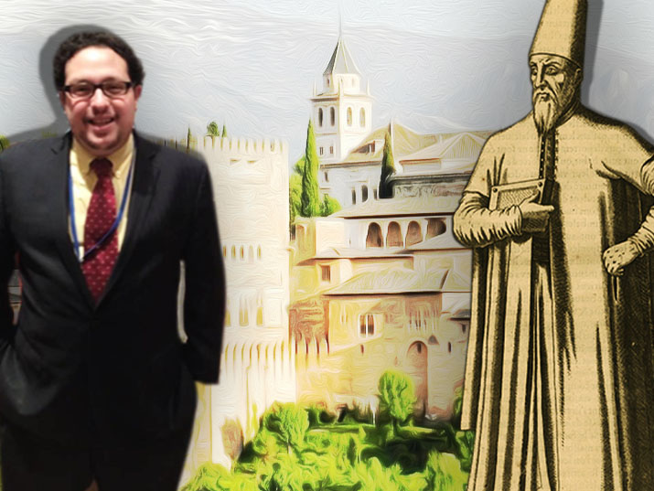

For centuries, members of the Amon family served as advisers and physicians to sultans, esteemed rabbis and businessmen across three continents
The name first appears in the first book of the Torah.
The Almighty – in bestowing a new name upon Abram – announces to him that “Your name will be ‘Abraham,’ for I have made you the father of many [Av Hamon] nations.”
The name ‘Hamon’ thus translates as ‘multitude’ or ‘many’.
Talmudic scholars, moreover, indicated that there exists a deeper meaning to this name. Indeed, the commentators state that the very name “Abraham” is but an abbreviation of “Av Hamon,” (‘Father of Many’), while each letter signifies a special attribute or character trait of Abraham, the progenitor of not only the Jewish people, but of monotheism itself.
As a last name, it will variably be spelled “Hamon” or “Amon”.

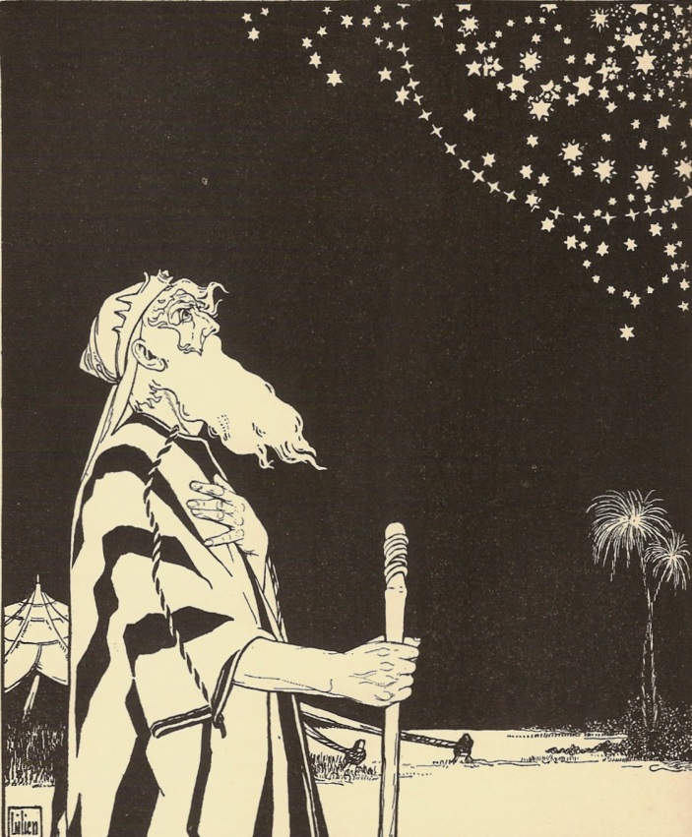
Abraham contemplating the multitude of stars, by E.M. Lillien.
From the Center for Jewish Art at the Hebrew University of Jerusalem;
available via the National Library of Israel Digital Collection

Abraham to Isaac
The first individual who bears this name in the historical record (and thus my family’s first appearance) seems to be Isaac Amon of Granada in the late 15th century.
Private physician to Muhammad XII (or Boabdil) the last Nasrid sultan of Granada, Isaac witnessed the surrender of the last Muslim ruled city to Ferdinand and Isabella, the Catholic Monarchs, in January 1492.
Besides some speculation, history tragically reveals no more of this forebear of the Amon family.
It does, however, record the existence of another Amon named Joseph, a younger relative who was also in Granada at that time.
One historian believed that Joseph was born in Italy, scion of the famous family of Rabbi Ovadia of Bartenura, though the consensus is that the Amon family is of Iberian origin.
Three months after the capture of Granada, and with it the end of the Reconquista (the Christian reconquest of Muslim Spain), Ferdinand and Isabella promulgated the infamous Edict of Expulsion from the Alhambra, ordering all professing Jews to convert or leave on pain of death by July 31, 1492. Following Tisha B’Av of that year, the last Jews left Spain, on the same day Christopher Columbus departed on his voyage of exploration.

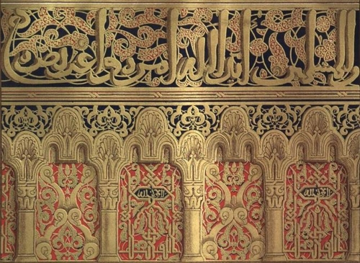
Alhambra design details illustrated in the 19th century book Reino de Granada.
From the National Library of Israel collection

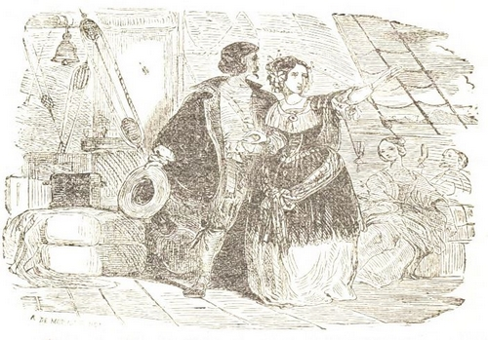
Depiction of Jews fleeing Spain, from a 19th century book on the Inquisition. From the National Library of Israel collections

At the Sultan’s Court
Joseph and his infant son Moses fled to the safety of the Ottoman Empire, along with multitudes of their co-religionists. As countless Jews arrived in Constantinople, Sultan Bayezid II (r. 1481-1512) is famously said to have declared that by expelling their country’s Jews, Ferdinand and Isabella had impoverished their own country and enriched his own.

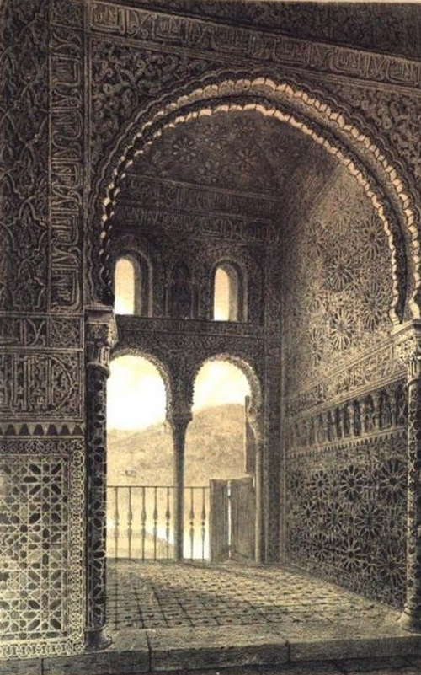
A patio in the Alhambra illustrated in the 19th century book Reino de Granada.
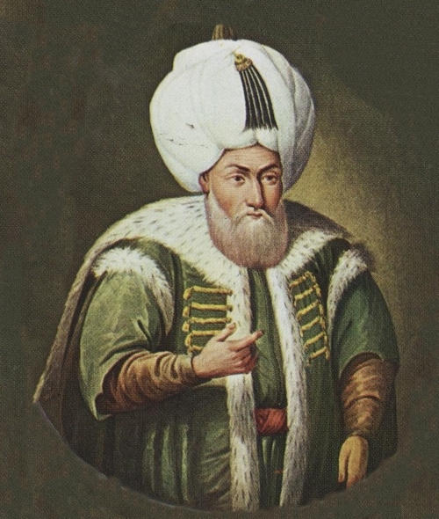
Bayezid II

Notwithstanding this venerable story, Amon family lore holds that Sultan Bayezid ordered Joseph to declare the Shahada and convert to Islam.
He was given three days to decide.
Joseph refused and defiantly proclaimed that he, his family, and his brethren had fled their ancestral homeland in search of religious liberty. He offered up his life but declared that he would not betray his faith.
Impressed by his staunch conviction, Bayezid invited Joseph to become his physician and advisor. Consequently, Joseph loyally served Bayezid and his son Selim I (r. 1512-1520), often accompanying them on military expeditions to Egypt and Syria, as the Ottoman Empire continued to increase its vast territorial holdings.
Joseph’s son Moses, who had left Spain as an infant, rose even higher than his father in the esteem and service of the Sultan and his Jewish brethren. He served as physician, advisor, and diplomat to Suleiman the Magnificent (r. 1520-1566), the longest reigning Ottoman sultan, throughout much of his 46 years in power.

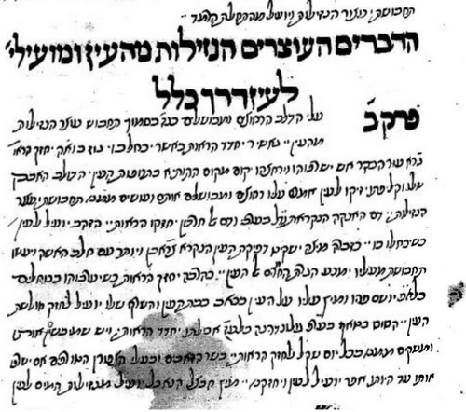

Excerpt on ophthalmology from a 16th medical text apparently written by Joseph or Moses Amon. From the Aharon Meir Mazia Collection, available via the National Library of Israel Digital Collection

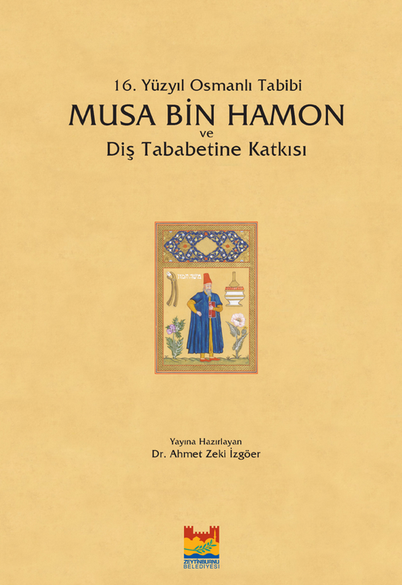
Recently published edition of a treatise on dentistry by Moshe Hamon

Moses funded a yeshiva, paid Jewish scholars to translate great works, and valiantly defended his brethren from infamous blood libel allegations. Most significantly, he persuaded Suleiman to intervene on Dona Gracia Nasi’s behalf with Venetian authorities, thus allowing her to immigrate to Constantinople.
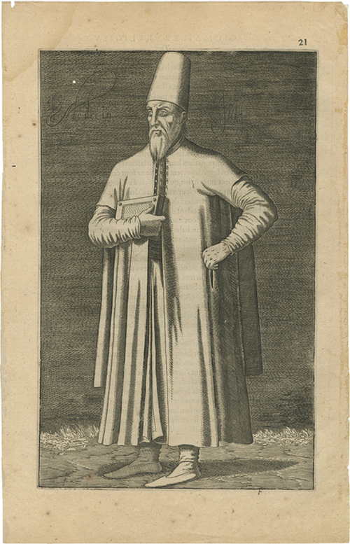
Etching of Doctor Moses Amon by 16th century French diplomat Nicolas de Nicolay

Although other Amons may be mentioned in various encyclopedias and resources, none of them merited to receive the historic stature or station of these three forefathers, all of them medieval physicians.

The Amons of late-Ottoman Istanbul
Closer to our own time, my great-great grandfather Ishak Amon Effendi is the earliest known member of my directly traceable family branch.
Born and raised in Istanbul, he was a teacher of mathematics, a rabbi, and a member of the Communal Council. His grandson (my grandfather) told me that as a sign of his prestige, Rabbi Ishak was even offered the position of Chief Rabbi of the Ottoman Empire following the Turkish War for Independence.
Unwilling to become involved in political machinations, he declined the offer to succeed Rabbi Haim Nahum Effendi, who had left to become Chief Rabbi of Egypt. Nonetheless, the Ottoman government bestowed “Effendi” (a title of nobility equivalent to being knighted in England and rarely given to Jews) upon him as a sign of the esteem in which he was held.
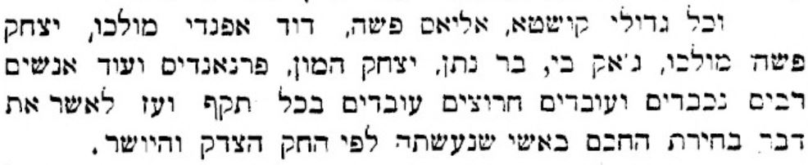 In this article published in the Eliezer Ben-Yehuda publication Hashkafa on 9 November 1906, Ishak Amon (in Hebrew “יצחק המון”) is mentioned as one of the notable residents of Istanbul (in Hebrew “קושטא”) who voted for the new Chief Rabbi of the Ottoman Empire. From the National Library of Israel Digital Collection
In August 2019, with the assistance of the Turkish Chief Rabbinate, the Neve Shalom Synagogue, a good friend named Ismail Baran Can Yildirim, and several cemetery employees (who barely spoke English), Rabbi Ishak’s grave was finally found in the Sephardic cemetery of Istanbul, located in the Arnavutköy neighborhood.

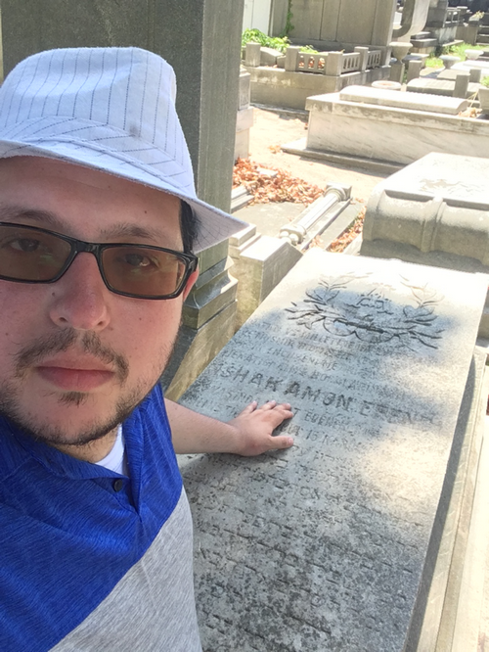
Isaac Amon at the grave of Rabbi Ishak Amon Effendi in Istanbul

Though the letters are fading, words in Turkish and Hebrew note that he was honored by the nation for his contributions and mourned by his people.
Rabbi Ishak’s son Davit was my great-grandfather. Born in 1881, the same year as Ataturk, he owned and operated his own import-export business in Istanbul. Married by Rabbi Raphael David Saban, the future Chief Rabbi of Turkey, Davit had two brothers and a sister. He died in 1977, the year after my father started medical school, and a dozen years before I was born in the United States.

The Midwest via modern Turkey
His son – my grandfather – Rene Isaac Amon, was a formative influence in my own life. Born in December 1923, a month and a half after Ataturk proclaimed the Turkish Republic, he grew up in a multi-ethnic, multi-confessional, multi-national neighborhood of Istanbul.
He was a polyglot, who spoke French with his parents, Ladino (Judeo-Spanish) with his grandparents, Greek with his friends, Turkish in the streets, and Hebrew in school. He later learned German and Russian for study purposes and perfected his English as an attaché between the Turkish Army and the British military during the Korean War.
As a teenager, he met Ataturk a few months before the latter’s death. He married my grandmother, Denise Nehmad from Beirut, in Istanbul’s Neve Shalom Synagogue in December 1952. Then-Chief Rabbi Raphael David Saban presided over the ceremony.

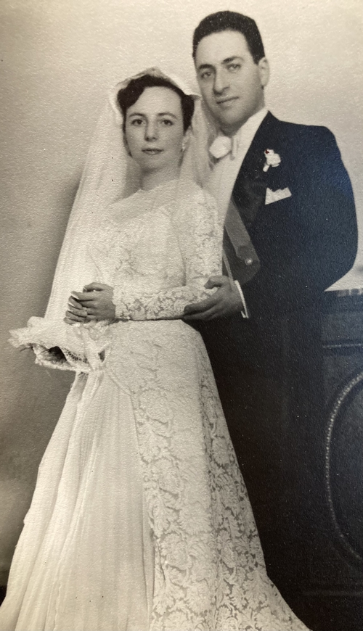
Wedding photo of Denis and Rene Isaac Amon

Shortly thereafter, my grandparents made the decision to move to America, with a young child – my father Erol – in tow. Arriving in Chicago during fall 1957 (when my dad was three years old), my grandparents had to reorient themselves to a new culture.
My grandfather’s Masters in Engineering from Istanbul Technical University was insufficient for career advancement. As such, despite 15 years of practice, he attended Northwestern University to obtain his PhD (and thus earn “his union card” as he put it). In his early 40s, he was thus writing his dissertation, teaching full time at the University of Illinois at Chicago, and raising my father.
Living in St. Louis, I visited my grandparents every summer growing up. During the High Holidays, they would take the train or get a ride from Chicago to St. Louis and stay with us for a few months.

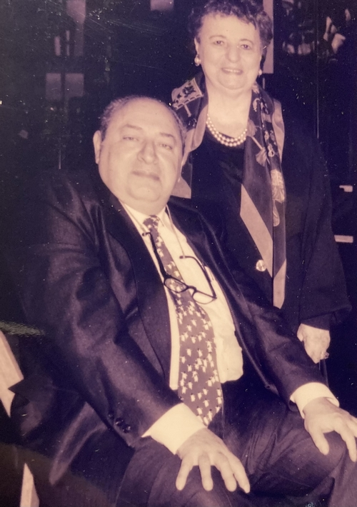
Denis and Rene Isaac Amon
My grandfather’s interests were numerous and his curiosity insatiable. He continued to read works in multiple languages, discuss religion, history, literature, engage with mathematical problems, and watch movies with us at night.

Into the 21st century
My grandmother (of Nahmad and Safra family origin), passed on in September 2013, while my grandfather passed on in October 2018, two months’ shy of his 95th birthday.
Mentally lucid and cognizant until the end, (speaking in French and Ladino with friends in person and on the phone even just a few days before his passing), he impressed upon our family the importance of remembering our history and passing it on to future descendants, to those who will unfortunately not know him except through our indelible recollections and memories.
In this final enterprise, he followed the notable example of our lawgiver and prophet Moses, who near the end of his own life exhorted the Nation of Israel to “remember the days of old, consider the years of ages past. Ask your father and he will inform you; your elders and they will tell you.”
From the Joseph and Margit Hoffman Judaica Postcard Collection, the Folklore Research Center at the Mandel Institute of Jewish Studies, the Hebrew University of Jerusalem; available via the NLI Digital Collection

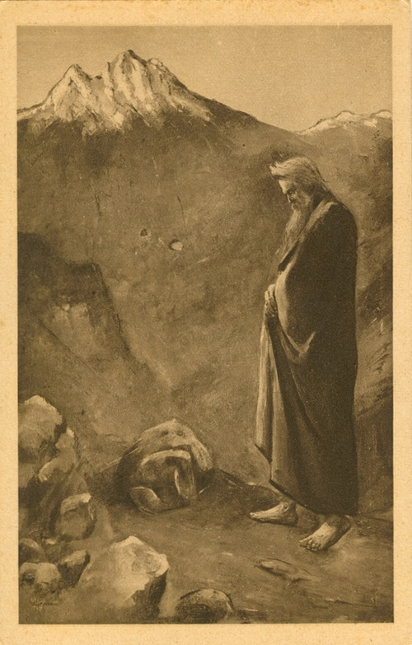
Lesser Ury’s “Moses am Sinai”, early 20th century (Publisher: J. Wieland & Co).
My genetic story (from 23&Me) reveals that I have relatives on five continents. Indeed, the Amon Diaspora spans the globe; members live in the United States (such as Cleveland, Seattle, New York, Boston, and St. Louis), Costa Rica, Turkey, Israel, France, the United Kingdom, and Australia.
Even more significantly, my Amon ancestors hail from Egypt, Iraq, Italy, Turkey, Lebanon, Spain and Portugal.
Though great expanses of space and time separate us, they live on in us.
Our DNA is the “living embodiment” of our chronicle in the scroll of family, Jewish, and human history.
It is said that we are only remembered for three generations. Accordingly, it is incumbent upon us to bear witness to the lives of our ancestors throughout the centuries, so they may live on for posterity. As the late Rabbi Jonathan Sacks, former Chief Rabbi of the United Kingdom and member of the House of Lords memorably wrote, “I hear their call to write the next chapter… [and] continue their journey because… I may not let it and them fail. I cannot be the missing letter in the scroll.”
Ultimately, from 15th century Isaac Amon to 21st century Isaac Amon, the story and legacy continues.

Reprinted from the December 30, 2020 email of the National Library of Israel. This article has been published as part of Gesher L’Europa, the National Library of Israel’s initiative to share stories and connect with people, institutions and communities in Europe and beyond.

What Did the Rebbe Say to the Anti-Religious Chief Justice Who Came for Simchat Torah?
By Tzvi Freeman

A Lesson in Remaining One People Despite Our Differences

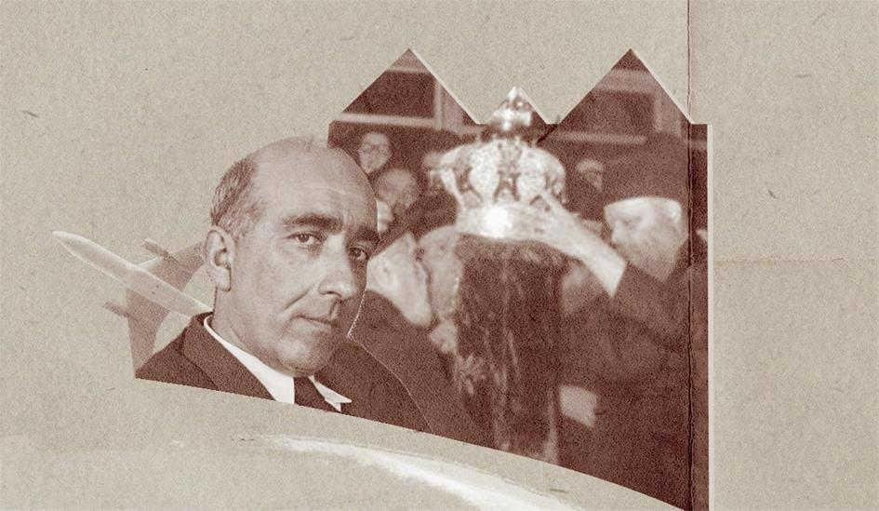

What do you do if you’re celebrating and rejoicing with friends, and the man who opposes you in your greatest life-battles turns up at the party?
This was Simchat Torah, 1975, at Chabad Lubavitch Headquarters, 770 Eastern Parkway. Thousands of Lubavitchers were packed in tight, along with anyone else who wished to witness
the most joyous hakafot in the world on the most joyous day of the year.
The gabbaim—esteemed official administrators—of the synagogue were frantically attempting to bring some order to the ceremony, while seeking out the This was just the wrong man at the wrong party.contingent that would come every year from the Israeli consulate.
That’s when they saw Haim Cohn. And they didn’t know what to do. This was just the wrong man at the wrong party.

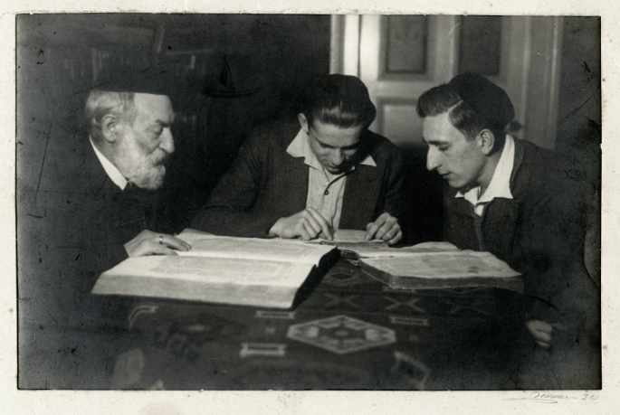

Rabbi Yosef Cohn and his grandsons Leo and Haim studing Talmud in Hamburg, circa 1932. Credit: United States Holocaust Memorial Museum, courtesy of Noemi Cassutto.

Wrong Man, Wrong Place
Who was Haim Cohn?
To Israelis, he is still known as one of the major architects of Israeli law, a great man of thought, and as a champion of human rights. Indeed, he was in New York for the United Nations general assembly, representing Israel in the Human Rights Commission. But Haim Cohn was also well known for his fierce opposition to all things religious, especially when they concerned the Israeli State.
Cohn came from a family of deeply religious Torah scholars in Lübeck, Germany. In 1929, at the age of eighteen, Cohn set out for Jerusalem, where he studied under Rabbi Abraham Isaac Kook, who he came to greatly admire, and at the Hebrew University. He returned to Europe to complete his degree in law at the University of Frankfurt, marrying there a young woman who was not interested in religion.
After returning to the Holy Land with the rise of the Third Reich in 1933, he gradually turned not just away from, but against Torah Judaism, actively opposing the rabbis, both as an authority of Israeli law and as a member of the T'hila Movement for Israeli Jewish secularism.
“The Elisha ben Avuya of our generation,” was the title given him by Rabbi Tzvi Yehuda Kook, son and protégé of his Elisha ben Avuya was a brilliant sage of the Talmud, the teacher of Rabbi Meir, who had turned to heresy.
Smoke rose from his grave, the Talmud tells, for well over a hundred years—and that was after the sages prayed for mercy on his soul. “Because he knew G-d’s greatness and yet rebelled.”¹
Eventually, Cohn divorced his first wife and traveled to America for a secular marriage to a woman who had been previously married—an act that spurred the fury of rabbis in Israel. By Torah law, a descendant of Aaron, such as Haim Cohn, is forbidden to marry a divorcée.
But perhaps what concerned the gabbaim most was Haim Cohn’s role in the “Who Is a Jew” controversy.
This was a topic the Rebbe had addressed incessantly for the previous five years, warning in the strongest language imaginable that compromise on such a core issue posed an existential danger to the Jewish nation.

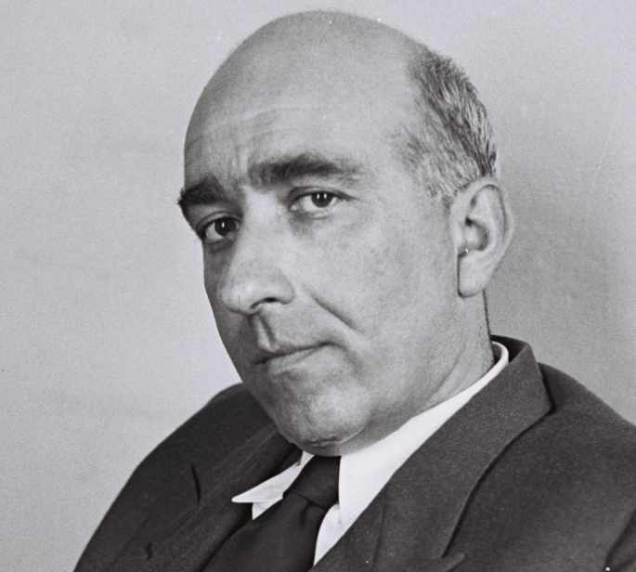
Haim Cohn, Israeli jurist and politician, 1911-2002 (credit: Teddy Brauner)

Haim Cohn, on the other hand, as a Justice of the Supreme Court of Israel, stood his ground that Jewishness, as the state, is a social construct, and anyone who personally identifies as a Jew should be embraced by the state as a Jew.
The gabbaim who beheld this man standing before them knew well the controversy, indeed, the outright condemnation in many quarters that would arise if they gave him any part in the ceremony. Small wonder they stalled.

The Weight of Torah
But the Rebbe noted the hesitation of the gabbaim and protested.
“A Jew wants to take on the yoke of Torah,” he chided them, “and you won’t give it to him?”
The Rebbe personally purchased the reading of the first verse of the ceremony and said something to a gabbai, who then called out, “We hereby honor the illustrious Justice of the Supreme Court, Reb Haim haKohen, with the verse, “Atta Hareisa.”
Haim Cohn bellowed out his verse, loud and proud, and the Rebbe, the gabbaim, and the crowd of chassidim echoed him in full chorus.
The episode had not ended. When the gabbaim took out the Torah Scrolls, the first and the heaviest—the one known as “Moshiach’s Sefer Torah”—was heading straight towards Haim Cohn.
Again the gabbaim hesitated. This was a very heavy scroll after all, and Haim Cohn was no young man. It would make more sense to hand him one of the smaller, lighter scrolls.
The Rebbe looked Cohn straight in the eye. He asked, “Are you ready to accept upon yourself the weight of the yoke of Torah?”
If you never experienced that “Are you ready to accept upon yourself the weight of the yoke of Torah?” the Rebbe asked him.look, it’s difficult to relate. Two sharp blue eyes pierce through your flesh down to your bone and deep into your soul. There is nowhere to hide and nothing of you that remains hidden before those eyes.
Haim Cohn answered in the affirmative. The gabbaim relented.
When the singing and dancing began, Haim Cohn was still clutching his Torah, singing and dancing along with the consulate members and chassidim for a full three-quarters of an hour. Even as the Rebbe sang and clapped and encouraged the crowd with explosive joy, his eyes never left Haim Cohn.
That night, Cohn returned to his hotel. He returned to Israel, to his post, and to his opinions. Ten years later, he was still writing about “Who Is a Jew,” without any deflection from his original stance.

Looking Deep
If you never met the Rebbe, if you didn’t know his ways, you might misinterpret this story.
You might say, “The Rebbe was very smart. He knew how to deal with his detractors. He knew that rather than arguing with a Jew, better to befriend him.
That way, you have a far better chance of enlisting them to your cause—or at least, mitigating their gunfire. Too bad it didn’t work in this case.”
But that is not the Rebbe. And the proof: In this case, the risk was too big to fake.
With utter confidence, the Rebbe declared that this Jew was here for one purpose: “to accept the yoke of Torah.” And he even took the gamble of publicly asking a man who had fought against Torah for 30 years—with no sign of regret, “Are you ready to accept the yoke of Torah?” What if Cohn had said “no?”
And even if he didn’t say no, what if he didn’t mean what he said? The Rebbe was certainly a stickler when it came to halachah. How could he permit handing a Torah Scroll to a man known for his fight against things sacred to the Jewish people—and asking him to lead an entire congregation in prayer (as indeed the Rebbe’s critics demanded to know upon hearing the story)?

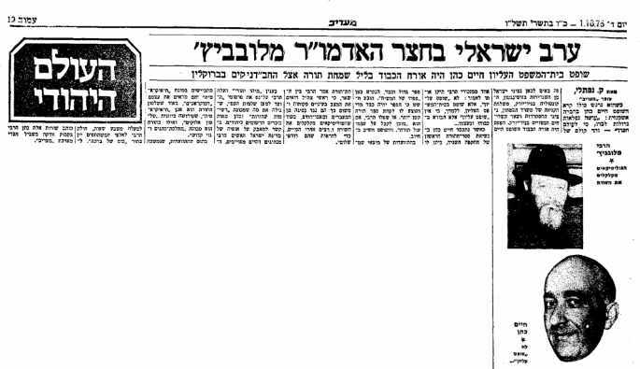

An article from the Israeli newspaper "Maariv" reporting Chaim Cohen's participation in festivities at 770.

The Rebbe saw before him a Jew. And he believed in that Jew.
He believed that, regardless of everything this Jew had said and done for the past thirty years, a Torah Scroll remained for him the most precious, sacred object in the world. And that his innermost, deepest desire was to carry and embrace that Torah.
Did it help? Let’s say it didn’t. But, as the first rebbe of Chabad wrote in his classic work called the Tanya, when you see a Jew who is not doing the right thing, pull that Jew in with thick cords of love. Perhaps he will change his ways, perhaps not. Either way, you’ve fulfilled the mitzvah of loving another Jew.
But I believe it did help.
You see, years later, a certain Chabadnik befriended a certain Israeli who lived in Manhattan. Before Simchat Torah, he invited him to come to 770 and celebrate with the Rebbe.
But the man refused, adamantly. “I have a friend,” he explained, “who went there one year. And it changed his mind about many things. I am not interested in changing my mind about anything. I’m not coming.”
The friend, as you may have guessed, was Haim Cohn.
Outwardly, perhaps, at least in the immediate, nothing changed. But then, Maimonides writes in his Laws of Repentance that if a Jew has regret in the recesses of his heart, even if he remains recalcitrant, his repentance is accepted and his share in the World To Come reinstated.²
And eventually, as Maimonides writes in a famous letter to the Jews of Yemen, this Jew will come to a complete repentance. As the verse goes, “Return, wayward children, and I will heal your returning.”³

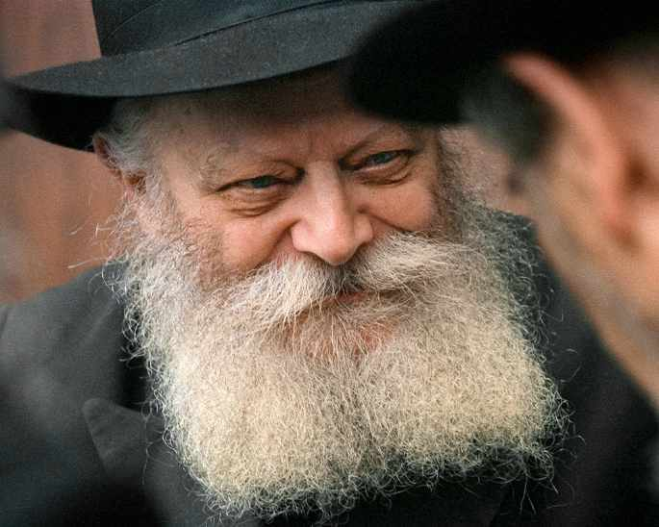
Lubavitcher Rebbe

Judaism as Belief in Jews
Some people today have lost faith in their fellow Jews. With the conflation of politics and religion and the intensely polarizing pull of social media, some have gone so far to declare that we have become, G-d forbid, two separate peoples.
Such a perception can only arise when our eyes do not see beneath the most external presentation of a Jew. When we judge people by their behavior, by their stated
opinions, by their choices at the voting polls that go against our own.
But that is not Judaism. Judaism is not an ideology or even a set of practices that determine whether we keep you as a Jew or chuck you out as a stranger.
Rather, Judaism is a divine wisdom, known as Torah, that, when presented in all its authenticity, Judaism is not about who is in and who is out, but about utter faith in your fellow Jew, that his or her deepest desire is to embrace the Torah.has the unique capacity to awaken the inner spark of a Jew, thereby connecting all of us together as one people with one Torah and one G-d.
Connect with that other Jew and you will see the good that’s there. It’s likely not so far from the surface. You may even find there’s far more you agree upon than you disagree upon.
As with Haim Cohn and the Rebbe. Cohn was a champion of human rights, something I imagine the Rebbe admired in him. He was also known for visiting the prisoners he had sentenced to jail, to ensure they were being well-treated.
"If I had my way," he once said, "I'd scrap prisons." Interestingly enough, the Rebbe said pretty much the same to Justice J. B. Weinstein.
So when you see another Jew at your party, even if he’s not the person you want to see there, even if you think he’s a sinner, even if you believe he is actively destroying the most sacred, essential elements of our people, even if he voted for the party you most despise, look deeper. Believe in that Jew.
As much as you believe in G-d, believe in that Jew.

FOOTNOTES
1. Jerusalem Talmud, Chagigah 9b.
2. Mishneh Torah, Laws of Repentance 3:14.
3. Jeremiah 3:22.

Reprinted from the Parshat Korach 5781 email of Chabad.Org Magazine.

The Tulsa Race Massacre
And Oklahoma’s Jews
By Phil Goldfarb

How local Jews - some with fresh memories of European pogroms - did their small part to help victims of one of the worst acts of racial violence in US history

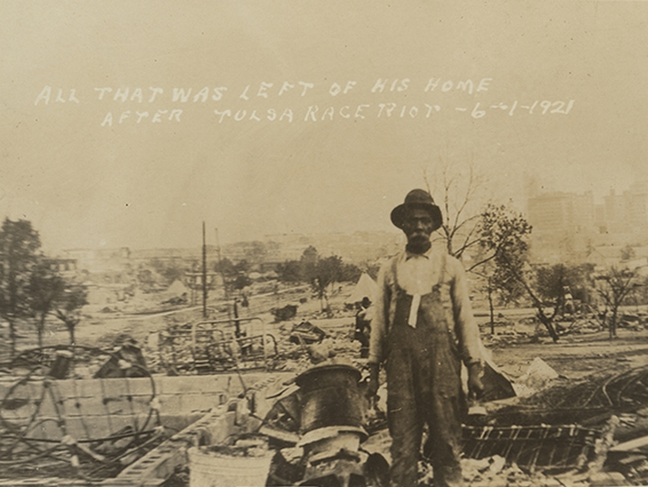
"All That Was Left of His Home after the Tulsa Race Riot, 6-1-21" (Public Domain via DeGolyer Library, Southern Methodist University)

The Tulsa Race Massacre – also known as the Black Wall Street Massacre and the Tulsa Race Riot – was one of the most horrendous incidents of racial violence in United States history. On May 31 – June 1, 1921, hundreds of people were injured and killed, and thirty-five blocks of the city were destroyed, along with over 1,200 homes.
While relatively few whites exhibited empathy and compassion to the persecuted African American community of Tulsa – largely due to the influence of the Ku Klux Klan (KKK) and others – many Jewish families made efforts to help African American families by taking them into their homes or businesses, feeding and clothing them, as well as hiding them during and after the atrocity.
During the time of the Race Massacre, a number of the Jewish families went into North Tulsa to secure their black employees, friends, and their families, in order to protect them at least until Martial Law was over on June 3rd… some even longer.
Many of the Jews in the city were recent immigrants from Eastern Europe who remembered firsthand suffering through violent pogroms and anti-Semitic policies in the Russian Empire and elsewhere.

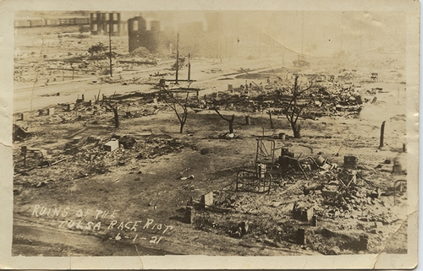
“Ruins of the Tulsa Race Riot, 6-1-21” (Public Domain via DeGolyer Library, Southern Methodist University)

Here are a few family stories from that terrible time that have been passed down within the Oklahoma Jewish community.

Pickle Vats and Underskirts
Jewish Latvian immigrant Sam Zarrow (1894-1975) and his wife Rose (1893-1982) owned a grocery store and hid some black friends in their large pickle vats at the store, while Rose concealed some of the little kids under her skirt! In addition, they hid others in the basement of their home. Sam and Rose’s sons, Henry (1916-2014) and Jack Zarrow (1925-2012) became two of the most well-known and philanthropic men in Tulsa’s history, supporting a range of causes across the city.

Waiting with a shotgun
Tulsan Abraham (Abe) Solomon Viner (1885-1959) and his wife Anna (1887-1976) owned the Peoples Building and Loan Association. On the day of the Massacre, Abe went to all of the homes on his block, collected all of the maids from their quarters and assembled them in his living room. He then sat by the front door with a shotgun in case anyone broke into the house.

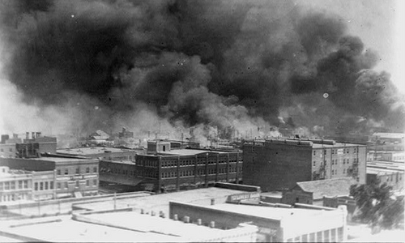
Smoke billowing over Tulsa during the Race Massacre (Photo: Alvin C. Krupnick Co. / Public Domain via Library of Congress)

Threatening the Klan
The Race Massacre had a far-reaching effect even outside of Tulsa. At the time, Mike Froug (1889-1959), his wife Esther (1889-1967) and daughter Rosetta Froug Mulmed (1914-2003) were living in Ponca City, Oklahoma running a clothing store called the Pickens Department Store. Immediately after the Massacre, several Ku Klux Klan members came to his house at night and set a cross on fire on his front lawn.
Knowing who the perpetrators were (frequent shoppers in his store), Froug went to the head of the Klan with his gun and told him that if they ever did that again, he would shoot them. This act had such a profound effect on Froug that when he and his cousin Ohren Smulian (1903-1984) opened the first Froug’s Department Store in Tulsa in 1929, they became the first store in the city after the Massacre to allow whites and blacks to not only shop together but to try on clothes at the same time. In fact, Frougs was also the first white-owned store in Tulsa to have black salespeople.

“Get your Jew crew out of Tulsa”

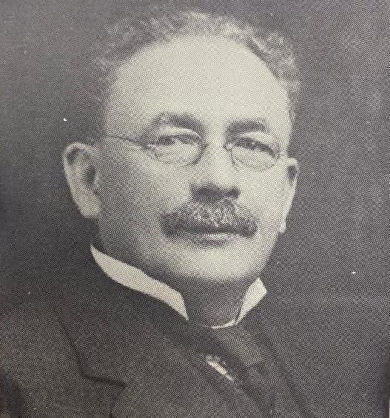
Successful oilman N.C. Livingston was an active leader in the Tulsa Jewish community, heading the establishment of the burial society and Orthodox synagogue, where he also served as president and taught a Talmud class. From B’nai Emunah, 1916-1966, part of the National Library of Israel collections

Jewish Lithuanian immigrant and oilman Nathan C. Livingston (1861-1944) and his wife Anna Livingston (1871-1934) had a newly married black couple named Gene and Willie Byrd working for them in 1921. Gene was the family driver while Willie was their housekeeper. During the Race Massacre, the couple and eight others of their family stayed in the Livingston’s basement and in their garage apartment for several days until they felt safe to go home. The following year, N.C. Livingston’s son Julius received a letter from the KKK telling him and his brothers Jay K. and Herman to “get your Jew crew out of Tulsa.”
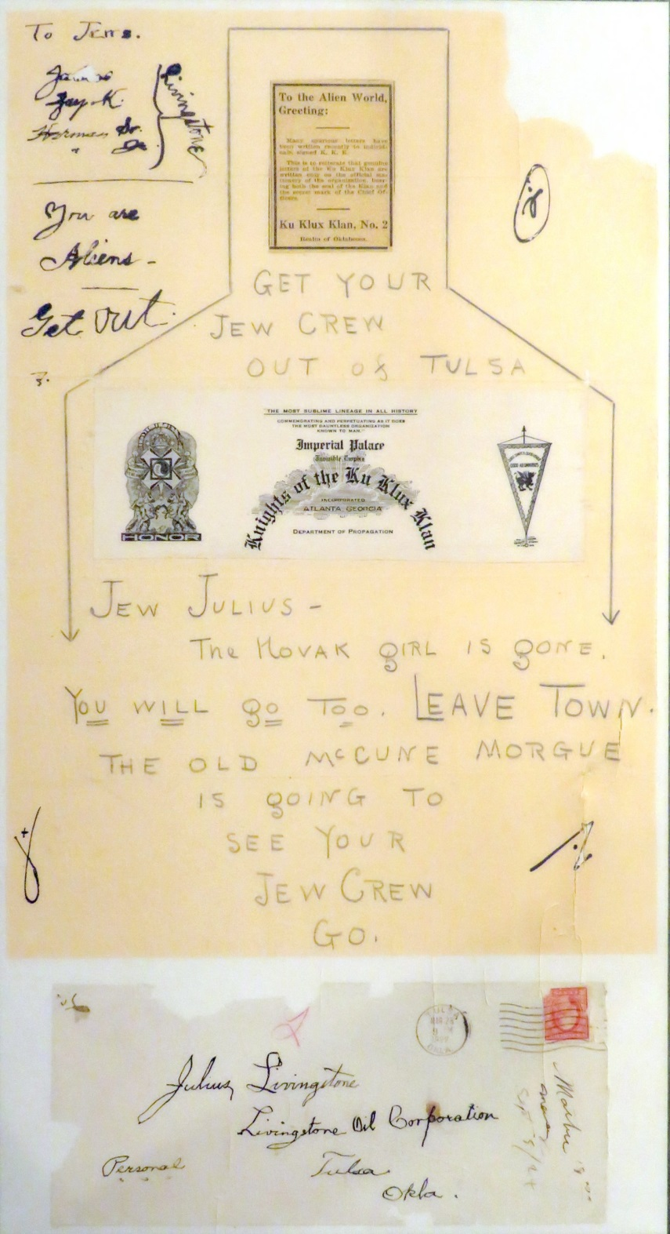
1922 Letter to Julius Livingston telling him to get his “Jew Crew out of Tulsa” (SMMJA Livingston Archives)

Staying Home
During the Massacre, Jewish Lithuanian immigrant and oil producer Jacob Hyman Bloch (1888-1955) and his wife Esther Goodman Bloch (1895-1927) told their two young daughters, Jean and Sura, to stay away from the windows and no to go to school or outside to play, while hiding their housekeeper in their home.
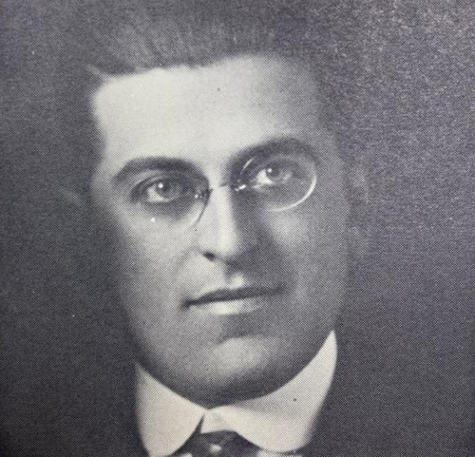
Jacob Hyman Bloch was also an active member in the local community, succeeding N.C. Livingstone as synagogue president in 1924. From B’nai Emunah, 1916-1966, part of the National Library of Israel collections

Driving to Safety
Jewish Latvian immigrant Jacob Fell (1885-1959) and his wife Esther Fell (1886-1980) owned The Mis-Fit Clothing Store in Tulsa. During the race riots, Jacob gathered up several black friends, hid them in his large storage car trunk, and drove them to a safe area.

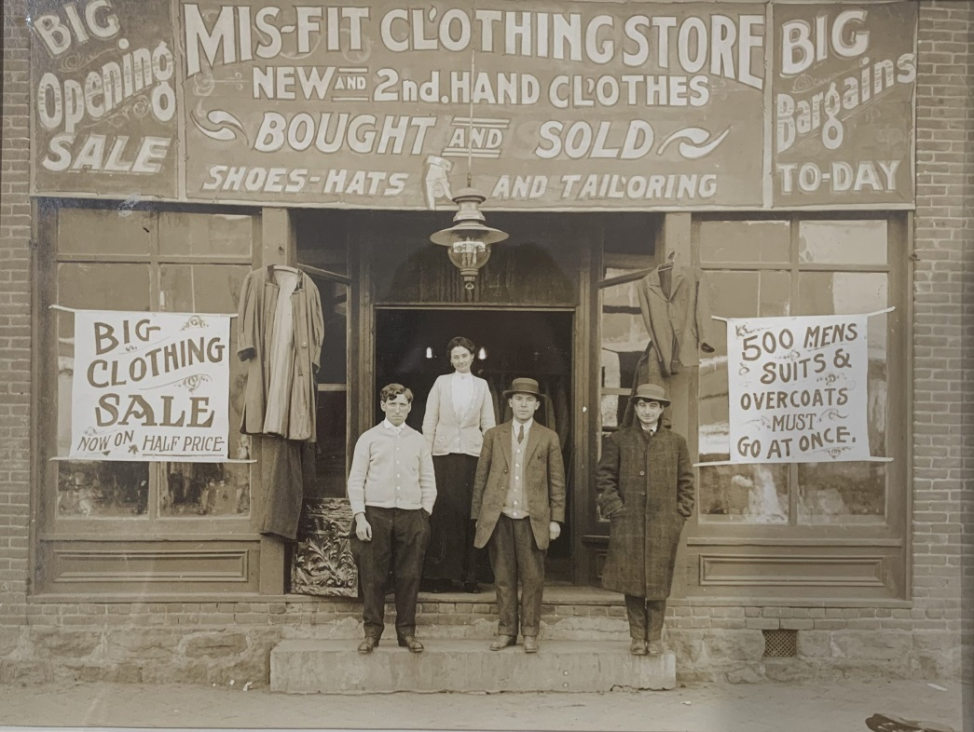
The Mis-Fit Clothing Store in Tulsa

“But Not You Mr. Katz”
In Stillwater, Oklahoma the Ku Klux Klan also had a robust chapter. German immigrant Jacob Katz (1873-1968) started his department store in Stillwater in 1894, becoming the first Jew in the town. Katz was a highly respected merchant and town promoter and was on the Stillwater Board of Commissioners. During the heyday of the KKK, right after the Tulsa Massacre, members marched through Stillwater with anti-Jewish signs (there were only 12 Jews in Stillwater at the time!), along with one that read at the end of the line: “But not you Mr. Katz.”

Reprinted from the June 1, 2021 email of the National Library of Israel. A version of this article was originally published in the May 2021 edition of the Tulsa Jewish Review. It appears here as part of Gesher L’Europa, the National Library of Israel’s initiative to share stories and connect with people, institutions and communities in Europe and beyond.

Is that Bourbon
Really Kosher?
By Rabbi Yair Hoffman

Welcome back 1950’s. Although most of us don’t really admit it, regarding a number of products, our great-grandparents (or grandparents depending upon how old the reader is) relied heavily on ingredient lists to determine what was kosher or not.
Times, of course, have changed and now, most people only consume products with reliable hechsherim– at least in regard to most areas. But, shockingly enough, the one area where we are still in the 1950’s mindset is alcohol. Dubious alcohols are found in our shuls, at our weddings, our frum-owned kosher liquor stores, and in our liquor cabinets at home.
`In this column, the focus will be only upon bourbon – but there are others that need to be addressed as well. We will also discuss some of the heterim – but it should be known that most Poskim do not allow use of these heterim as will be discussed.
Many people assume that bourbons are kosher because of the famous WCBIIA question. (WCBIIA stands for “What could be in it already”) The answer to WCBIIA is – plenty. On account of Jewish ownership of many distilleries – there is a problem of Chomez Sh’avar alav Hapesach – that the Bourbons while they were developing and forming – were under Jewish ownership over Passover and were not sold.

Background
Before we get to the nature of the halachic problem – let’s get some background into Bourbon.
Bourbon, of course, is America’s native alcoholic drink by law, no different than Tequila is legally native to Mexico. The Bourbon law was passed in Congress in 1964. Bourbon is a type of whiskey, but it’s alcoholic content must be made out of at least 51% corn. Most distilleries make it from 65% to 75% corn, however.
Legally, nothing may be added to bourbon during the distillation except for water. The flavor, therefore, comes only from the charred oak barrels. When Wild Turkey wanted to add honey to their Bourbon – they had to name it, “Wild Turkey Liqueur” and then renamed it again to “American Honey.” Jack Daniels wanted to filter their bourbon through maple charcoal for flavor. They had to call it Tennessee Whiskey – not bourbon. 95% of Bourbon is made in Kentucky.
The law is also that the barrels must be entirely new – never used for anything else. So there is no yayin nesach of sherry casks issues. It is also a legal requirement that Bourbon must be aged in the barrel for two years.

How Widespread the Problem Might Be
The three largest bourbon distilleries in Kentucky are 1] Jim Beam, 2] Heaven Hill, and 3] Buffalo Trace. Jim Bean is not Jewish owned, – but the latter two are. There are perhaps four or five other smaller distilleries that are also Jewish owned – and only a handful of people are keeping tabs on it. The CRC had been working with Buffalo Trace in 2010 to produce a line of Kosher Bourbon. In 2020, they made available a kosher line. Buffalo Trace is owned by the Goldring family.
According to an interview given by Rabbi Litvin a Chabad Rabbi who lives in Kentucky there are about four or five distilleries in Kentucky that are Jewish owned. The problem is that just like in other industries – there are something called “jobbers” – where a label actually has it manufactured in a different plant. Heaven Hill is owned by Jews, and actually manufactures over 3000 products.
Barton is one of the distilleries that allows jobbers, so to speak, it is Jewish owned, and does not take care of the chometz issues.
New Riff Distillery actually used to sell their Chometz, but forgot to do so this year. There is another company that is Jewish owned called Southern, which is being sold perhaps, thus creating possible complications. There is Lux as well, which is a Jewish owned company.
Heaven Hill, a distillery that is Jewish owned, has the labels for Evan Williams, Elijah Craig, Larceny, and William Heaven Hill – and even more. The CRC has a three-tiered list regarding bourbons: Not recommended (3), Certified (23), and Approved (30). They write that certified is, of course, preferable to approved. Other Kashrus agencies and organizations also have lists where Approved is one of the categories – even though there is no hechsher per se.
The problems are that the underlying issues of Chometz Sh’avar alav haPesach are so rapidly changing that the Approved list (which we will call – List #3) is often wrong, or misused and quite, quite, often – outdated. The outdated nature of things is just passed along from year to year. Below are the three lists of the CRC.

Not Recommended
Trader Joe’s – Kentucky Bourbon Straight Whiskey
Wild Turkey – American Honey Sting
Woodford Reserve – Frosty Four Wood

Certified
Black Dirt Distillery – Bourbon Star K*
Buffalo Trace – Kosher Bourbon Rye
Buffalo Trace – Kosher Bourbon Wheat
CH Distillery – CH Straight Bourbon Whiskey
Dead Drop – Bourbon
Jim Beam – Apple
Jim Beam – Honey
Jim Beam – Kentucky Fire OU
Jim Beam – Maple OU
Jim Beam – Peach OU
Jim Beam – Red Stag Black Cherry OU
Jim Beam – Red Stag Hardcore Cider OU
Jim Beam – Red Stag Honey Tea OU
Jim Beam – Red Stag Spiced OU
Jim Beam – Vanilla OU
Journeyman Distillery – Feather Bone Bourbon
Koval – Bourbon OU*
Laws – Four Grain Straight Bourbon
Laws – Straight Corn Whiskey –Bottled in Bond
Laws – Two Grain Straight Bourbon Whiskey
Lion’s Pride – Bourbon OU*
The Josephs Brau Brewing Company -Heller Bock
The Josephs Brau Brewing Company -Hofbrau Bock

Approved
Baker’s – Unflavored
Basil Hayden’s – Unflavored
Black Maple Hill – Unflavored
Bookers – Unflavored Bourbon
Elijah Craig – Unflavored
Evan Williams – Unflavored
Four Roses – Unflavored
Heaven Hill – Unflavored
Hirsch – Unflavored
Jim Beam – Black
Jim Beam – Devil’s Cut
Jim Beam – Signature Craft – 12 years
Jim Beam – Unflavored
Knob Creek – Unflavored
Larceny – Unflavored
Maker’s 46 – Unflavored
Maker’s Mark – Unflavored
Michter’s – Unflavored
Noah’s Mill – Unflavored
Old Crow – Unflavored
Old Fitzgerald – Unflavored
Old Grand-Dad – Unflavored
Old Pogue – Unflavored
Parker’s – Unflavored
Prichard’s – Unflavored
Rhetoric – Bourbon
Rowans Creek – Unflavored
Wild Turkey Bourbon – Unflavored
Willett – Unflavored
Woodford Reserve – Unflavored

A Multi-Layered Heter Perhaps
There is a rationale to be lenient to allow the drinking of these spirits, but in this author’s opinion it is not something that we probably should NOT be doing. The Mishna Brura (449:5) cites a view that when there is a doubt, one may eat Safaik Chometz Sh’avar alav haPesach. It is, however, a debate among the Poskim. Many Poskim have, however, ruled that when there is a need – one can rely on the lenient view.
It could be that the slight research that the Kashrus agencies have done in regard to list #3 – can at least be qualified as a “Safek” – a doubt, in as far as the afore-mentioned Mishna Brurah (in 449:5) is concerned.

Non-Observant Jew
There is also a debate among the Poskim as to the nature of a Jew who is not observant. It is possible that, according to some Poskim the prohibition of Chometz Sh’avar Alav HaPesach, a Rabbinic prohibition, may not have been enacted on someone who has thrown off Torah Judaism.
Both the Mishna Brurah (OC 347:7) and the Vilna Gaon (YD 151:7) reject this view, but it very well could be the view of the Shach in YD (151:6). The Dagul Mervavah understands this Shach as permitting a Rabbinic violation when this is the case. Rav Moshe Feinstein zt”l (Igros Moshe YD Vol. I #72) writes that one may rely on the Dagul Mervavah’s reading of the Shach only in conjunction with another factor.

The Snifin Approach
Perhaps one could combine both of the above issues in what is known as the snifin approach to Halachic rulings. In that approach, multiple mitigating halachic factors and even minority opinions, are combined to create a heter. It is also interesting to note that there is a great debate as to the nature of the snifin approach as well. May we also include minority halachic opinions that have been out and out dismissed by the Poskim? Or may we only include views that are actually correct, it is just that the more stringent approach has been adopted?

Another Issue Regarding Alcohol and Spirits
There is another debate between the Rashba and the Noda BiYehuda of which most people are unaware. It pertains to the issue of Bitul B’Shishim, something becoming nullified in a 60 to 1 ratio.
The debate can be called, “Ikro Kach” and it refers to an item where it is normally part of the process of production. If this is the case, the concept of bitul of the non-kosher ingredient does not apply according to the Rashba. The Noda BiYehuda (Mahadura Tanina #56), however permits it.
What do we do? The custom is to follow the Rashba (See Bais Yoseph YD 134 and Mogain Avrohom OC 446) when we have a kosher infrastructure in place, but when we are new to an area, we follow the lenient view of the Noda BiYehudah (Melamed L’ho’il Vol. II #29).
Many people used to rely on the Noda BiYehudah’s view in the 40’s and 50’s. Nowadays, however, we no longer rely on this view because we consider the United States as an area where we have an infrastructure. Few people rely on the Noda BiYehudah’s view in the United States nowadays, except perhaps in regard to non-kosher wine casks.

Conclusion
In this author’s view, it is time to finally say goodbye to the 1950’s. There are enough bourbons and whiskeys that are supervised so that we can consider ourselves as having an infrastructure. It would also be a benefit to the kashrus agencies to let go of this leniency. It will also put more pressure on the companies to seek truly kosher supervision. This is, of course, the author’s suggestion and should be a question that is posed to our own shul Rabbonim, Poskim, and Kashrus agencies. The author did consult with a number of Rabbonim and Poskim, however.
The author may be reached at yairhoffman2@gmail.com.

Reprinted from the June 10, 2021 website of Yeshiva World.

Renaissance and Redemption

By Herman Wouk

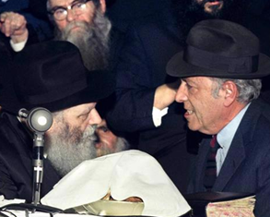

Herman Wouk drew deeply from his intense, decades-long relationship with the Rebbe, Rabbi Menachem M. Schneerson, of righteous memory, shown together here at a Chassidic gathering in 1975. (Photo: Velvel Schildkraut via The Living Archive/Jewish Educational Media)

Herman Wouk on His First Meeting with the Rebbe

Editor’s note: The late, great American novelist Herman Wouk, who passed away in 2019 at the age of 103, was widely acclaimed as one of the greatest American war novelists of all time. Through his novels, plays and historical works, Wouk not only introduced generations of readers to the history of the 20th century, but candidly invoked the moral choices facing humankind.
For decades Wouk turned to the Rebbe, Rabbi Menachem M. Schneerson, of righteous memory, for inspiration and guidance in his personal, communal and literary life. In private meetings and lengthy correspondences,
the Rebbe challenged and encouraged the author to utilize his pen and position for the good of the Jewish people and humanity at large.
When Wouk referred to his work in Jewish education as ‘modest acts’, the Rebbe rejected this appellation: “... [I]n wide segments … the impact of your ‘modest acts’ strikes deeper and wider than similar acts of a Rabbi or Rebbe (myself included) could attain, for obvious reasons.”
On the occasion of the Rebbe’s birthday in 1971, Wouk flew to London and delivered a speech at a benefit dinner held by the Lubavitch Foundation of the United Kingdom. When a reporter at the event assumed the popular novelist and playwright was fitting the talk in between engagements, Wouk clarified to him that he had flown in especially for the dinner and was flying back to Washington at its conclusion. What follows are recently discovered excerpts of Wouk’s speech that evening, which were contemporaneously published by the Lubavitch Foundation:
My grandfather was a Lubavitcher Chassid, the man to whom This Is My God is dedicated, and that is the real reason why I accepted this invitation and left my desk to cross an ocean to speak to you—to a group that I have never met before … .
Exactly a week ago tonight, I went to see the Lubavitcher Rebbe. I had never met the Rebbe before. I met his predecessor, who blessed me before I went out to serve in the Second World War. But I had not had the privilege of meeting his successor, though I had read many of his writings, of course.
The Rebbe spoke to me for about one and a quarter hours. I want to try to tell you something about him because, make no mistake, his presence fills this room and any room where Lubavitch activity goes forward. This is a man who is a spiritual center of a world-wide movement.
It has been my fortune through my work to meet great men. I have met ministers of state, and I have spoken at length to heads of state—and Rabbi Schneerson, the Lubavitcher Rebbe, is one of the most striking and impressive men that I have ever met.
You go into this small building, 770 Eastern Parkway in Brooklyn. I flew there from Washington and flew back again the same night. You are ushered into a small book-lined room. It is not a room for business. It is a study, and there he sits behind his large desk with a large clock ticking away as though to emphasize the extraordinary preciousness of his time, but he waves you to a chair with a regal yet simple gesture, and with a relaxation that indicates he has all the time in the world for you.
The first impression you have when you look at this man’s face, is one of personality of extraordinary intensity. He wears a black hat that you see on the heads of some of the members of the movement here, but it has a broad brim and the light falls only partly on his face so that his face, with intense close-set eyes and a beard going grey, gives him a presence of stern and extraordinary gravity, and a sense, too, that here is a man who carries the weight of a world—if not of the world—on his soul.
This is a feeling that never quite leaves you all the time you speak to him, though he speaks simply, clearly, and even humorously.
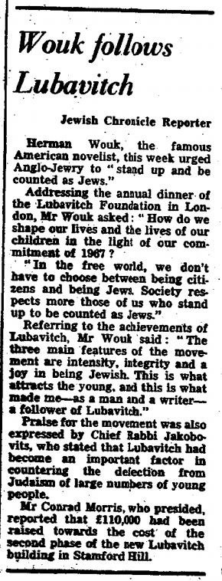
Jan. 22, 1971, London Jewish Chronicle report on Herman Wouk's talk at the Lubavitch Foundation's benefit dinner.
At one moment Rabbi Schneerson was talking about a point of Jewish Law that was ironic and amusing and he sat back in his chair and laughed. The light fell full on his face, and all the shadows vanished, and there was the pale, beautiful face of my grandfather—serene, at peace with the world and with G-d, and full of simple warmth and love. He leaned forward and returned to his subject and the black hollows on his face reappeared … .
. . I suggest that what we have to do now is to reach out our hands to each other and say: What can I learn from you? What can [we] learn from [each other]? How can you help? How can I help? And how can we go forward together?
In this grave crisis of our survival, and in this great intellectual and cultural crisis, we need light and chizuk—strength—from wherever it can come. Lubavitch has proved on the record with their education of the young, with their network of crusading religion and education all over the world, and with their encounters with each of us, that they have something to give.
The Jewish people and the Jewish destiny are my life. In my considered judgment, Lubavitch has made, is making, and will continue to make a substantial contribution to the coming renaissance and redemption of the Jewish people, and on that basis are entitled to your support.
That they can help each of us, as my grandfather once helped me, to find our way to that ladder that Moses built—Toras Moshe for the assimilated Jew—which he mounted first, and the rungs of which, with G-d’s help, we will all set our feet and rise.
When I think, when all is said and done, what I owe to Lubavitch—the inspiration that resulted in the writing of This Is My G-d; the impulse to personal religious living which has made my family life of continuous light, closeness and pleasure; and the outlook which has shaped my work and, for good and ill, made my novels different and peculiar to me.
When I think of all this, then it seems to me that these few halting words that I have spoken in praise of Lubavitch are a very little thing for me to have done, but that your inviting me here to speak these words is an honor—and for that honor, with all my heart, I thank you.
Note: As of this writing, Wouk’s speech from that evening in London has not been found in its entirety. A Jan. 22, 1971, report in London’s Jewish Chronicle (an image of which is included above), however, contains a few more quotes from that evening:
“In the free world, we don’t have to choose between being citizens and Jews,” Wouk urged the gathered. “Society respects more those of us who stand up to be counted as Jews.”

Then, in reference to Chabad-Lubavitch’s achievements and the reason for its success, he added:

“The three main features of the movement are intensity, integrity and a joy in being Jewish. This is what attracts the young, and this is what made me—as a man and a writer—a follower of Lubavitch.”

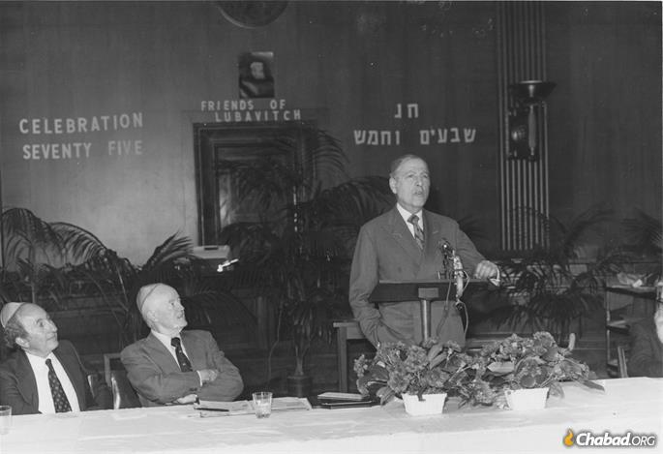
Herman Wouk addressing a Washington, D.C., audience during Celebration 75, which marked the Rebbe's 75th birthday in 1977. Former Vice President Hubert Humphrey looks on. (Photo: Lubavitch Foundation of Michigan/A Chassidishe Derher)
Reprinted from the Parshat Chukat 5781 email of Chabad.Org Magazine.
‘The Rabbi Said It Was OK’: Hasidic Mother of 10 Becomes Doctor
By Corey Kilgannon

An ultra-Orthodox mother navigated strict cultural norms to become one of the few Hasidic female doctors in the country.

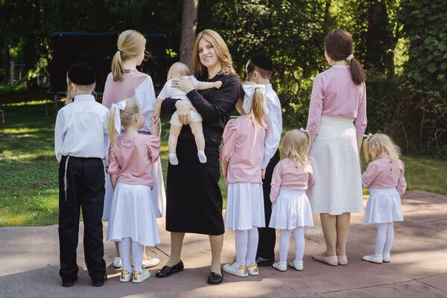
Alexandra Friedman, who graduated from medical school last month, with nine of her 10 children. She did not want their faces shown online for privacy reasons. Photo Credit by Sara Naomi Lewkowicz for The New York Times

Years ago, Alexandra Friedman saw a T-shirt bearing a message she never forgot: “Become the doctor your mother always wanted you to marry.”
It seemed like an impossible goal for a Hasidic woman in Monsey, N.Y., a predominantly Orthodox Jewish enclave some 30 minutes north of the city that is home to some of the strictest Orthodox communities.
Many women marry young, and their lives revolve around caring for children, speaking Yiddish and abiding by inflexible lifestyle and dress guidelines to adhere to Hasidic traditions.
She and her husband, Yosef, have 10 children, ranging in age from an 8-month-old son to a 21-year-old daughter.
But last month, she became an anomaly in Monsey by graduating from medical school and obtaining a residency in pediatrics. Dr. Friedman’s graduation makes her one of the few female Hasidic doctors in the country, said Dr. Miriam A. Knoll, president of the Jewish Orthodox Women’s Medical Association.

Unusual for Medical Students to Have Any Children
“It’s unusual for medical students to have any children, let alone 10 children,” Dr. Knoll said. “So to come from a conservative background and have that many children, you’re fighting an uphill battle, one that just takes extraordinary drive and commitment.”
When Dr. Friedman began thinking about medical school five years ago, even her best friends had doubts. One of them, a mother of 14 children, thought Dr. Friedman’s already busy schedule as a wife and mother would never allow her to handle the rigors of medical school. Another urged her to become a store cashier instead.
Dr. Friedman believed that pursuing medicine would augment her spirituality, not detract from it.
“In Judaism, there’s a belief that if you don’t use the gifts given to you by G-d, you’re not really honoring G-d,” she said in a recent interview.
Even while struggling with the arduous academic demands over the past four years, she met the domestic responsibilities expected of an ultra-Orthodox mother. She continued tending to her children and refrained from studying on Jewish holidays and on the Sabbath, each Friday evening through Saturday evening.

Even Gave Birth to Three Children During Her Studies
None of her obligations seemed to hurt her grades or keep her from graduating on time within four years, and she even gave birth during her studies to three children: her 8-month-old, Aharon; and her 3-year-old twin girls, Mimi and Layla.
She graduated first academically of the 135 students in her class at Touro College of Osteopathic Medicine in Middletown, N.Y.
Dr. Friedman was not always Hasidic. As the daughter of a U.S. Army general, she was part of a secular Jewish family that moved around the country a lot.
She considered herself a feminist — and still does — and earned a bachelor’s degree in biology. In her 20s, she began medical school but dropped out and developed an interest in Orthodox Judaism, following its strict guidelines and avoiding many distractions of the outside world.

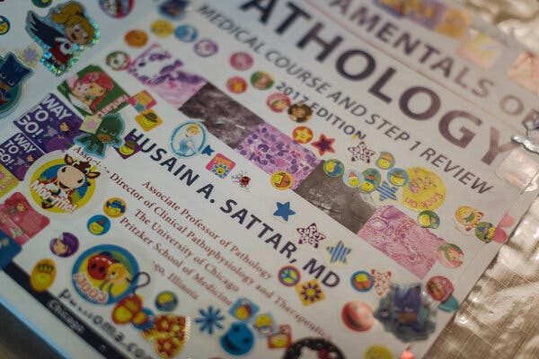
Dr. Friedman’s children adorned her anatomy and surgery textbooks with brightly colored stickers. Photo Credit by Sara Naomi Lewkowicz for The New York Times

She studied Yiddish and began wearing a wig and modest, full-length clothing. She stopped driving and having casual conversations with men or even looking them in the eye. Smartphones and the internet were off-limits.
In 2008, after she had moved to a Hasidic section of Crown Heights, Brooklyn, to study at a Hasidic seminary, she met Yosef Friedman, a widower with two daughters from his previous marriage. They married and eventually settled in Monsey.
After she had had several children, her mind turned back to her medical education.
“Being religious was kind of a full-time job, but once I got the hang of motherhood and Orthodox life, that yearning sort of came back,” said Dr. Friedman, who approached her religious mentor, Rabbi Aharon Kohn, and asked him in her still-imperfect Yiddish for guidance.
Both realized that medical school would be doubly challenging for a mother from Monsey. The Hasidim in Monsey largely handle judicial issues among themselves, shop at Jewish stores and send their children to religious schools.
Also, there would inevitably be clashes between academic requirements and Hasidic guidelines. Dr. Friedman would need to use the internet and interact with male students, teachers and doctors. What if emergency medical treatment lasted into Shabbos? And since Hasidic women are discouraged from driving, how would she even get there?

School’s Sensitivity to Orthodox
Students Impressed Her Rabbi
Touro’s sensitivity to Orthodox students, she said, made it “an easier sale” to the rabbi, who recounted a story about how his grandfather, also a rabbi, once urged a woman in Israel to become a midwife to help other Hasidic women.
He ultimately agreed, even after Dr. Friedman wondered if her friend was right about her becoming a cashier instead.
“He said absolutely not — he wanted me to be of service to my community,” said Dr. Friedman, who interviewed for admission to medical school four days after giving birth to the couple’s seventh child.
Dr. Friedman’s new path raised eyebrows in her tightly knit Hasidic Jewish community.
“People would say, ‘What? You’re going to medical school?’ and I’d say, ‘The rabbi said it was OK,’” she recalled while sitting recently in her neat two-story home in a leafy section of Monsey.
She sat near shelves bearing a shofar and a menorah. Scattered on the floor were children’s toys. The family was packing for their upcoming move to Boca Raton, Fla., to begin her residency.

Began Getting Questions from Other Hasidic Females
As a medical student, Dr. Friedman began assuming a sorely needed role advising Hasidic female acquaintances who had limited information on medical issues but many questions — ranging from menstrual and infertility issues to how gynecological treatment comported with Jewish law and cultural guidelines regarding modesty.
“People became excited to have a woman who understands the community and understands medicine,” said Dr. Friedman. When Monsey became a coronavirus hot spot last year, she began fielding calls from friends seeking more updated information than Yiddish weekly newspapers provided.
“They felt comfortable asking me, ‘Is it getting better, getting worse?’” she said.
She urged friends early on to wear masks, and in recent months, as more calls have come in regarding vaccination for the virus, she has recommended getting the shots.
She and her husband both contracted the virus last year but experienced no serious symptoms, she said.
Mr. Friedman, 50, who makes minimum wage as an aide for patients with disabilities, said the family has lived paycheck to paycheck to afford medical school and relied on various scholarships. Student loan money sometimes helped pay the rent.

Husband Honored for Being a Supportive Spouse
“Every obstacle seems to get blown out of the way,” said Mr. Friedman, who received a dean’s award from Touro for being a supportive spouse. “It makes me realize that this was just meant to be. This is what she’s meant to do.”
He began working nights in order to tend the children during the day.
Far from being a distraction, Dr. Friedman said her busy family life provided balance and stress relief from the tense demands of studying for boards and exams.
Instead of hitting the library with her fellow students, she studied at home with her children around her. They quizzed her with flash cards and adorned her anatomy and surgery textbooks with brightly colored stickers. They watched her practice her sutures before bedtime.
While in labor for 12 hours with her twin girls, she studied for the microbiology part of the board exam.
“It kept my mind off the contractions,” she said.
While the internet is often discouraged among the Hasidim as overexposure to the secular world, Dr. Friedman secured the rabbi’s permission to buy a laptop and get internet service installed to access medical information and study guides that fellow students shared on social media. She got a smartphone for college-required apps on surgical procedures.

Obtained Rabbinical Approval to Drive a Car
She also obtained rabbinical approval to drive the family car herself, but her husband continued to drive her out of their immediate neighborhood, then hop out and walk home, to avoid upsetting her Orthodox neighbors.
She continued to wear her wig during surgeries, but Rabbi Kohn agreed she could replace the traditional Hasidic head scarf with a surgical cap and wear scrub pants covered with a disposable surgical gown.
Shaking hands with male colleagues was still discouraged, but the rabbi agreed that accidental and necessary contact with male doctors during surgery was permissible, as was looking them in the eye during medical discussions.
When students began practicing osteopathic manipulations on one another in large classes, Dr. Friedman secured a female partner and wore full clothing instead of shorts and a sports bra like other female students.
Rabbi Moshe Krupka, executive vice president of the Touro College and University System, called Dr. Friedman a “poster child” for Touro’s emphasis on supporting particular needs of students from diverse backgrounds.
But Dr. Friedman’s biggest supporter was Rabbi Kohn.
Last June, he died from Covid-19 at age 69.
In September when her youngest child was born, Dr. Friedman honored the rabbi who encouraged her medical school dream by naming her son after him: Aharon.
“The last thing he told me,” she said, “was, ‘Don’t quit.’”

Corey Kilgannon is a Metro reporter covering news and human interest stories. He was also part of the team that won the 2009 Pulitzer Prize for Breaking News.

Reprinted from the June 24, 2021 website of The New York Times. A version of this article appears in print on June 27, 2021, Section MB, Page 1 of the New York edition with the headline: Hasidic Mother of 10 Has a New Role: Doctor.

‘Toyve the Black Cantor’
And His 1930 World Tour
By Henry Sapoznik

When celebrated African-American Yiddish soloist Thomas Larue crossed the Atlantic, he didn't know what was in store...

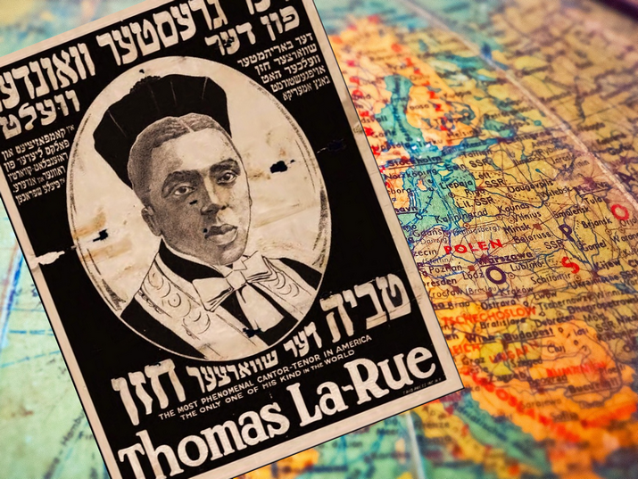
Billed as "The greatest wonder in the world", reactions to LaRue's appearances in Europe varied greatly (Poster image source: The YIVO Institute for Jewish Research)
Edvin Relkin the 50 year-old promoter of the provocative and attention-grabbing LaRue world tour, worked his way up from a childhood as a Yiddish theater candy butcher to become a leading director. The audacious tour idea seemed to offer unlimited possibilities with a heretofore untapped market: a European audience which had rarely even seen a Black person let alone one who spoke like a native Yiddishist.
After lining up two producers in Poland, Relkin, whom Variety dubbed “The East Side Yiddish showman”, lived up to that appellation and took what was already an eyebrow raising experience – an articulate and accomplished Black man who had mastered singing in Jewish languages and styles – and transformed it into a living musical diorama of Jewish history underscored by the chosen concert itinerary: Palestine, Egypt, Western and Eastern Europe.

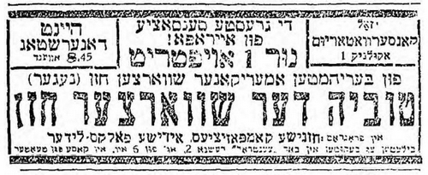

“The Greatest Sensation in Europe! Just one concert of the famous American Black Cantor (Negro) Toyvye the Black Cantor in a program of cantorial compositions and Yiddish folk songs.” Advertisement appearing in Haynt, 9 October, 1930. From the National Library of Israel Digital Collection
For the tour, Thomas LaRue was transformed into “Toyve Ha’Cohen,” the last part added for its implied “in-your-face” inference of his Jewish priestly lineage. Gone, too, was the story of the inner city child of a single mother who favored the company of Jews, now rebranded with a more colorful creation myth which toggled between: “…a Jew descended from generations of the Ten Lost Tribes in the city of Bet El Set between Abyssinia and Arabia,” (Republika Lodz, November 26, 1930) to his being “…a Shabtis, [a descendant of the followers of the 17th century false messiah, Shabbtai Zvi] with a father who was a healer and made herbal elixirs as did Toyve himself in New York” (Dos Naye Lebn, Bilaystock, October 24, 1930).
In the November 21st edition of Unzer Grodner Express, Ha’Cohen’s father was “…named Petrosi, a very cultured man who was a high official in local Abyssinian government, while his mother Alia, died when he was young.” And in order to explain (however improbably) LaRue’s New Jersey residence, Unzer Grodner Moment Express on November 21 noted that his father “…wanted him to be a fully realized Jew, so he was sent to study with a Russian rabbi in Newark.”
After the initial announcement in the June 1928 issue of Variety, the tour was finally ready to begin.
On September 19, 1930 several Polish Yiddish papers ran the following story:
“Cairo (Jewish Telegraphic Agency) En route to Europe, a concert was given here by the Black Cantor from New York where he is known as ‘Toyve the Black Cantor.’ The Black cantor’s program of cantorial hymns and Yiddish folk songs elicited great interest and his large audiences had many non-Jews.”

Warsaw
The tour’s first European stop was Warsaw, the jewel in the crown of cantorial cities, given its world-renowned synagogues. Warsaw Jewish audiences were tough. Their enthusiastic devotion to cantorial singing split the difference between being about spiritual or esthetic uplift and being an aggressive blood sport.

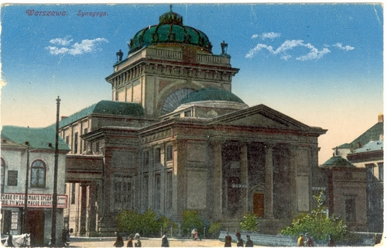
The Great Synagogue of Warsaw, early 20th century. From the Joseph and Margit Hoffman Judaica Postcard Collection; available via the National Library of Israel Digital Collection

It was the latter which LaRue would experience at his premier.
In an unsigned October 10 Unzer Express concert review, the author makes clear at the outset (and at the close too, for good measure) that Eddie Rankin’s Polish partners were two “shady characters” who had earlier produced a disastrous cantorial concert leaving angry attendees demanding refunds, with the promoters nowhere to be found. This, then, was the Warsaw community (and Unzer Express) declaring war on the impresarios via the Toyve concert.
Knowing that they had previously been conned by the “shady characters,” everyone figured that the “Black Cantor” was a scam, too.
When LaRue stepped onto the stage, Conservatory Hall was largely empty but for some comped guests, a handful of intrepid curious and the ubiquitous confrontational hecklers in the gallery (at one point, they derisively called out “Sing ‘Sonny Boy!'” referring to the Al Jolson hit of the previous season).

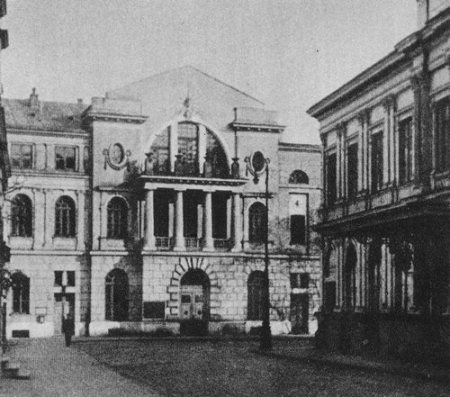
Warsaw Conservatory, early 20th century (Public Domain)

And, despite LaRue not being the primary target of the boycott, the collateral damage he experienced was decisive, resulting in a truncated 50 minute concert with what little audience there was streaming out. It was capped off with a corrosive poison pen hit-piece in Unzer Express chastising LaRue for his stage mannerisms, his cantorial singing being influenced by 78 rpms, and even his Jewishness.
On the Unzer Express humor page, opposite the scathing review, a cartoon (which may appear offensive by today’s standards) continues to jab at the producers accused of booking someone who doesn’t even know how to read from a prayerbook:
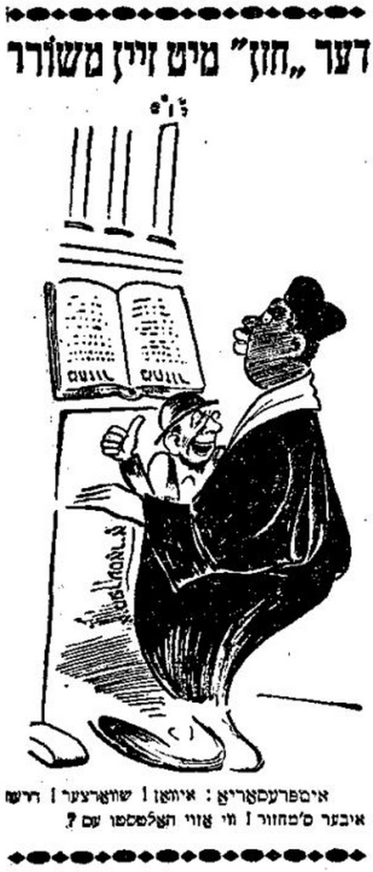

“The ‘Cantor’ With His Apprentice. Impresario: Ivan! [shorthand name for a Gentile] Black Man! Turn the prayerbook right-side up. How are you holding it?” Published in the Unzer Express, 10 October 1930. From the National Library of Israel Digital Collection

Bialystock
“Toyvele, the Black cantor demonstrated here that the defamation he faced in the pages of a well-known Warsaw newspaper was completely without merit.”
So ran the lead line in the October 29 review of LaRue’s Bialystock concert. The paper, Dos Naye Leben (The New Life) had been fans of LaRue’s since 1921 when they re-ran an ecstatic review from New York’s Morgn Zhurnal about LaRue in “Yente Telebende.”
The paper rolled out the red carpet for LaRue giving him three features including an October 24 sit down with their editor:
“…he is a genial young man of not just looks but his speech makes it seem as if the waters of the Jewish Diaspora have cascaded down upon him…”
The writer also deflated the charge in the Warsaw paper about LaRue’s reliance on commercial sound recordings by deftly acknowledging it:
“True, his cantorial prayers sound as if he learned them off phonograph records and lack the burning immediacy of traditional cantorial improvisation, but the same can be said for a hundred percent of modern cantors even those who are currently practicing.”
And finally, a stellar October 29th concert review:
“...the audience gave him several standing ovations not allowing him to go on with the rest of the concert…. He is an unrivaled master worthy of the kind of praise heaped upon opera singers. In bestowing sincerity, honesty and artistic heart in each of his songs, you experience his true artistry.”

Grodno
After appearing in Grodno on October 25th, then traveling to Leipzig and Berlin at the beginning of November, Larue returned to Grodno towards the end of the month amid a flurry of intense local interest, with Unzer Grodner Express (Our Grodno Express) reporting on November 20:
” …the Black cantor arrives here direct from Berlin where his concerts in their largest concert hall generated such a colossal response that he had to increase to 12 his scheduled three concerts… The Berlin music critics were effusive in their praise of the Black cantor in the Berliner Tageblatt, Vossische Zeitung, Morgen Post and many others. Reviewers were captivated by the concerts so it would stand to reason that in Grodno – where we know a thing or two about cantors – his imminent arrival has generated so much interest.”

The Tour Ends
Following a performance in Lodz, LaRue would end his European tour where it started in Warsaw, as a guest of the Polish state radio in a concert of cantorial songs, thus having the last word in the city which gave his European tour its terrible start.
There would be a small European coda when LaRue returned to Europe the following year. An Associated Press dispatch in the April 13, 1931 New York Times noted that Toyve Ha’Cohen had just sung at the Hungarian Academy of Music in Budapest. Curiously, there appear to be no mentions of LaRue in the New York Times for any of his local New York performances.

Performed at the Brooklyn Parkway Theater
In 1936, LaRue’s old employers, Jacobs and Goldberg (for whom he did Dos Khupe Kleyd and Yente Telebende), brought him back to the theater in the drama Di Falshe Tokhter (The False Daughter) at Brooklyn’s Parkway theater, having lost their Harlem Lenox Theater during The Depression. LaRue’s appearance – in a specially created “cabaret” scene – not only made it into the Yiddish press, but was also carried in the October 10th edition of the African-American newspaper The Amsterdam News.
One preview notice for a 1936 New Year’s eve concert and dinner dance at a synagogue in East Orange, New Jersey reveals the kind of complicated dynamic between LaRue and the communities he served. Atypically, LaRue is not singing cantorial and Yiddish music, but leading something called “The Bumble Bees Radio Broadcast Orchestra” and, in a reprise of an appearance at their last New Year party, organized and MC’d a minstrel show replete with “coon shouters” (blues singers).

Last Appearance in 1953 Hannukah Concert
The last known LaRue appearance is for a December 1953 Hanukah concert in his native Newark.
LaRue remains a cypher, occasionally visible in articles and display ads in period newspapers as a performer but also naggingly invisible there, too as a man.
LaRue inhabited a curious niche within the Jewish community, an uneasy mix of being apart from and a part of it.
Did he marry? Did he have children? Did he attend a synagogue when not performing synagogue music? What did he do between the ever-decreasing Jewish concerts? For that matter, was he even Jewish?
The kind of music culture in which LaRue had invested himself would, in the outwash of the Holocaust, go into a freefall with post-War Jewish audiences for whom the old time florid soloistic cantorial style gave way to milder “congregational singing,” while Yiddish, a major Jewish language and its attendant culture would decline after a majority of its speakers were murdered and its fecund old world communities destroyed.
Thomas LaRue’s final resting place was recently discovered in Linden, New Jersey, yet it is tragic that when he passed away, he certainly may not have been honored in the traditional way, which would have greatly resonated: to the strains of “El Mole Rachamim,” the prayer for the dead, a cornerstone intonation in the traditional cantorial repertoire, and something with which LaRue would have been intimately familiar.

—
A version of this article appeared on Henry Sapoznik’s Research Blog. It appears here as part of Gesher L’Europa, the National Library of Israel’s initiative to connect with people, institutions and communities across Europe and beyond, through storytelling, knowledge sharing and community engagement.

Reprinted from the July 1, 2021 email of the National Library of Israel.

Conservative Female Rabbi Crosses Lines and
Becomes Orthodox
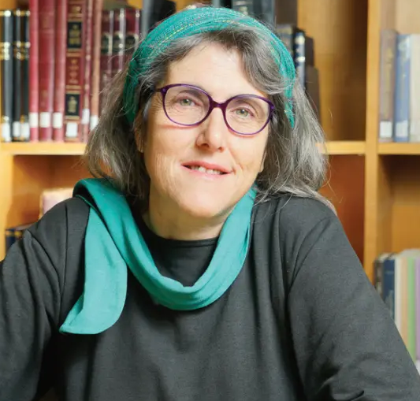

Einat Ramon was the first Conservative rabbah to be ordained in Israel, and a dean of the Conservative Jewry’s rabbinical college who had ordained many rabbis and rabbahs for the movement. She headed many religious battles mostly against the haredim during the 1990’s.
In an open article that was publicized this week, she explains why she crossed the lines and now affiliates herself with Orthodoxy:“Ironically — that’s how it looks from the passage of years — it turned out that I was looking for Judaism, a deep connection with the Creator of the universe, and a community that studies and prays, but the political battles sideswiped me from the important to the trivial.

Becoming a Mother was a Seminal
Event that Changed Her Priorities
Ramon points to becoming a mother as the seminal event that had the greatest impact on her and changed her priorities. But she attributes the ideological revolution she underwent to the shrinking of Conservative Jewry from a third of all Jews in the U.S. to only 18% today — and among the youths, only 10%.
“One of the Conservative rabbis in Israel told me that while for every person who leaves the Orthodox world, many become religious, in the Conservative world we don’t see a similar phenomenon. The feeling among many of our leaders in Israel and abroad is that the Conservative moment is losing the battle in the diaspora in the face of the post-modern world, which is pulling the carpet under those who want to maintain clear boundaries of Jewish law.”
She warns that the same can happen to “Orthodox-lite”: “Those who want to prevent the disappearance of modern Orthodox must be aware of the crises that has begun in the secular, Reform and Conservative world. Clear boundaries must be made on fundamental topics of Jewish law — which the other movements have failed to do. Modern Orthodoxy should be careful to see the Torah world in a positive light and not nullify it because of “western enlightenment” which had and still has plenty of flaws.

A Strong Orthodoxy Set Boundaries
Against Destructive Immoral Forces
“It appears that in our generation, without the secular rebellion against Orthodoxy, the Jewish people wouldn’t have been able to pick themselves up from the ruins and set up the State of Israel. But without a strong Orthodoxy, which sets up boundaries against the destructive immoral forces in the world both from the west and the east, while wisely drawing Jews back to their Jewish essence without compromising on Torah principles, we would be unable to keep the Jewish people in existence in general and Israeli society in particular.
Talking about “partitions” in shul between men and women, she says: “Particularly in our times, when aggressive forces are demanding the total nullification of any differences between men and women, the partition is more important than ever.”
She says about the subversive Women of the Kotel group: “Leave the women’s section at the Kotel alone to the women who come to pray every day…”
Ramon rejects the so-called haredi takeover of the Kotel and the imposition of a partition which many claim did not exist during the Mandate. “The women during the period of the Mandate who prayed at the Kotel were clothed from head to toe and most congregated at one corner. The reason there was no partition was because of the British oppression of the Jews and the collaboration of the British police and Muslims who see the Kotel until today as a holy place for Muslims.
“The fact that the District Court intervened and violated the delicate balance at the Kotel is particularly astonishing and displays a lack of respect to Jewish tradition and its leaders. I doubt an Italian court would tell the Pope how to run the prayer arrangements in the Vatican.”

Reprinted from the website of Hidabroot.com

How Fleischmann’s Yeast Built the Jewish Catskills
By Joel Haber, JTA
Two Hungarian brothers brought compressed yeast to the US - and propelled their company to the forefront of the industry.

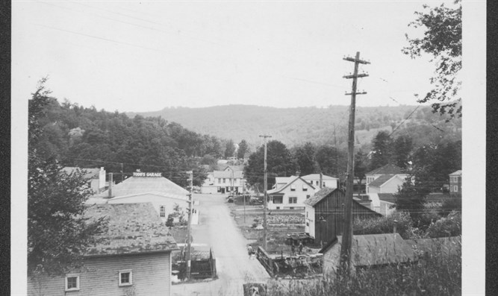
Fleischmanns, Catskill Mountains, Delaware County, July 1925.
The New York Historical Society via Getty Image

Many home cooks this past year, in an Instagram-inspired spirit, upped their challah-baking game with new braiding patterns, interesting flavors and vibrant colors. Yet it was a more standard ingredient that unwittingly connected many to their roots.
If you used Fleischmann’s yeast for your challah, you leavened your dough with the essence of American Jewry.
The Fleischmann family’s story echoes the experience of many other immigrant Jews: They built on their experience from Europe, using it to fully integrate into American society. Without routines to hinder them, innovative business practices brought them success. Finally, they used their power to benefit their community.
Hungarian brothers Charles and Max Fleischmann were part of the mid-19th-century wave of Central European Jews arriving in America. They settled in Cincinnati, where they became yeast manufacturers in 1868. Charles had learned the process in Prague and Vienna, eventually overseeing production on a noble’s estate. The origin tale of Charles bringing a single vial of pure yeast to America is likely fabrication, but he probably did see America’s poor-quality baked goods as a business opportunity.

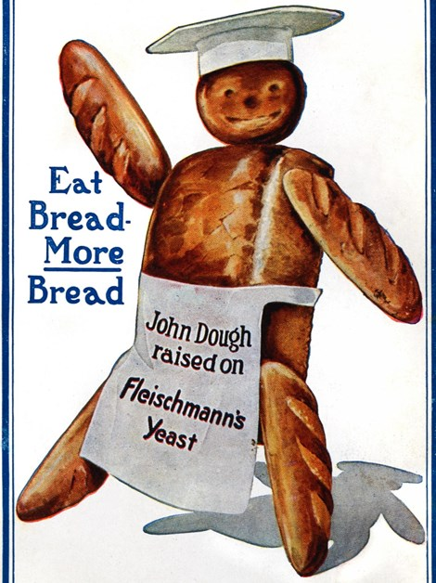
Fleischmann's Yeast Advertisement, 1915 Chris Hellier_Corbis/Getty Images

Soon, the Fleischmanns were mass producing pressed cakes of yeast. Many claim theirs was the first commercially produced version of this product. But while Charles did hold some production patents in America, the main steps were invented decades earlier in Vienna. His genius lay not in inventing a new product, but in its clever distribution and marketing techniques.
The compressed yeast could only survive a few days, so reaching customers quickly became essential.
Cincinnati was a hub of transportation routes, and Fleischmann’s also built a network of production and distribution centers in order to reach most of the country. Delivery improved in the 1880s with the invention of refrigerated railcars.
With supply taken care of, however, demand for the unfamiliar product lagged. Fleischmann’s had to familiarize America with compressed yeast. Unfettered by preconceptions on “proper” business practices, Fleischmann’s Yeast found out of the box solutions.

Participating in the 1876 Centennial
Exhibition in Philadelphia
Their first major marketing coup was at the 1876 Centennial Exhibition in Philadelphia, where they featured a Vienna Model Bakery to demonstrate their product. The fair attracted 10 million visitors, many of whom stopped to sample the delicious bread. Soon compressed yeast became the preeminent solution for home bakers.
Another early marketing effort featured a promotional cookbook giveaway. Fleischmann’s followed others in using this fairly new medium, continuing well into the 20th century. The company also offered wrapper premiums — customers could trade in yeast package labels for free kitchen utensils.
But Fleischmann’s most significant contribution to consumer marketing was in what we now call branding. From the start, Charles Fleischmann guarded the company’s name and image, zealously warning his customers against cheap imitators. Fleischmann’s branding was so successful that by the late 1920s they controlled over 93% of their market.

Expanding their Product Line
Fleischmann’s also paralleled other Jewish immigrants via their expanding product line. In the 2012 book “Jews and Booze,” Marni Davis highlights the disproportional representation of immigrant Jews within American alcohol businesses in the late 19th century. Within just a few years of starting the company, Fleischmann’s added distilled spirits to their offerings, using the grain alcohol that was a major byproduct of yeast production. Adding juniper berries and other botanicals, they produced America’s first distilled gin, with other hard liquors soon to follow.
While this all ties the family into the American Jewish experience, their greatest related legacy is also their least recognized. The late 1800s saw prominent anti-Semitic discrimination aimed at wealthy American Jews. More than once, the Fleischmanns were denied entry at fancy hotels and resorts.
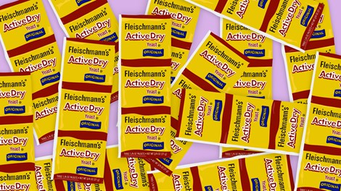
Fleischmann's yeast Grace Yagel
Fleischmann's Yeast Advertisement, 1915 Chris Hellier_Corbis/Getty Images

Charles Fleischmann used his amassed fortune to beat the anti-Semites at their own game. Purchasing 60 acres in Griffin’s Corner, New York, he created a resort village specifically for Jews. Eventually incorporated as Fleischmanns, New York, the town grew to include mansions, summer homes and hotels (many with kosher food to accommodate Orthodox customers).

No Budget-Level Bungalow Colony
Fleischmanns was no budget-level bungalow colony, either. The luxurious features included heated swimming pools, a golf course, a deer park, a stocked trout pond and an artificial lake from which they could harvest ice in the winter. This famous resort town launched a classic 20th-century Jewish phenomenon: vacationing in the Catskill Mountains, the so-called Borscht Belt that is indelibly linked with American Jewish popular culture.
Without Charles Fleischmann’s pre-immigration experiences in Europe, he might not have started his company, and with deeper roots in the country, he might never have broken new ground to reach success. His family story prominently reflects that of broader American Jewry.
Although Fleischmann’s is no longer a family owned company, there may be no more appropriate ingredient to put in your challah than Fleischmann’s yeast. And for an extra dose of Jewish pride, have a Fleischmann’s gin and tonic after kneading the dough.

Reprinted from a July 7, 2021 dispatch of the JTA (Jewish Telegraphic Agency.) This article originally appeared on The Nosher.
Biden Bows Down to Chareidi Mother Of 12, Rivlin’s Chief Of Staff

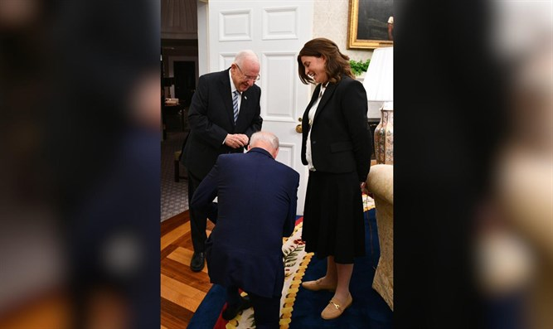President Joe Biden bows down in tribute to Rivka Ravitz, the mother of 12 children. (Photo: Chaim Tzach/GPO)

In an amusing incident that occurred while President Reuven Rivlin was visiting the United States, President Joe Biden kneeled down in tribute when he heard that Rivlin’s chief of staff, Rivka Ravitz, is the mother of 12 children. The story made the front page of Yediot Achranot on Friday.
When Rivlin introduced Ravitz to Biden during his recent visit, he said: “She’s a very religious woman, she has 12 children.”
Biden’s reaction shocked everyone in the room – he bent down on his knee and told Ravitz: “I have a picture of my mother here, you have to see who she was!”
Ravitz has been working for Rivlin for almost 23 years, accompanying him during his career as a Likud MK and party chairman, communications minister, Knesset speaker, and finally as his chief of staff during his term as president for the past seven years. She accompanied Rivlin on all his trips overseas, has met three presidents, the pope and many other important figures and makes a Kiddush Hashem by refraining from shaking the hands of any of them.

Biden shows Ravitz a picture of his mother. (Photo: Chaim Tzach/GPO)

She is married to Yitzchak Ravitz, currently the mayor of Telzstone, and the son of the late Avraham Ravitz, z’l, who served as an MK for Degel HaTorah. In fact, Avraham Ravitz was the one who recommended his daughter-in-law as an employee when Rivlin was seeking someone 23 years ago.

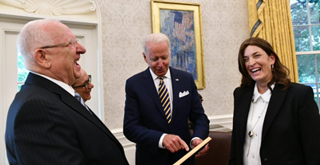
Biden shows Ravitz a picture of his mother. (Photo: Chaim Tzach/GPO)

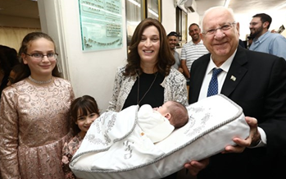
Ravitz with Rivlin at the bris of her 12th child. (Photo: Shlomi Cohen)
A Dialogue Between Israeli Generals and Vietnamese General Nguyen Giap

In the mid-1990’s, as the first Palestininian Intifada was kicking into high gear and terrorist attacks were on the rise almost daily, two IDF major generals were coming to the end of their long and storied military careers.
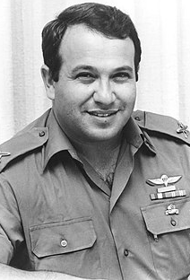
General Meir Dagan

General Meir Dagan had led everything from commando squads to armored brigades and would later go on to serve as director of the famous
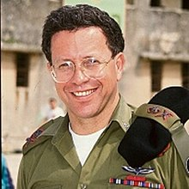
General Yossi Ben Hanan - 1994

Israeli spy agency, the Mossad. General Yossi Ben Hanan, after serving as one of Israel’s most successful tank commanders in the 1973 Yom Kippur war, would go on to lead the armored corps and the IDF’s vaunted Research & Development arm - though he is most famous for the 1967 Life magazine cover photo of his 22-year-old self-standing in the waters of the Suez Canal, a symbol of Israeli vitality and military success.

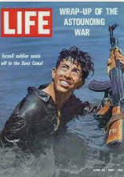
Future General Yossi Ben Hanan on the cover of the 1967 LIFE
Magazine whose feature story was on that year’s Israeli Six-Day War Victory

By the mid-1990s, the two grizzled veterans, newly released from their military duties, planned to travel together to Vietnam.
Many Israelis travel to the Far East for a number of reasons, vacationing being only one of them. In this case, both generals were avid students of military history, including the Vietnam conflict.
They applied for visas and made a special request to the Vietnamese authorities: to meet General Vo Nguyen Giap. Nguyen Giap was one of the great strategic minds of the twentieth century, a former schoolteacher who played a central role in developing the strategic thinking and organizational capabilities that transformed ragtag rural provincials into a military force that would rout the most powerful nations in the world, from the Japanese occupation to the French and the Americans over three long decades of conflict culminating in the end of the Vietnam War in 1975.
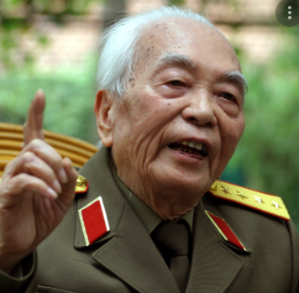
Vietnamest General Nguyan Giap

Giap was also a ruthless and often tyrannical leader, murdering opponents of Vietnam’s communist movement and overseeing a guerrilla war that sacrificed hundreds of thousands of his own fighters to the cause. He was no hero to the Israelis, but he nevertheless cut a fascinating figure in the annals of modern warfare.
Unexpectedly, the request was approved. Giap agreed to meet them. When the Israelis arrived in Vietnam, they sat down with the man who by then had spent decades as his country’s defense minister. It was a long meeting.
They discussed various aspects of military strategy and the great Israeli generals put their military prowess up against the Vietnamese legend. For hours, they spoke and suddenly Giap indicated that it was time to leave. When the Israelis rose to leave, Giap unexpectedly turned to the Palestinian issue.
“Listen,” he said, “the Palestinians are always coming here and saying to me, ‘You expelled the French and the Americans. How do we expel the Jews?’” This was a new twist. The Palestinians were asking Giap for advice on how to rid the land they consider Palestine, of the Jewish people and the State of Israel.
The generals were intrigued. “And what do you tell them?” they asked. “I tell them,”
Giap replied, as he walked away from the group, “that the French went back to France and the Americans went back to America. But the Jews have nowhere to go. So in that case, the Palestinians will never expel them.”

Reprinted from the Parshas Matos-Masei 5781 email of Rabbi Dovid Hoffman’s
Torah Tavlin.

Sad Story of an Iconic Photo

Future General Yossi Ben Hanan on the cover of the 1967 LIFE
Magazine whose feature story was on that year’s Israeli Six-Day War Victory
Photo by the late Paul Schutzer who was killed on the first day of the Six-Day War
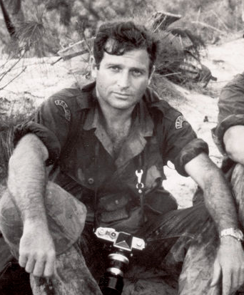
Paul Schutzer (1930-1967)
As a child he considered becoming a painter or a lawyer, following his father and brothers, but at 22, Paul Schutzer (1930-1967) yielded to his childhood love of photography. He entered the professional ranks as an errand boy and shipping clerk for the Freelance Photographers Guild, and managed to secure a few assignments.
Schutzer was only 26 when he joined the LIFE staff. He had a knack for taking pictures of powerful people—Eisenhower, Nixon, Kennedy—and yet he said, “It’s the quiet things that happen around us every day that are the really important things. A good camera story need not be dramatic, but it must be entertaining and a personal adventure for the viewer.”
That’s certainly so, but Schutzer never shied from dangerous subjects; in fact, one colleague said he had “almost too much courage.” Schutzer was killed on assignment for LIFE covering the first day of the Six-Day War when an Israeli half-track in which he was riding was struck by a 57mm shell.
—Adapted from The Great LIFE Photographers

American Soldiers in Vietnam
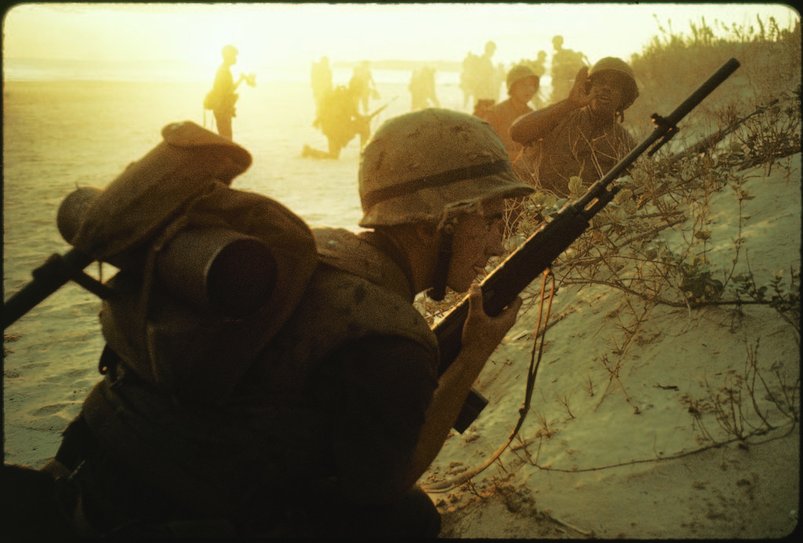
American soldiers of 7th Marines landing on the beaches of Cape Batangan during the Vietnam War. (Photo by Paul Schutzer/The LIFE Picture Collection)

Onboard with the
Freedom Riders

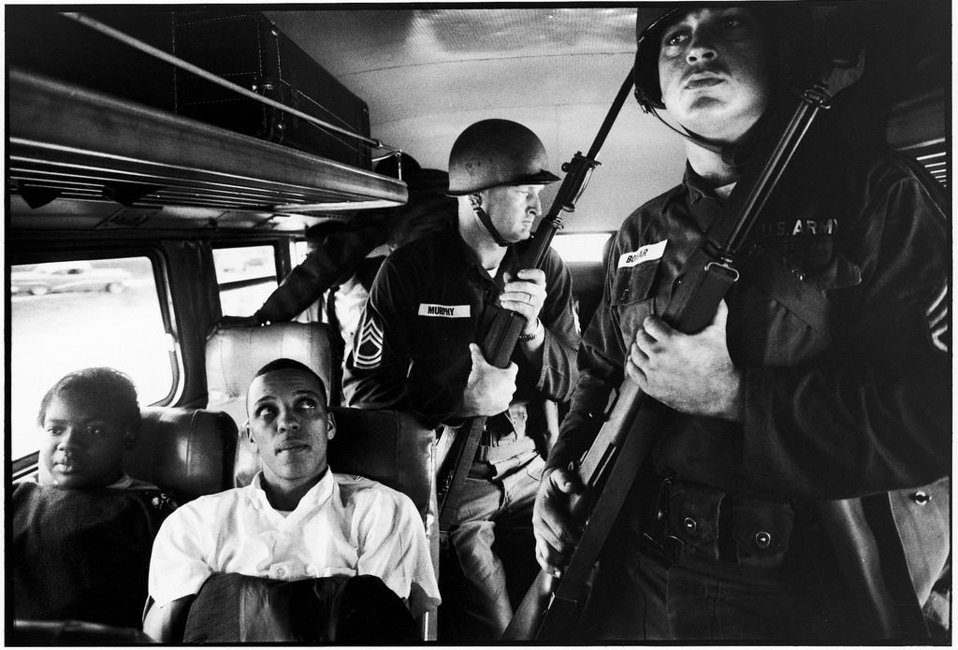

Freedom Riders Julia Aaron & David Dennis sitting on board interstate bus as they are escorted by two Mississippi National Guardsmen holding bayonets, on way from Montgomery, Alabama to Jackson, Mississippi. (Photo by Paul Schutzer/The LIFE Picture Collection)

Ilan Ramon, Israel’s
1st Astronaut, and
The Meaning of Life
By Nati Gabbay

Long before he became the first Israeli to be launched into space, Ilan Ramon, as a 23-year-old fighter pilot, asked Prof. Yeshayahu Leibowitz: “What is man’s purpose in this world?” Leibowitz did his best to answer.

Distinguished Professor,
I have long struggled with many strange questions that can perhaps be gathered under the heading: What is man’s purpose in this world? And the more questions that are asked, the greater the contradictions and ambiguities.
I am a young man—23 years old. I turn to you—an older person with such rich knowledge and experience, whose opinion is so important to me—I turn to you and ask:
How do you see the world we live in?
How do you explain the essence of life?
How do you view man’s purpose and goal in life?
And how is a man to achieve this purpose?
And you, honorable Professor, looking back, do you think that you have achieved the goals or purpose placed before you?
Dear Professor, I know how limited your time is and [that it is] devoted to important matters, and yet I would be very grateful if you could address my questions and perhaps enlighten me on life’s dark path.

With respect,
Ilan Ramon

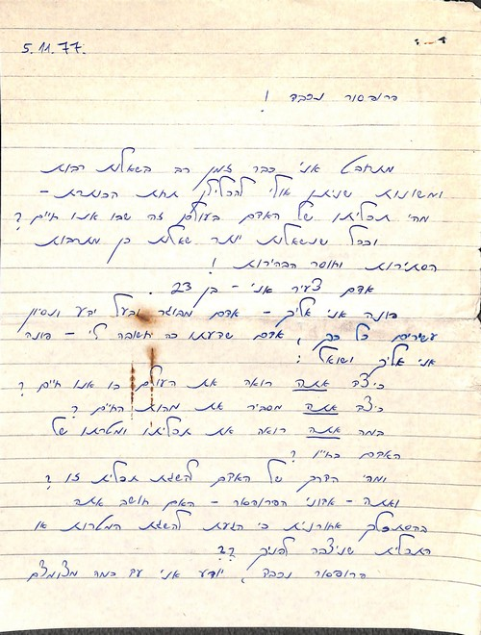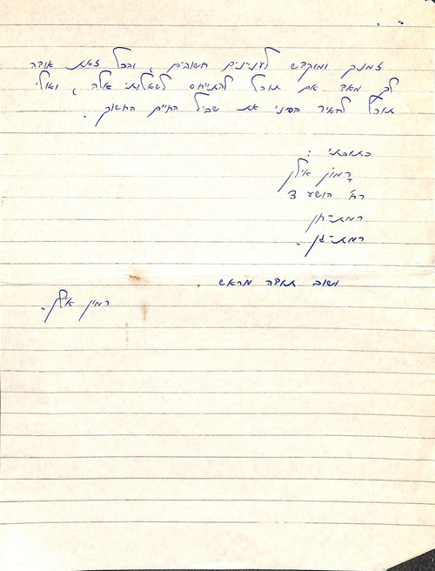
Ilan Ramon’s Hebrew letter to Prof. Yeshayahu Leibowitz, the Yeshayahu Leibowitz Archive, the National Library of Israel

***
The young Israeli Air Force pilot Ilan Ramon sent the above letter to Professor Yeshayahu Leibowitz in 1977.
Five days later, Leibowitz sent his reply:
Dear Ilan Ramon,
Your question “How do you see the world we live in?” is not clear to me. What does “see the world” mean? Do you mean cosmologically, physically, metaphysically or…?
In your question, “How do you explain the essence of life?”—I do not know what you mean by the words “essence of life.” Do you mean biological, psychological, historical or…?

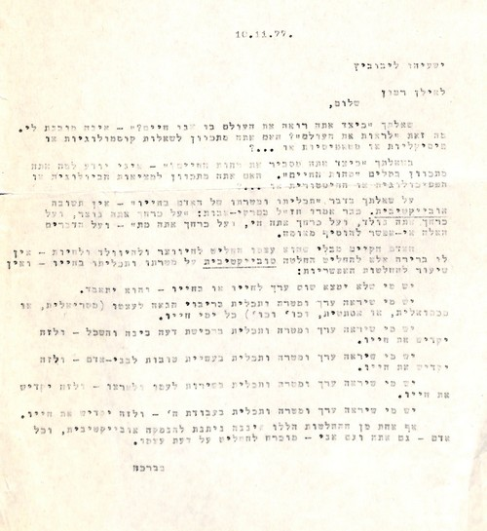
Leibowitz responds to Ilan Ramon.
The Yeshayahu Leibowitz Archive, the National Library of Israel

Regarding your question about “man’s purpose and goal in life”—there is no objective answer. In Pirkei Avot the sages say: “Against your will you were created, and against your will you were born, and against your will you live, and against your will you die”—and to these words, there is nothing more to add.
Man exists without having decided to be created or to be born or to live—he has no choice but to make a subjective decision about his goal and purpose in life—and there are countless possible decisions:
There are those who will find their own life to have no value, nor will they find any value in anything within that life—and they will commit suicide.
There are those who will see value and purpose in maximizing pleasure for themselves (material or sexual, or aesthetic, and so forth) all the days of their life.
There are those who will see value and purpose in acquiring knowledge—and will dedicate their lives to this.
There are those who will see value and purpose in helping their fellow man—and will dedicate their lives to this.
There are those who will see value and purpose in the service of their people and country—and will dedicate their lives to this.
There are those who will see value and purpose in serving G-d—and will dedicate their lives to this.
None of these decisions can be objectively justified, and every person—you and I included—must make their own decision.

Very truly yours,
Yeshayahu Leibowitz

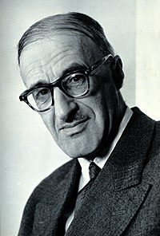
Professor Yeshayu Leibowitz

On January 16th, 2003, more than 25 years after writing the letter above, Colonel Ilan Ramon became the first Israeli to enter space, aboard NASA’s Space Shuttle Columbia. Ramon and the rest of the seven-person crew perished only a few days later, on February 1st of that year, when the Columbia disintegrated upon reentry into Earth’s atmosphere.

Reprinted from the June 20, 2021 email of the National Library of Israel.

Rabbi Yoel Kahn, 91, Oral Scribe
And Leading Disciple of the Rebbe
By the Chabad.Org Staff

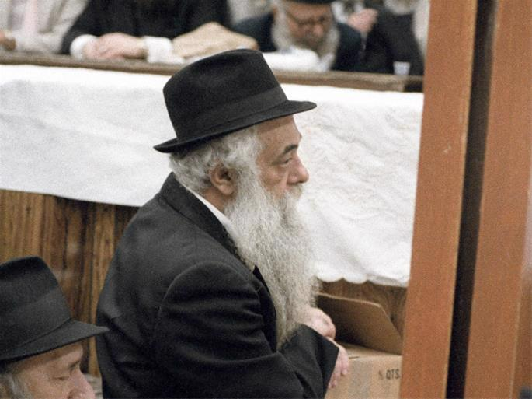
Rabbi Yoel HaKohen Kahn, known simply as Reb Yoel, was chief scribe of the Lubavitcher Rebbe, Rabbi Menachem M. Schneerson, of righteous memory, for over 40 years. Seen here in a familiar pose listening to the Rebbe teach at the farbrengen gathering of 12 Tammuz 1983. (Photo: Jewish Educational Media/The Living Archive)

Rabbi Yoel HaKohen Kahn, known to all simply as Reb Yoel, was a leading disciple of the Lubavitcher Rebbe, Rabbi Menachem M. Schneerson, of righteous memory, and his oral scribe. Blessed with unique intellectual gifts and a once-in-a-generation memory, Reb Yoel was single-mindedly dedicated to absorbing, recording and disseminating the Rebbe’s voluminous teachings for more than seven decades. He was a walking repository who could reach back decades into the past to instantly recall vast swaths of the Rebbe’s talks almost verbatim. Kahn passed away on Thursday, July 15 (6 Menachem Av) at the age of 91.
He had arrived in New York at a providential moment. When the Soviet-born rabbinical student set out from the port of Haifa, Israel, in February of 1950, he had intended to study in the glow of the Sixth Rebbe, Rabbi Yosef Y. Schneersohn, of righteous memory (1880-1950). By the time his ship docked at Ellis Island 12 days later, the revered master had passed away. Chassidim quickly recognized the Sixth Rebbe’s son-in-law, Rabbi Menachem M. Schneerson, as his successor as Rebbe. Within weeks Reb Yoel had begun transcribing the Rebbe’s oral talks and mailing them to Jewish communities across the world.
On the first anniversary of the Sixth Rebbe’s passing, the Rebbe finally agreed to take on his father-in-law’s role and become the seventh leader of Chabad, delivering his first Chassidic discourse that evening. While previously, Chassidim would have received a written version of the discourse in the days after the farbrengen, with this new Rebbe nothing was forthcoming.
When Reb Yoel had a private audience with the Rebbe a week later, it became clear to him that the due to his already-then packed schedule of engagement with those seeking his advice and counsel from the wider Jewish world and even far beyond that, the Rebbe would not be providing written versions of his oral discourses.
Instead, the Rebbe expected the chozer (oral scribe) and his team to hand in notes that he would edit. This would be Reb Yoel’s lifelong calling. Over more than four decades he stood before the Rebbe and diligently memorized thousands upon thousands of hours of complex Torah teachings. Reb Yoel would also lead the singing during the Rebbe’s farbrengens and the oral repetition (chazara) that followed.
The Rebbe’s primary medium of teaching was the farbrengen, Chassidic gatherings held in his synagogue at 770 Eastern Parkway in Brooklyn, N.Y., during which the Rebbe would seamlessly move from discussions of Maimonides’ legal code, to the mystical depths of the Zohar, complex passages of Talmud, Chassidic philosophy and current events, all of it refracted through his unique prism of Torah synthesis.
There were less than a handful of occasions when Reb Yoel wasn’t on hand to memorize these talks. Early on, one Shavuot holiday, the Rebbe arrived unexpectedly to deliver a surprise discourse at daybreak, waiting for Reb Yoel to arrive before beginning. To ensure that never happened again, the next year Reb Yoel was ready and waiting at his usual place when the Rebbe arrived.
Reb Yoel was also a master educator, with an exceptional ability to clarify even the most abstruse, esoteric and abstract of Chabad teachings, and make them accessible to anyone willing to exert a little effort to concentrate their mind and make themselves receptive. Through his fluent elucidations, notions that ordinarily remain in the realm of transcendent faith were seamlessly translated into clear cut logical arguments that proceeded step by sure-step into irrefutable conclusions.

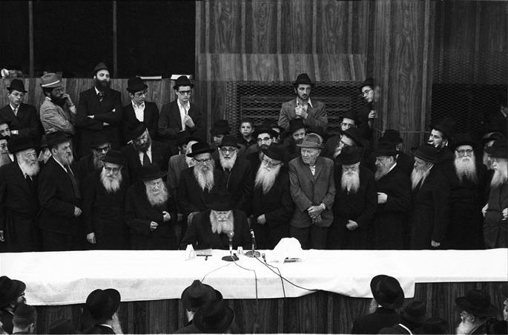
The Rebbe delivers a Chassidic discourse on Sept. 4, 1975. Reb Yoel, whose hat can be seen directly in front of the Rebbe, would listen, memorize, absorb and then transcribe the discourse, which he would then hand in to the Rebbe for editing. (Photo: Jewish Educational Media/The Living Archive)

Humble and unassuming, he nevertheless spoke with measured authority, punctuated by bursts of sharp wit and twinkling humor. His hat tilted back on his head above his broad forehead, his long and bushy beard in chronic disarray, and a cigarette perpetually between his fingers (in later years he would swap the cigarette for a perpetual glass of tea), he was a compelling teacher who left an indelible mark on the many generations of students who studied under his tutelage from the mid-1950s right up to the last years of his life.

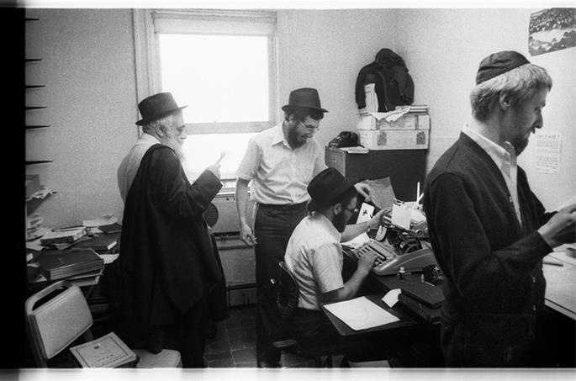
Reb Yoel (left, circa 1979) guided generations of young scholars in the arts of memorization, repetition and transcription. (Photo: Jewish Educational Media/The Living Archive)

As chief chozer, Reb Yoel also guided generations of young scholars in the arts of memorization, repetition and transcription, and it is important to to note that many of the Rebbe’s talks were delivered on Shabbat and Festivals, when electronic recordings cannot be used.
Under Reb Yoel's watchful eye, these teams of scholars would commit the Rebbe’s teachings to writing in multiple languages and formats. Though the Rebbe did not usually write on his own, he poured countless hours into the editing process. At times, the Rebbe edited so heavily that it would have been easier for him to have written it on his own in the first place, but through this process he was teaching Reb Yoel and the team of chozrim how to organize the free-flowing oral word into clear, concise and compelling prose.
One of the most characteristic features of the Rebbe’s interpretive approach is the combination of sweeping breadth with meticulous attention to detail, and Reb Yoel honed a writing style whose rigorous and incisive precision deftly marshalled the array of references, questions, interventions, elaborations and clarifications into tightly argued and accessible essays.
He would spend countless hours, day and nights, laboring to draft and redraft, edit and re-edit, until he deemed a piece ready to be submitted to the Rebbe for review. Over the decades, Reb Yoel’s careful work produced Likkutei Sichot, the 39 volume set of the Rebbe’s edited talks; the six-volume Maamarim Melukatim containing the Rebbe’s edited discourses and the as of yet unfinished Torat Menachem, numbering 118 volumes at the moment, which presents Hebrew renditions of the Rebbe’s farbrengens in their complete and unedited form.

A Leading Editor of Chassidic Encyclopedia
Possessed of an extraordinary capacity for the organization of wide ranging and complex fields of knowledge, Reb Yoel was tasked by the Rebbe to lead the compilation of Sefer Ha’Arachim, a scholarly encyclopedia of Chassidic concepts, the ninth volume of which was released in 2019, and upon which Reb Yoel continued working until his last days.
This project was so immense that these nine volumes only cover a fraction of the entries that begin with the first letter of the Hebrew alphabet, aleph. The published corpus of Chabad chassidic texts comprises several thousand volumes of extremely intricate and varied material, including such diverse areas as philosophy, hermeneutics, ethics, cosmology, psychology and kabbalah. T
he ideas are not presented systematically or topically, but associatively, with each new rebbe engaging the teachings of his forebears and building expansive new layers of explanation upon them. A single idea is often engaged in hundreds of different textual iterations, and each provides rich and nuanced perspective that is not replicated elsewhere.
The task of parsing this thick web of interwoven teachings, and organizing them into a set of alphabetically organized articles, would actually have been impossible even for Reb Yoel, had the Rebbe himself not laid the groundwork for him through his own meticulous compilation of indexes to the Chabad corpus in the 1940s and 50s. Moreover, the Rebbe also provided the particular conceptual framework through which all these diverse details could be seen as refractions of a single whole.
On this basis, and with the Rebbe’s constant encouragement, Reb Yoel took on this epic intellectual undertaking. The first volume of Sefer Ha’Arachim was published in 1970, with a special treatise penned by the Rebbe himself included as an appendix. It’s title translates as “On the Essence of Chassidus,” and it sets out the Rebbe’s vision of Chassidus as the revelation of the essence that transcends all particulars and inheres at the core of every single element of existence.

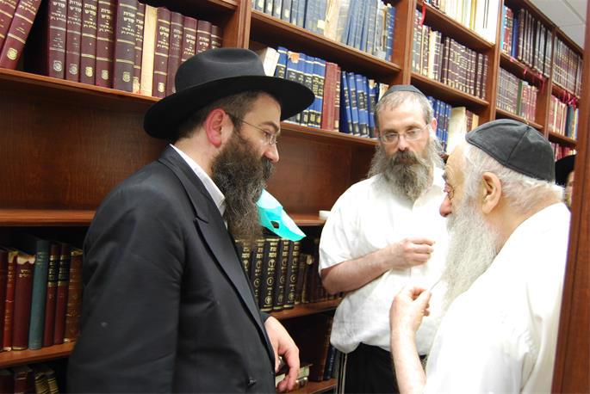
Reb Yoel (right), seen here with Rabbi Dovid Feldman (center) and Rabbi Chaim Shaul Brook of Lahak, would continue mentoring and leading the process of bringing the Rebbe's teachings to the world until the end of his life. (Photo: Lahak)

In his position as mentor at the Central Lubavitch Yeshiva he continued teaching and guiding young rabbinical students not only academically, but even more importantly, in the vibrant practice of the Chassidic path in life. Due to his lifelong engagement with the Rebbe’s teachings, his insight and scholarship were sought by rabbis and leaders from across the Jewish world, and when—in his later years—he traveled to the Holy Land, he was warmly welcomed by revered Chassidic rebbes and sagacious heads of yeshivas.

A Lifetime of Dedication and Service
Yoel Kahn was born in Moscow, the Soviet Union, on 16 Shevat, 5790 (1930) to Refoel Nachman ("Folleh") and Rivkah Kahn, members of the underground network of Chabad Chassidim who bravely fought to bolster Jewish life and observance behind the Iron Curtain. For the first three years of his life, he never saw his father, who had been imprisoned by the Soviets for counter-revolutionary activities and the crime of maintaining a connection with the Sixth Rebbe.
Reb Folleh Kahn, a prolific writer, would later recall his Soviet prison experience in the Hebrew-language Behind the Iron Curtain. Among his other works, books read and referenced to this day, are Lubavitch V’Chayaleha, which tells the stories of the graduates of the original Tomchei Temimim Yeshivah in the village of Lubavitch, and Shmuos V’Sippurim, recording Chassidic stories going back generations and the author’s own recollections from his time in Lubavitch before World War I.
In 1935 the family managed to leave Russia for Poland, at one point traveling through Austria. There, at the Purkersdorf sanatorium, a young Yoel met the Sixth Rebbe’s son-in-law for the first time, as well as his father-in-law, the Sixth Rebbe. Later, as they waited on the platform in the Vienna train station, they were surprised to see the future Rebbe arriving to see them off. Memorably, he distributed chocolate to Reb Yoel and his siblings. From Europe the family headed to Mandatory Palestine, where Yoel was enrolled in the fledgling Chabad yeshivah in Tel Aviv, which was then led by Rabbi Chaim Shaul Bruk.
A brilliant prodigy with an aptitude for in-depth study, he plumbed the depth of Torah scholarship. His study partners included Rabbi Shlomo Berman, who later became a head of the Ponovezh yeshivah in Bnei Brak.
After arriving in New York and learning of the passing of the Sixth Rebbe, Reb Yoel immediately formed a bond with his successor, the Rebbe, and began to thirstily drink in his words. Yoel’s letters home to his parents from that period chronicle the awe, respect, and admiration that he and his peers felt toward the new Rebbe and the high hopes that his leadership heralded for Chabad, the Jewish people, and the world.
In 1954, Reb Yoel married Leah Butman, and the couple settled in the Crown Heights neighborhood, where he served in the position of mashpia (Chassidic mentor), serving as both teacher and personal guide to young students, introducing them to the beauty and depth of Chassidic thought. In time, he became the primary mashpia of the Central Chabad Yeshivah. For yeshivah students and scholars from outside of the Chabad world, he was often the first port of call, a wise and erudite guide to the complex spiritual world of Chabad Chassidism.
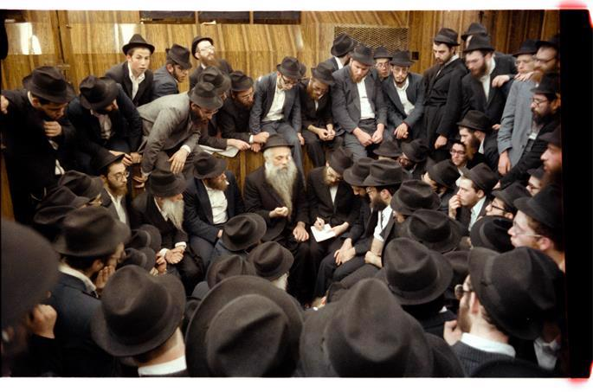
Chazarah, or repetition, following the Rebbe's farbrengen on Sept. 23, 1979. Reb Yoel is in the center, elucidating a point, while to the right, taking notes, is Rabbi Dovid Feldman, today chief editor of Lahak. Chazarah took place in the synagogue and was open to everyone. (Photo: Jewish Educational Media/The Living Archive)

Following the Rebbe’s passing in 1994, he served as a bastion of authentic Chassidic wisdom and an elder statesman, rooted in the teachings of the Rebbe, from whom he never parted.
Reb Yoel Kahn is survived by his wife, Leah Kahn, and deeply mourned by hundreds of thousands of his students and those whose lives have been enriched by the teachings he conveyed.

Reprinted from the July 15, 2021 email of Chabad.Org Magazine.
Montreal's Days of Shame:
By Dr. Yvette Alt Miller

When 75 Doctors Went on Strike
Until a Jewish Doctor Resigned

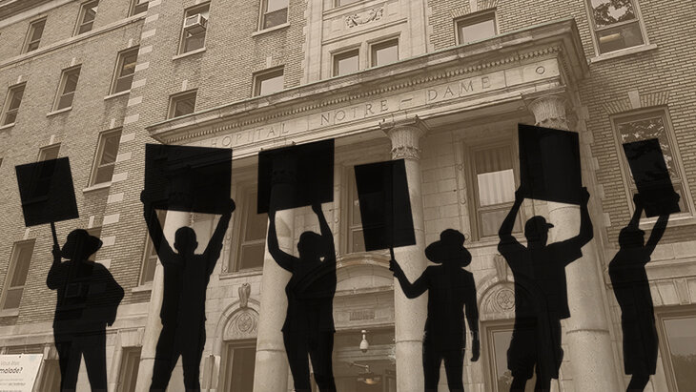
In 1934, doctors in five hospitals walked off the job rather than work with a Jew.

In the 1930s, the calls to boycott Jewish businesses and stop hiring Jews rang out. The location of these odious messages wasn't Nazi Europe; it was in Montreal, Canada. Anti-Jewish feeling was running so high that when a Montreal hospital hired a Jewish intern, it triggered mass walk-outs by doctors at hospitals
across the city. This little-remembered boycott shook Jewish communities across Quebec and deserves to be known about today.
In the 1920s and 1930s reactionary nationalist feelings were running high in the French-speaking Canadian province of Quebec. “Many Quebecois viewed Quebec as the surviving remnant of the French Roman Catholic ancien regime that had been ended by the French Revolution,” explains Dr. Edward C. Halperin, who researched the 1934 doctors’ strike.

Catholic Schools Inculcated a Fear of Non-French Catholics
Before 1963, there was no option for receiving a secular public education in the province (all schools were either Catholic or Protestant), and the region’s highly religious Roman Catholic schools inculcated a fear and dislike of non-French Catholics.
“Children in Quebec’s Roman Catholic schools received an education emphasizing royalist and religious values. Jews, Asian persons, and Black persons were viewed as undesirable immigrants and economic competitors.”

Jews Blamed for the Poor Economy
Amid the economic misery of the Great Depression, some of Canada’s most influential leaders blamed Jews for the poor economy. Jewish stores were boycotted in Ottawa. In Quebec an Achat chez or Achat chez nous - “Buy from Home” movement quickly turned into an anti-Jewish tool, urging French Canadians to boycott Jewish businesses.

Father Grouix Stirred Up Hatred Against the Jews in Quebec
Quebec nationalist leader Father Lionel Grouix stirred up hatred of Jews among Quebecois. In a 1933 article, he urged readers to heed his solution to “the Jewish Problem” by boycotting Jewish businesses. “Do not buy from the Jews…” he ranted. This and similar calls to refuse to do business with Jews were repeated in other French-Canadian newspapers as well.
“While ‘Achat chez nous’ does not in its title specifically target Jews,” notes Prof. Ira Robinson, Professor of Judaic Studies at Concordia University in Montreal, “its spokesmen were clear enough.

Urged to Fight Only Against
One Race - the Jews
Though in theory the campaign could be directed at anyone who was not French and Catholic, (French businessman) Henri Leroux in 1926 wrote that the organization must ‘fight against only one foreign race, the Jews.’ Another Quebec cleric assured an audience in Vancouver that 'Achat chez nous’ was not directed at English Canadians but solely at Jews.”
Canadian poet Irving Layton recalled his childhood growing up Jewish in Montreal in the 1920s being marred by the ever-present threat of violence directed at him because he was a Jew.

Clashes Around Easter time
“The strongest memory I have is of clashes. Around Easter...something seemed to happen to the gentiles. They took it as a cue to come and beat up on the Jews. So, without fail, every Easter, they would descend on the embattled Jews with bottles and bricks…” (Quoted in A History of Antisemitism in Canada by Ira Robinson. Wilfrid Laurier University Press: 2015.)

Jewish Doctors in Montreal
While Jewish businesspeople and professionals were subject to boycotts in Quebec, Jewish students were also subject to quotas, not only in Quebec but throughout Canada and the United States. Universities and medical schools strictly limited the number Jews who were admitted.
For Jewish medical students, life in Montreal in the 1930s was particularly challenging. Home to two medical schools - the English language McGill University and French-language Universite de Montreal - the region only had a limited number of opportunities for would-be Jewish doctors to study and train.
In the early 1930s, between 11% and 15% of McGill’s medical students and 6% of Universite de Montreal were Jews. Dr. Edward C. Halperin notes that the anti-Jewish feeling was fierce. In 1933, students from Universite de Montreal “marched in the streets, angrily shouting anti-Jewish slogans. Tear gas was required to disperse the crowd.”

The Top Graduate was a Jew
Despite this hatred, the top of the Universite de Montreal’s graduating medical class in 1934 was a Jew, Dr. Samuel Rabinovitch. Four of his brothers were already doctors. Dr. Rabinovitch was offered internships in St. Louis and New York, but he wished to stay closer to home.
He applied for an internship with the Hopital Notre-Dame, one of Montreal’s major teaching hospitals, despite the fact that no Jews had ever before been hired as interns there.
In February 1934, the hospital reviewed applications for new interns for the coming academic year. They filled nearly all their openings with French Canadian applicants, but still had one open spot that they couldn’t fill, and offered it to the star medical student Dr. Rabinovitch, who accepted the position.
He became the first Jew to be hired as a staff physician at a French-Canadian hospital. This was to provoke a storm of outrage that threatened to shut down hospitals across Montreal.
“We do not want him because he is a Jew.”

Hospital Immediately Faced Bitter Criticism for Hiring Jewish Doctor
The Hopital Notre-Dame faced criticism immediately. Letters poured in from the public, demanding that a “foreigner” or a Jew should not “replace” a Catholic intern. French-Canadian medical students submitted a petition to the hospital demanding that they fire Dr. Rabinovitch. “We do not want him because he is a Jew,” their petition read.
The incoming class of interns warned that if the hospital did not fire Dr. Rabinovitch, they would walk off the job in June when their internships officially began. In the face of increasing outrage, the Hopital Notre-Dame refused to back down.

Hospital was Loyal in
Supporting Dr. Rabinovitch
“The hospital administration was wonderful to me,” Dr. Rabinovitch later recalled.
As the days ticked down to the June 15th deadline the French-Canadian interns refused to budge. If Dr. Rabinovitch was allowed to start his internship, all the other interns at the hospital would walk out. At midnight on June 14, 1934, the interns walked out of the hospital and refused to see any patients, even those requiring urgent attention.

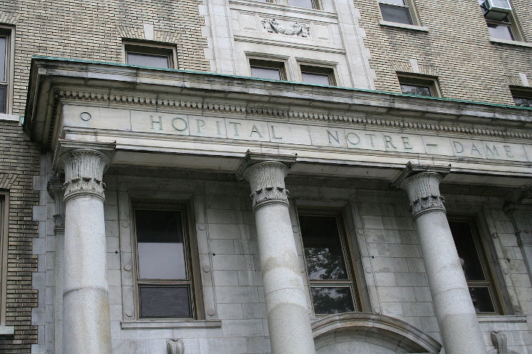
Hopital Notre-Dame in Montreal

Over the next two days, the interns of the Hopital Notre-Dame were joined by interns at four other hospitals across the city. Seventy-five doctors refused to work while Dr. Rabinovitch was one of their colleagues. Nurses in these hospitals threatened to strike too, demanding that Dr. Rabinovitch be fired.
Jewish leaders in Montreal worried that the strike would soon widen to include a full-scale boycott of Jewish businesses in the region. The hospital stood firm, refusing to give in to these outrageous demands, but the atmosphere in Montreal was darkening for the city’s Jews.
The French language newspaper Le Devoir covered the story, referring to Dr. Rabinovitch as “the foreign physician” and “the Jewish physician”. Dr. Rabinovitch was accused of being tied to “high finance,” in a not-so-subtle dig at the anti-Jewish stereotype that equates Jews with money and international finance.

Another Jewish Doctor
Becomes a Target
As the strike wore on, another Montreal Jewish doctor came into the antisemites’ crosshairs. Dr. Abram Stillman was doing a post-doctoral training in urology at the Hotel-Dieu hospital, where interns were also on strike protesting Dr. Rabinovitch.
A French nationalist group demanded that Dr. Stillman be fired from his post-doc and a “French Canadian (appointed) in his place” immediately.

A Luke-Warm Defense
Dr. Oscar Mercier was a famous urologist who was supervising Abram Stillman, but he refused to issue a full-throated defense of his Jewish student. Instead, Dr. Mercier reassured locals that Abram Stillman was “not taking the place of a French Canadian” and was “not occupying an official position” as a post-doc. Instead, Dr. Mercier hastened to explain, Dr. Stillman was “just...a visitor.” Abram Stillman was allowed to keep his post, but the lack of support that the Hotel-Dieu hospital extended to him was chilling. Over 75 Montreal interns continued their strike.

Non-Jewish Interns Refused
To Go Back to Work
With interns refusing to go to work, Dr. Rabinovitch and community physicians labored feverishly to see all the patients under their care. Across Montreal, patients went unseen as the interns continued their strike.
Behind the scene, representatives from Montreal's Jewish community met with administrators at city hospitals to try and mend the dire situation.

Tenders His Resignation
Finally, on June 18, three and a half days into the strike, Dr. Rabinovitch tendered his resignation. His resignation letter was printed in several of the city’s newspapers. “In view of the serious and dangerous conditions to which the patients of the Notre-Dame and other hospitals have been exposed...I feel it is my duty as a physician to tender my resignation as intern to your hospital,” he wrote.
“...I bemoan the fact that so many French-Canadian physicians, namely (new) graduates, should have ignored the first duty of their oath which they have so recently taken, and am glad of the fact that my resignation will make possible the immediate care that is so badly needed by those poor unfortunates who are today patients in the hospitals affected by the controversy.”
“I feel deeply grieved that the French interns have taken up a racial question where the care of the sick should be their first and only consideration and that they have completely disregarded the first duty of” medical care…
“The duty of a captain is not to abandon; the first duty of a soldier is not to desert his post; and the first duty of a physician is not to desert his patient…”
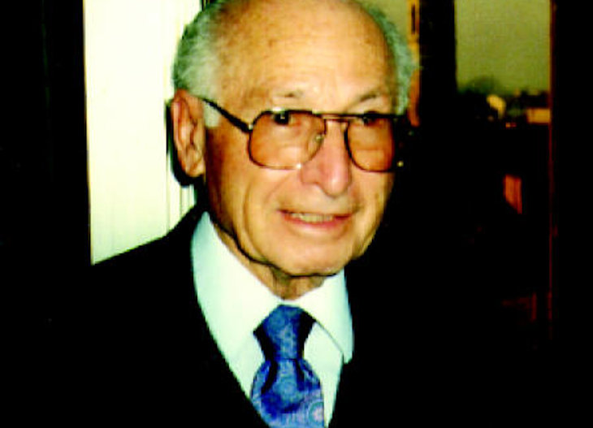
Dr. Sam Rabinovitch

Dr. Rabinovitch’s resignation letter also noted that he had no choice but to resign; the continued strike was delaying operations and putting patients’ lives at risk.
Even though the Hopital Notre-Dame had threatened to fire those interns who refused to work, they never levied any sanctions on them. Within hours of Dr. Rabinovitch’s resignation, Montreal’s interns were back at work, with no repercussions for their dangerous and prejudiced walk-out.
The Hopital Notre-Dame did help Dr. Rabinovitch to find a new position as an intern in St. Louis. Ironically, the hospital where he worked as an intern was a Catholic institution. He specialized in Internal Medicine.

Opening the Jewish General Hospital in Montreal
To some observers, the 1934 doctors’ strike became known as the “Days of Shame”. Later that year, the Jewish General Hospital opened in Montreal, offering Jewish physicians a world-class setting where they could train and hone their skills.
The Jewish General Hospital had been planned for many years, and was designed as a place to allow Jewish doctors to work in dignity, something that had clearly been lacking in Montreal.
The Jewish General Hospital championed what’s has been called “the first official non-discrimination policy in Canada: patients and employees of all cultures, languages and religions were welcome.”
The hospital continues to flourish today, offering medical care in the diverse Cote-des-Nieges neighborhood in Montreal, where it
continues to treat all patients, and still boasts some of the world’s leading medical researchers and physicians.

Jewish General Hospital in Montreal as it looks like today.

In 1940, Dr. Rabinovitch returned to Montreal and practiced medicine well into his 90s. In his old age, he was thought to be Canada’s oldest practicing physician.
After returning to Canada, he treated people from all faiths. “The patients cared more about my reputation for being a caring and honest doctor than they did about my religion,” he recalled.
Dr. Rabinovitch died in 2010 at the age of 101. Even after his long career, the memory of the 1934 strike remained vivid. “I bear no ill will toward anybody,” he later explained. “For the striking physicians, “it was just the case that I was Jewish and they were Catholics… I just did not belong. I suppose in the end that is the frightening thing about hatred...it is just that simple.”

Reprinted from the July 18, 2021 website of Aish.com
A Halachic Guide to
Tefilas Haderech
By Rabbi Dovid Heber

Rabbi Dovid Heber

During the past year and a half, STAR-K mashgichim continued to conduct inspections in the United States and abroad in a manner deemed safe for them and factory personnel. STAR-K is very thankful for their tremendous mesiras nefesh to ensure that our certified products maintained the highest level of kashrus, even in the midst of a worldwide pandemic.
Still, many consumers who frequently travel stayed home. With great siyata d’Shmaya, an effective vaccine was developed that has allowed us to resume our busy travel schedules and to once again recite Tefilas Haderech on a regular basis. Let us examine the halachos of this beautiful tefilla.[1]
The Tefilla
Tefilas Haderech is based on the Gemarain Brachos (29b-30a), with some minor variations, depending upon one’s nusach. The Gemara says it is recited in loshonrabim (plural; e.g., shetolicheinu, etc.).[2] When returning the same the day, the words v’sachzireinu l’shalom are added after l’chaim, ul’simcha, ul’shalom.[3]

The bracha is recited only once a day, even when traveling a long distance.[4] “Day” has the same guidelines as Birkas Hatorah: it begins after one wakes up in the morning and concludes when one goes to sleep. For instance, if someone drove 1300 miles from New York to Miami, leaving at 6:00 a.m. on Monday and arriving in Miami 20 hours later at 2:00 a.m. on Tuesday, he would recite Tefilas Haderech only once (i.e., upon leaving New York). The same is true if one left New York on Monday at 3:00 a.m.

Travelling from New York to San Diego
If one travels over the course of a few days, Tefilas Haderech is recited every day that one travels. For example, assume someone drove from New York to San Diego and booked a hotel room in two cities along the way, with the following itinerary:
Sunday: New York to St. Louis (overnight in a hotel in St. Louis)
Monday: Spend the day touring St. Louis (overnight in a hotel in St. Louis)
Tuesday: St. Louis to Albuquerque (overnight in a hotel in Albuquerque)
Wednesday: Albuquerque to San Diego (arrive at destination)
In this case, Tefilas Haderech was recited only on Sunday, Tuesday, and Wednesday, since those were the travel days. It was not recited on Monday, as there was no travel outside the city, nor on the days after reaching the destination in San Diego (i.e., Thursday and onward until he departs from there).[5] See below for when one should recite the tefilla on a multi-day journey.
What Distance Must be Traveled?
If one travels the distance of a parsa (2.8 miles) out of town, one should recite Tefilas Haderech. However, “town” does not mean the “city limits.” Rather, to be considered a long enough trip, the traveler must meet both of the following two conditions:

He must travel a parsa (2.8 miles) past an “open area” where there are no houses.[6]
He must leave the general metropolitan area of the city (ibura shel ir).
Besides long-distance trips (e.g., New York – Detroit), this would include shorter “out of town” trips, for example Lakewood – Monsey or Lakewood – New York, as these trips meet both of the above “trip” conditions.
The following are three examples when Tefilas Haderech is not recited.
One drove 35 miles from Yeshivah Shaar Hatorah in Queens to The Yeshivah of Staten Island. Since the trip, albeit lengthy, was entirely in the city of New York, Tefilas Haderech was not recited.
One drove 5 miles from Telshe Yeshivah in Chicago to Yeshivah Bais Medrash L’Torahin Skokie. Although Skokie is a different city, it is in the metropolitan area of Chicago, so this does not constitute a trip that requires Tefilas Haderech. Furthermore, the entire route includes a built-up area.
One drives 29 miles via the Hollywood Freeway (U.S. 101) from Yeshivah Gedolaof Los Angeles to Mesivta of Greater Los Angeles near Calabasas. Since it is built-up along the way with houses, Tefilas Haderech was not recited as the driver never left the metropolitan area.

At What Point in the Journey Is Tefilas Haderech Recited?
Once a trip is deemed long enough to require the recitation of Tefilas Haderech, one must determine the ideal place to recite it. The Mishnah Brurah states[7] that it should ideally be recited within the first parsa (2.8 miles) after leaving the ibura shel ir – that is to say, after traveling slightly more than 70 amos (42 yards) past the last house of the built-up area of the metropolitan region. The latest time to say Tefilas Haderech is before reaching within a parsa (2.8 miles) of the metropolitan area of one’s destination.
Typically, Tefilas Haderech is recited during a long stretch of highway with no houses on either side, or when crossing a bridge over a wide river (a stretch of road that obviously has no houses). For example, when traveling from Baltimore to New York or New Jersey on I-95, the ideal location is when crossing the bridge over Big Gunpowder Falls (mile marker 70.2, about 6 miles after getting on I-95 from the I-695 Beltway ), as that is the first area of the trip that is not built-up.
When traveling westbound on I-70 to Pittsburgh,[8] Cleveland, or beyond, recite Tefilas Haderech when crossing the Patapsco River Bridge shortly after exiting the beltway. When traveling south on I-95 to Richmond or beyond, recite Tefilas Haderech on the Patapsco River Bridge after I-195. When traveling to Ocean City, Maryland, recite Tefilas Haderech on I-97 after exit 10 as you cross the Severn Run.
If someone is traveling for a few days, Tefilas Haderech may be said in the hotel when preparing to leave, beginning with the second day of travel.[9] For example, on a trip from New York to Atlanta, Tefilas Haderech would be recited on the first day on the Outerbridge Crossing, or on the Goethals Bridge from Staten Island to New Jersey. If the person stayed in Baltimore overnight, Tefilas Haderech could be said either in the hotel when preparing to leave or when driving through Baltimore City as he begins the second leg of his trip.
If traveling by air, the accepted minhag is as follows:
If the airport is in town, one should ideally recite Tefilas Haderech on the runway shortly before takeoff. If one is concerned that he might forget, he may say it after the plane begins to taxi on the runway or even upon boarding the plane. B’dieved, if he forgot, he may also say it after takeoff.
If the airport is out of town, one may say it on the way to the airport after leaving the built-up area. This is true even if one would not recite Tefilas Haderech when just driving to the airport (i.e., going to that airport does not constitute a trip in and of itself).

Reciting Tefilas Haderech
Ideally one should recite Tefilas Haderech while standing up and stationary. However, since it is generally not safe to pull over to the shoulder (and certainly not to get out of the car on the shoulder of the road, unless it is an emergency), the accepted minhag is to recite Tefilas Haderech while driving.
Because Tefilas Haderech does not begin with ‘Baruch Ata Hashem’, there is a hiddur (stringency) to first recite a “long” bracha immediately prior to Tefilas Haderech. Examples of long brachos include ‘Mei’ein Shalosh’ and ‘Asher Yatzar’.[10] For instance, if someone ate dates and grapes at the beginning of the trip, at the time one is obligated to say Tefilas Haderech, one would first recite the bracha of ’Al Ha’eitz‘, thereby creating a bracha hasmucha l’chaverta, and then follow immediately[11] with Yehi Ratzon of Tefilas Haderech. But this is not mandatory.
When being motzi others in Tefilas Haderech,[12] one must meet all the conditions of “shomei’a k’ona”.[13] Furthermore, when traveling in a group (e.g., on a bus), if one person recites Tefilas Haderech to be motzi others, it may not be recited over a microphone. If those in the back of the bus cannot hear the person in the front reciting Tefilas Haderech, an additional person should be appointed to recite it from the middle of the bus for those in the back to properly hear it and be yotzei. If one is on a bus and hears someone reciting Tefilas Haderech over a microphone, he should repeat it for himself.
It is no coincidence that when discussing Tefilas Haderech, the Gemara reminds us to recite it b’loshon rabim (something that applies to all tefilos). The Gemarais reminding us that even when alone on a trip in the most isolated places, far away from our families and kehilos,we are indeed part of the heilige tzibur known as Klal Yisroel. Internalizing this reminder gives us the siyata d’Shmaya to bez”H stay safe – physically and spiritually – wherever we travel.

[1] These halachos are based on the psak of HaRav Moshe Heinemann, shlit”a, Rabbinic Administrator of STAR-K. For a full discussion of this topic, see Shulchan Aruch Orach Chaim (O.C.) and Mishna Brurah, siman 110. Two excellent contemporary seforim are Sefer Darchei Zmaneinu by Rabbi Moshe Finkel and Kuntres Tefilas Haderech by Rabbi Aron Stauber.
[2] Note, however, that the word v’sitneini is said by many in loshon yachid (singular, ending with “ni” instead of “nu”). See Mishnah Brurah 110:19.
[3] There is a machlokes Rishonim (differing opinions amongst the early commentaries) as to whether “v’sachzireinu l’shalom” (we should return peacefully) is always part of Tefilas Haderech. The Shulchan Aruch Harav in hisSiddurmakes “a compromise” by adding this only if “one’s intention is to return immediately”. The term “immediately” is understood to mean the same day. Many have adapted the minhag of this “p’shara” (compromise). If one forgot to add these words on the day he was traveling round trip, Tefilas Haderech should not be repeated later on the way home as, b’dieved, the regular Tefilas Haderech without v’sachzireinu covers the return trip if he traveled the same day.
[4] The exception to this is if one stopped with an intention to stay overnight, and then the person changed his mind. For example, someone drove from New York to Cleveland and checked into a hotel intending to leave for Chicago the next morning. After hearing the weather report of a blizzard the next day, the person changed his mind and decided to leave immediately for Chicago. Tefilas Haderech would be recited for a second time that day. See Shulchan Aruch O.C. 110:5.
[5] If after departing one continued traveling all night and then the next day, there is aquestion as to whether Tefilas Haderech is recited on the second day of the trip. For example, if one flew on Tuesday from Newark to London and then on Wednesday morning boarded a plane from London to Tel Aviv, should he say Tefilas Haderech again on Wednesday morning? Another example is three people drove 1800 miles from Lakewood to Denver, left at 11:00 a.m. on Tuesday, drove all night and arrived at 1:00 p.m. the next day. Should they say Tefilas Haderech again on Wednesday morning? In these cases, Rav Heinemann is of the opinion that Tefilas Haderech is not recited on the second day. However, in order to satisfy all opinions, one should ideally insert Tefilas Haderech into the bracha of Shma Koleinu during Shacharis Shemona Esrei on Wednesday morning.

[6] Warehouses, offices, and businesses would be considered part of the parsa [2.8 miles]of open area as no one lives at these locations.
[7] Siman 110 seif katan 29. The Shulchan Aruch (ibid. se’if 7) maintains that one should recite it when one is “hichzik baderech”, and the Rema (ibid.) explains this to mean within the first parsa(2.8 miles) of the trip. The Mishnah Berurah then states this does not mean within the first parsa of one’s home, but rather after leaving town. B’dieved, if one said it before leaving the city he is yotzei. See Mishnah Berurah 110:29.
[8] In this section, we give examples of travel to some popular destinations. Indeed, if one travels towards Pittsburgh to, Breezewood, for example, one would still recite Tefilas Haderech. If you are not sure if your trip is long enough to require Tefilas Haderech, consult your rav.
[9] See Mishnah Berurah 110:29.
[10] It is important not to “delay” the recitation of Asher Yatzar. If one used the restroom before departing, one should not “save” the Asher Yatzar for later in order to precede Tefilas Haderech.
[11] In this case, if being motzi others, do not say “birshus” between the bracha and Tefilas Haderech.
[12] There is a discussion as to whether a minyan is required to be motzi others in Tefilas Haderech. The custom is to be lenient and allow one person to be motzi another even with no minyan present.
[13] For example, the person reciting Tefilas Haderech must have daas (in mind) to be motzi others (his recitation allows others listening to fulfill their obligation) and those listening must have daas to be yotzei (have their obligation fulfilled). The person reciting must be on the same level of chiyuv (obligation) as the listener. Therefore, a child cannot be motzi a gadol (adult) in Tefilas Haderech. There are several other conditions (which also apply to Kiddush and other tefilos) that are beyond the scope of this discussion.

Reprinted from the Summer 5781 issue of Kashrus Kurrents, a publication of Star-K Kosher Certification.

100 Strangers Attend
Jewish Burial for Man
From Tiny Alaskan City
By Menachem Posner

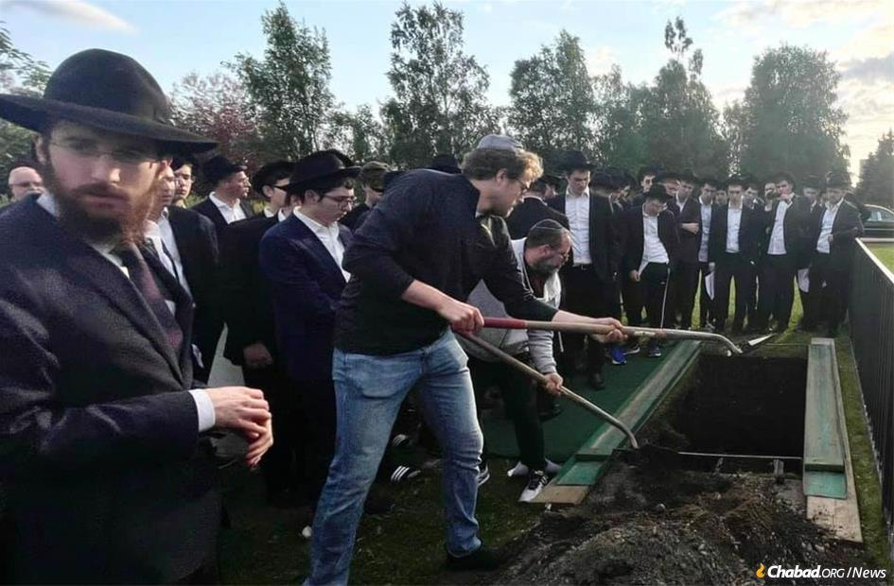
Rabbi Levi Glitsenstein, left, at the funeral of Jules Claven.

Jules Claven lived for decades in close proximity to bears, moose, caribou and sheep in the Alaskan town of Soldotna (population 4,000), but nowhere near a Jewish community.
In his 80th year and terminally ill, he called the Alaska Jewish Campus, which is listed on the Chabad.org directory, with a single wish: “I have three weeks left,” he told Rabbi Levi Glitsenstein, who picked up the phone. “I don’t have any family with me, and although I wasn’t so involved in the Jewish community, I really want to be buried with my people. Rabbi, can you help me?”
The rabbi promised Claven that he would do what he could to arrange a kosher burial.

Called the Rabbi Every Other Day
For the next three weeks, Claven would call the rabbi every other day. In the course of their conversations, Clavin shared his Hebrew name (Yosef ben Eliezer HaKohen) and memories of Jewish life in New England, where he accompanied his grandfather to synagogue services.
For a long time, Claven, a medical therapist, divided his time between Miami and Soldotna, but in recent years had made Alaska his home.
“Rabbi, will you make sure to come and take me?” he’d ask with concern. Only after Glitsenstein assured him that he would did the man hang up with a modicum of comfort.
With each phone call, his voice got quieter and weaker, but the question was the same.
Knowing that the end was near, the two had a video call together, during which the rabbi led his newfound acquaintance in saying the final confession on Chabad.org. Even though he had not lived among Jews or attended services for so long, Claven remembered the Shema prayer by heart in Hebrew.

His Final Wishes are Honored
On July 20, he passed away. As per his final wishes, his remains were brought to Anchorage, where the taharah was performed by members of the Seattle Chevra Kadisha (“Sacred Society”), who flew in for the funeral.
On July 22, about 100 Jews gathered at the Jewish section of Anchorage Memorial Park Cemetery to see him off on his final journey.
In addition to Chabad rabbis, the crowd included local community members, tourists and even the students of a traveling yeshivah camp.
Not one person in the crowd had ever met the deceased, but that didn’t matter. He was family, a fellow Jew.
“This special mitzvah of caring for and honoring the dead is referred to as chesed shel emet, ‘kindness of truth,’ ” says Glitsenstein. It is considered the ultimate altruistic kindness since the deceased is no longer able to express his appreciation. “In his name, I want to thank the members of our community who joined us and shared with me the inspiration they took for life from this story.”
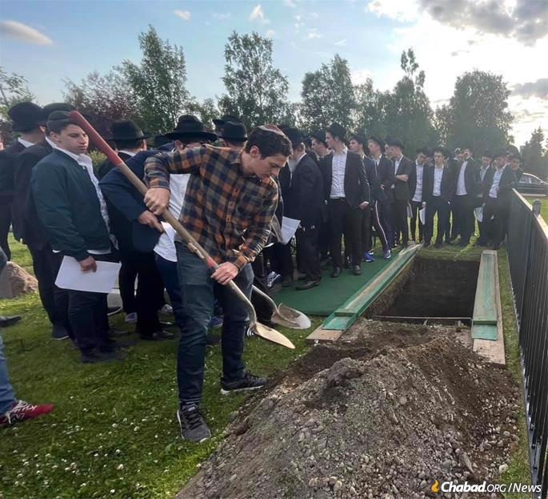
As per Claven's final wishes, his remains were brought to Anchorage, where the taharah was performed by members of the Seattle Chevra Kadisha, who had flown in for the funeral. About 100 Jews gathered at the Jewish section of Anchorage Memorial Park Cemetery to see him off on his final journey.

Reprinted from the July 26, 2021 dispatch of Chabad.Org News

Orthodox Athlete Missing
The Olympics
By Dr. Yvette Alt Miller

When Glenn Ackerman bought his daughter Estee her first table tennis set when she was 8, he couldn't even see her above the table. "All I could see was her paddle and she would hit the ball with unerring accuracy," Glen said in an exclusive Aish.com interview. It became obvious that Estee was exceptional at the sport. Each day after school, Estee would spend her evening practicing, improving her skills until she was a world-class player while still a child.
Soon, Estee Ackerman was the top ranked girl player in New York state, and one of the highest-ranking child players in the US. Her religious observance didn’t prevent her from thriving as a player. Her high school day lasted from 8am until 6pm, learning Jewish and general studies, and Estee would then spend hours practicing and honing her game. She played wearing a skirt and couldn’t share in meals in non-kosher restaurants with other players. Despite these minor differences, Estee always felt accepted by her fellow players.

In 2013 state table tennis officials invited her to play a fun match against Raphael Nadal, one of the greatest tennis players in the world. Estee was eleven years old at the time and beat the tennis champ. Since then, her skills and fame have only grown.
Estee tried out for the US Olympic Team in 2016, when she was 14. As an observant Jew she was at a disadvantage in the tryouts; athletes had three days to compete - Thursday, Friday, and Saturday. “The tryouts were single-elimination tournaments,” Glenn explains. Since Estee couldn’t play on Shabbat, she had only Thursday and Friday to prove her worth. Estee came in 14th. “I felt privileged to be part of the group trying out,” Estee recalls. “I was at a disadvantage but at the age of 14, I was proud to be at that level.” Glenn believes that Estee became the first Orthodox Jew to try out for a US Olympic team.
"I said to myself, this situation was going to happen to me one day," Estee told JTA for a 2016 profile. "I had to choose my religion or the love of the sport. On Shabbat, to be in my uniform, to go down to be competing in a national tournament, this is not the spirit of Shabbos. This is not what God would want me to do."
After 2016, Estee didn't give up on her Olympic dreams. The thought that she might try out for the 2020 US Olympic team sustained her as she continued to spend hours practicing her sport.

After graduating from high school in 2019, Estee went to Israel for a post high school gap year studying in Michlala Jerusalem College. She got in touch with Jerusalem’s table tennis clubs and is continuing her grueling practice schedule, practicing four days a week, in order to keep in shape for the US Olympic tryouts. She’s been playing for Jerusalem’s Hapoel table tennis team and helped them rise to first place in the country. “Her coaches think she’s one of the top ten players in Israel,” her father said.
In recent weeks, Estee’s Olympic dreams have been dashed. The 2020 Olympic Trials in table tennis are being held in Santa Monica February 27 through March 1, over Shabbat. In order to be considered for the team this time around, athletes will have to play all three days: Thursday, Friday and Saturday. When Estee applied to have an altered schedule and play all her games on Thursday and Friday, the answer was no.
“It’s definitely frustrating," Estee said. She understands that the people running the Olympic trials must have reasons for denying her request.

Even though her Olympic hopes lie in ruins, Estee is pleased she’s become an inspiration for other athletes and other Jews around the world. “I’ve received phone calls, emails, letters from people from all walks of life,” Estee said. "Jews from all different backgrounds have told me that they've been inspired to strengthen their Jewish observance and do more Torah learning."
“I’ve learned that you get repaid whenever you make a Kiddush Hashem (set a good example as a Jew). It can be five years in the future, or ten years, or in the World to Come. I hope to inspire others to stick with their dreams and shoot for the stars. And keep being Jewish your number one priority.”

Reprinted from the February 19, 2020 post on Aish.com\

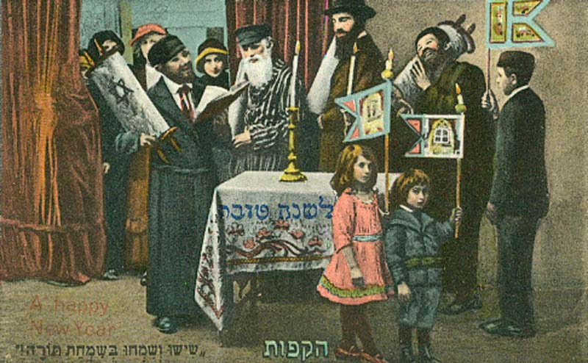
Classic early 20th Century Rosh Hashanah post card
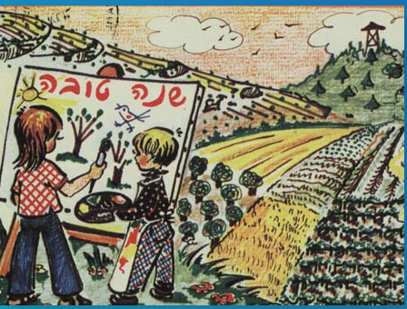
20th Century Israeli Zionist Rosh Hashanah post card
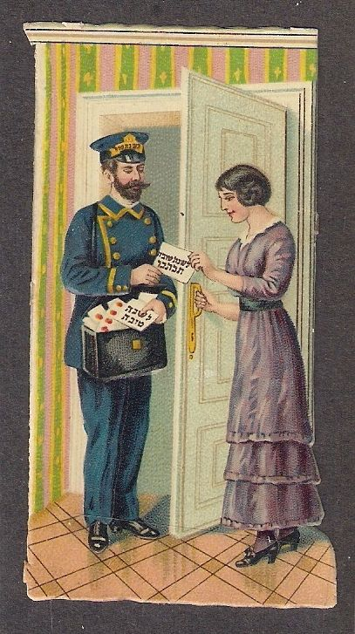
Classic early 1900s Rosh Hashanah (Shanah Tova) post card

Likkutei Sichos, vol. 24, pp. 227–228

